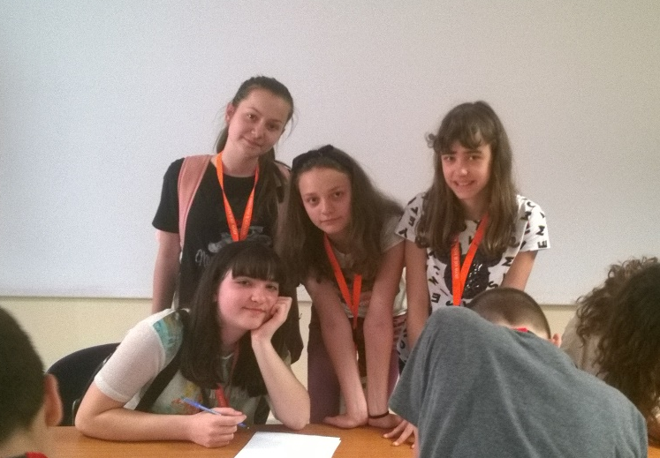
Italy, Portici, 4th meeting
My name is Tanya and I am pupil ambassador from Bulgaria. My favourite places were Positano and Amalfi. They were so colorful and joyful. Also the schools in Portici were very interesting. The pupils and teachers there were very kind to us. I really enjoyed the meeting with all the people in Italy. The games between us made us feel very united and I had a lot of fun when we had to answer some questions of the Adam’s quiz. Everyone was so gorgeous and positive and that made me feel very happy and thankful. I will never forget the incredible places that we visited and the amazing people that we met and their culture. Many thanks to all the people that tried their best to make us happy!!!

