**ACTIVE LEARNING**

[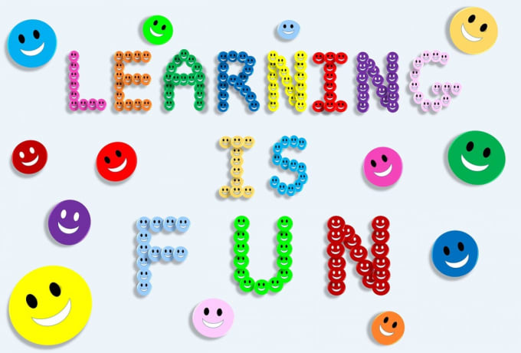](https://education.media/do-we-need-active-learning-in-the-classroom)

**DR. ÖZLEM ÖZER**

**HEADMISTRESS**

**ACTIVE LEARNING**

**What is Active Learning?**

Active learning is any approach to instruction in which all students are asked to engage in the learning process. Active learning stands in contrast to "traditional" modes of instruction in which students are passive recipients of knowledge from an expert.

Active learning can take many forms and be executed in any discipline. Commonly, students will engage in small or large activities centered around writing, talking, problem solving, or reflecting.

[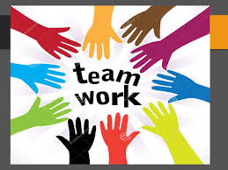](http://www.google.com.tr/url?sa=i&rct=j&q=&esrc=s&source=images&cd=&cad=rja&uact=8&ved=2ahUKEwj_ndb2htfgAhWL2KQKHbNSDrcQjRx6BAgBEAU&url=/url?sa=i&rct=j&q=&esrc=s&source=images&cd=&ved=&url=https://slideplayer.biz.tr/slide/10835006/&psig=AOvVaw3dTY1rTDg4bvA-ku5db7xL&ust=1551189775806141&psig=AOvVaw3dTY1rTDg4bvA-ku5db7xL&ust=1551189775806141)

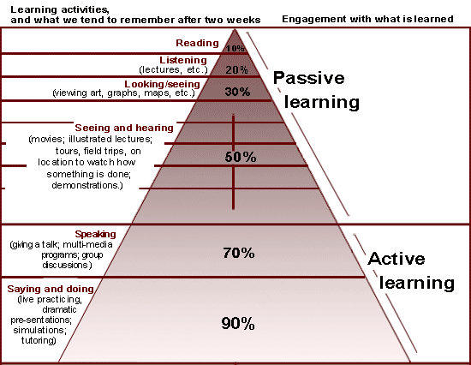

In a “traditional” class, it is common for only some students in a given course to participate in asking or responding to questions. In contrast, a class with successful active learning activities provide an opportunity for all students in a class to think and engage with course material and practice skills for learning, applying, synthesizing, or summarizing that material.

Using active learning strategies does not require abandoning the lecture format. Rather, adding small active learning strategies can make [lecturing](https://docs.google.com/document/d/1xHQtLfhA0xrL850Uv2mESRHfPcQfd23I40-AecBQ2uU/edit) more effective for student learning. These activities give students just a minute or two to check their understanding of recent material, practice a skill or highlight gaps in their knowledge before giving an explanation.

Active learning is an approach to instruction that involves actively engaging students with the course material through discussions, problem solving, case studies, role plays and other methods. Active learning approaches place a greater degree of responsibility on the learner than passive approaches such as lectures, but instructor guidance is still crucial in the active learning classroom. Active learning activities may range in length from a couple of minutes to whole class sessions or may take place over multiple class sessions.

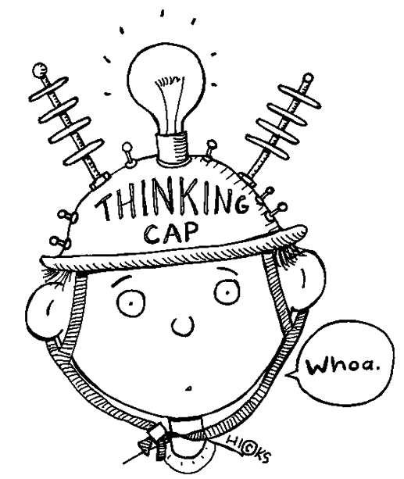

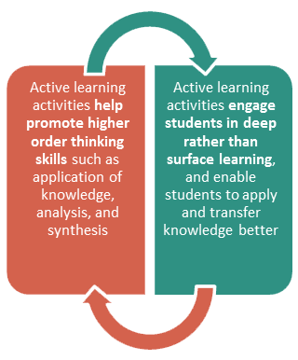

Active learning research attribute the following benefits to active learning:

• Creates greater student interest and motivation than traditional lecture.

• Involves students in learning-process activities rather than passive listening.

• Provides more frequent and immediate feedback to students.

• Promotes development of student skills in critical thinking.

• Improves writing and speaking skills.

• Increases individual accountability.

• Promotes greater academic achievement (breadth and depth); students learn to think about a subject/topic.

• Provides students with an opportunity to think about, talk about, and process course material.

• Improves recall of information.

• Contributes to more favorable attitudes toward learning.

• Places more emphasis on the teacher becoming a designer and facilitator of learning experiences rather than an imparter of knowledge.

• Emphasizes student-centered learning.

• Develops expertise in collaborative learning and teamwork.

• Creates opportunities for differentiated instruction.

• Promotes understanding. Note: Confucius stated, “I hear and I forget. I see and I remember. I do and I understand.”

Active learning activities **help promote higher order thinking skills** such as application of knowledge, analysis, and synthesisActive learning activities **engage students in deep rather than surface learning, and enable** students to apply and transfer knowledge better

[](https://hacikardesler.files.wordpress.com/2015/01/68ekip-calismasi.jpg)

**As a teacher, one of your biggest challenges is to plan lessons that inspire your students to stay actively involved in the learning process.**

**But you’ve probably noticed that traditional, teacher-centered learning plans aren’t** always conducive to achieving that inspiration.

[](http://www.google.com.tr/url?sa=i&rct=j&q=&esrc=s&source=images&cd=&cad=rja&uact=8&ved=2ahUKEwjjpsG1htfgAhUOMuwKHVSSABwQjRx6BAgBEAU&url=http://www.girisimder.org.tr/girisimcilik/takim-calismasi&psig=AOvVaw3dTY1rTDg4bvA-ku5db7xL&ust=1551189775806141)



Why use it?

Active learning improves student outcomes

There is a well-established evidence base supporting the use of active learning. The benefits to using such activities are many, including improved critical thinking skills, increased retention and transfer of new information, increased motivation, improved interpersonal skills, and decreased course failure (Prince, 2004).

As one example, the National Survey of Student Engagement (NSSE) has examined the engagement experiences of hundreds of thousands of students from over 1600 colleges and universities since 2000. The consistent results of these data show that hands-on, integrative, and collaborative active learning experiences lead to high levels of student achievement and personal development (Kuh, O’Donnell, and Schneider, 2017).

"My teaching evaluations have gone way up." **- David Saftner, Associate Professor, Civil Engineering**

As another example, a comprehensive meta-analysis of 225 science, engineering and mathematics education studies by Freeman et al. (2014) demonstrated that active learning can significantly increase course grades over didactic methods and is particularly effective in small classes of 50 students or fewer. In their analysis, students in courses without active learning were 1.5 times more likely to fail the course than students in courses with active learning.

Students in courses without active learning were 1.5 times more likely to fail than students with active learning.

[](http://www.pnas.org/content/pnas/111/23/8410.full.pdf)

Finally, research reveals a mutual influence between active learning and emotional states. Active learning can positively affect student motivation (Owens, Sadler, Barlow, & Smith-Walters, 2017); in turn, the overall impact of motivation moderates key learning characteristics such as attention and memory consolidation (Cavenagh, 2016).

Successful implementation

[Choose meaningful activities or questions](https://cei.umn.edu/active-learning#anchor-meaningful)

[Explain your rationale to students](https://cei.umn.edu/active-learning#anchor-rationale)

[Develop a facilitation approach](https://cei.umn.edu/active-learning#anchor-facilitation)

[Gather and record feedback](https://cei.umn.edu/active-learning#anchor-feedback)

_________________________________________________________________________________________________________________________________

Choose meaningful activities or questions

One of the most important aspects of active learning is choosing the activities or questions you’re going to use in class. When deciding what to ask or what to have students do, ask yourself:

* What are the most important things students should learn from this class session?
* What misconceptions or difficulty do students commonly have as it relates to this content?
* What kind of practice can students do that will help them prepare for an upcoming assignment or assessment?

"*Students from first generation or from underrepresented minorities benefit the most from active learning.*" **- Abdi Warfa, Assistant Professor, Biology**

Use the answers to these questions to choose activities and questions which will give students opportunities to meaningfully engage with the material. You want to have students engage in work that gives them feedback on how well they are understanding the material and practice in using the skills important for succeeding in your course. [Classroom Assessment Techniques](https://docs.google.com/document/d/1QMZC9igdgPggg1SC-NbOuAB05WnG3ujAtJ1zNEHssx4/edit) are one type of activity that works particularly well as you are getting started with active learning. Using these strategies, or variations on them, can help you hold your students’ attention and help them better retain and transfer knowledge and skills from your course.

"Students are not stupid and they're perfectly aware of when we are using meaningless, time-sucking activities in class." **- Sehoya Cotner, Associate Professor, Biological Sciences**

_________________________________________________________________________________________________________________________________

Explain your rationale to students

At the beginning of the semester and before you begin your first (few) activities, tell students why you’re having them engaged in activities during class. This is particularly important if active learning is not common in your discipline.

This explanation doesn’t need to be long or involved and can be as simple as, “In this course, I’d like you to be successful approaching your homework and exams, so we’re going to be doing in-class practice that I hope will make these easier for you. You’ll often be working in pairs or groups so you can bounce ideas off of each other and ask each other questions.”

_________________________________________________________________________________________________________________________________

Develop a facilitation approach

How you choose to facilitate active learning will be influenced by the context of your course (e.g. the number of students, the type of furniture in your class, time available) and the type of activity. Students can work individually, in pairs, or in small groups. These groups can be predetermined by the instructor or determined in the moment based on proximity.

One of the most effective approaches is to give students a short period of time to think on their own (30-90 seconds is often enough) and then have them work in pairs or small groups. If you are in a classroom with fixed seats, it is still possible for students to work together, but you may need to encourage students to move themselves to get into groups. If you have a student sitting alone, it is often easier and more effective to ask a group to invite an individual to join them rather than direct that individual to join a nearby group.

Keep students on task

One of the most important elements of successful active learning is students feeling a sense of accountability for participating in the assigned activity. If they don’t, they can easily get off task or choose not to do what you have asked. One of the most common questions instructors have is, “Do I have to grade all of this in-class work?” The short answer is no. You can choose to grade in class work, but it isn’t necessary as a way to hold students accountable.

For example, accountability can be established by notifying students before they start working on the activity that everyone should be prepared to share when the large group reconvenes. Then, when you reconvene the large group, randomly call on an individual or group to share what they discussed or how they approached the problem. You can also listen in on small group conversations and if you hear a particularly common or interesting question, call on that group to share their question to begin a larger discussion. Another way is to use clicker devices or [paper clickers](http://z.umn.edu/paperclickers) as a way for students to report their response.

"Don't feel you have to control everything and don't think you have to know everything ahead of time. Let it run and see what happens." **- Sheryl Breen, Associate Professor, POLSCI**

Students also tend to stay on task when they feel the value and relevance of the task they’ve been asked to complete. When tasks are similar or clearly related to upcoming assignments or assessments, students are intrinsically motivated to practice in order to prepare for that graded work.

Finally, keep activities short. Give students a clear goal or task, rather than a general  instruction like “discuss your answer”. Tell students you’re going to give them a limited and specified time to work. If they end up needing more time, provide it if possible.

Wrap-up activities

After students have worked in small groups, take time to provide a conclusion to the activity. This wrap-up is often where the most important learning takes place.

You can ask one group of students to share their reasoning or ask others if they had alternative ideas or approaches. If a response reflects a common misunderstanding, invite other students to help explain why this line of reasoning is incorrect. You can also not just correct the response, but help them to understand how experts approach the problem.

You can also highlight the ways that the activity reflects how they will be asked to use the information on an upcoming assignment. For example, you might say “We just walked through an analysis of this journal article, first looking at the methods and data tables, then critiquing the conclusions and argument. This is the same approach you’ll be asked to use as you read articles on your own and is the kind of reasoning I’ll expect on the paper due next week.”

Start how you wish to continue

If you plan to use active learning strategies in your course, make sure to use them consistently throughout the semester, starting the first week. Students quickly get into habits about how to behave in class, so set expectations early about participating and engaging in class. If students are resistant at first, keep encouraging them so you establish norms for their participation.

"If you try using group work for the first time on the fourth week or the eighth week - it's gonna crash. But if you do it on the first day, on the first activity? They'll listen to you." **- Murray Jensen, Associate Professor, Biological Sciences**

_________________________________________________________________________________________________________________________________

Gather and record feedback

Especially when trying new activities, develop a habit of recording and collecting feedback about how activities go. Save space in your notes, either paper or electronic, to record your thoughts about an activity after you’ve done it. This might be as simple as noting when a question or activity confused students or how long an activity took.

In order to refine your activities or facilitation, [ask students for feedback](https://cei.umn.edu/early-term-feedback-teaching). They can tell you if the activities are too long or short, too easy or too hard, and whether they are finding them valuable. Besides giving you helpful feedback, this can also provide an opportunity to reiterate why you’re doing active learning if you have a group of resistant students.

Addressing challenges

Active learning strategies can pose problems for instructors who are new to using them and for students who have had negative experiences with them prior to your class. What follows are common issues you may experience and some suggested solutions.

[Challenge 1 - Students are resistant to engaging in the activities](https://cei.umn.edu/active-learning#anchor-challenge1)

[Challenge 2 - Activities take too much time](https://cei.umn.edu/active-learning#anchor-challenge2)

[Challenge 3 - Students don’t want to work together](https://cei.umn.edu/active-learning#anchor-challenge3)

"One of the biggest challenges is discomfort... I think that can be overcome by just disclosing why we're doing this and the evidence based behind it." **- Katharine Nelson, Assistant Professor, Psychiatry**

 ________________________________________________________________________________________________________________________________

Challenge 1 - Students are resistant to engaging in the activities

* Begin using active learning strategies early in the term. Introduce the concept on the first day of class, and let students know that they will be expected to participate in such activities throughout the course.
* Use active learning frequently–at least once a class period initially. Vary the active learning strategies you use. After the first several sessions, students will understand that you're serious about active learning and will accept their role as participants more readily.
* Give clear instructions. State the goal students should meet, how much time they have for the activity, what procedures they should follow, and with whom they should partner (i.e., "turn to the person next to you" or "form groups of four with the people nearest you.")  Put directions for in-class activities on a PowerPoint slide so that students have something to refer to as they begin the activity.
* Explain to students why you're using active learning and the benefits they can expect from it.
* Be committed to your choice to use active learning and communicate that confidently to students. Students will be put at ease if they understand that you're in charge and have good reasons for what you're doing.
* Start small and simple. Use low-impact strategies such as think-pair-share or in-class writing exercises. These strategies are only a few minutes, and are "low stakes" for students who may be unsure or uncomfortable. As you and your students gain experience, you may decide to graduate to more involved activities.

_________________________________________________________________________________________________________________________________

Challenge 2 - Activities take too much time

* Use strategies to efficiently reconvene the large group at the end of active learning activities. For example, you might ring a bell or flash the lights to gain students' attention.
* Consider your learning objectives carefully. Based on them, what content is most important for students to master? Remove non-essential content so you can spend more time on activities that lead to better student learning.
* Consider what content you must cover in class and what content students can cover outside of class by themselves. It may be necessary to create assignments, activities, or other support to help students master material on their own.
* Attempt to use one or two brief active learning strategies during your lectures. Space the activities throughout the lecture to break it up and keep students engaged.
* Attempt to use [Classroom Assessment Techniques](https://docs.google.com/document/d/1QMZC9igdgPggg1SC-NbOuAB05WnG3ujAtJ1zNEHssx4/edit) to determine what students are learning and what is confusing them. These can help you decide when (and whether) you need to spend more time working with particular material.
* Avoid racing through material to finish it all by the end of the period. This is almost always counterproductive. Students tend to become overwhelmed and discouraged.
* Remember that just because you say it doesn't mean they learn it. Resolve to spend more time on less material.

_________________________________________________________________________________________________________________________________

Challenge 3 - Students don’t want to work together

* As part of your activity instructions, tell students to get into groups and first introduce each other. This sets the expectation that they may be working with others whom they do not know and allows them space to build rapport.
* Consider whether your activity is challenging enough to require two or more people to work on it. Does the task require that group members have differing perspectives, experiences, or knowledge? Design activities where there is genuine value in working together.
* At the beginning of the semester, approach people who are working alone and either encourage them to work with a nearby group or ask the group to invite the individual to join them. Do this everyday so students know that you expect them to work together.
* Consider assigning students to a single group so students know who they are accountable to all semester.

Research and resources

Resources

Videos of Active Learning in Action

**•**[From the Carl Wieman Science Education Initiative at the University of British Columbia](http://www.cwsei.ubc.ca/resources/SEI_video.html)

**•**[From the University of Michigan Center for Research on Learning and Teaching](http://crlt.umich.edu/arthur-f-thurnau-professors-engaging-students-classroom-and-beyond)

Books with Activity Ideas

**•**[Small Teaching](https://www.amazon.com/Small-Teaching-Everyday-Lessons-Learning/dp/1118944496/)(Lang, 2016)

**•**[Classroom Assessment Techniques](https://www.amazon.com/Classroom-Assessment-Techniques-Handbook-Teachers/dp/1555425003) (Angelo and Cross, 1993)

Research

[Cavenagh, S. (2016). The spark of learning: Energizing the college classroom with the science of emotion.](https://www.amazon.com/Spark-Learning-Energizing-Classroom-Education/dp/1943665338) Morgantown, WV: West Virginia Press.

Freeman, S., Eddy, S.L., McDonough, M., Smith, M.K., Okoroafor, N., Jordt, H., & Wenderoth, M.P. (2014). Active learning increases student performance in science, engineering, and mathematics. Proceedings of the National Academy of Sciences 111 (23) 8410-8415. <https://doi.org/10.1073/pnas.1319030111>

[Kuh, G., O’Donnell, K., & Schneider, C. (2017). HIPs at ten](https://drive.google.com/file/d/1HxYPnX8XM0CCmSX8aZtVVJPbuVa35ktL/view?usp=sharing). Change, 49(5), 8-16.

Owens, D., Sadler, T., Barlow, A., & Smith-Walters, C. (2017). Student motivation from and resistance to active learning rooted in essential science practices. Research in Science Education. <https://doi.org/10.1007/s11165-017-9688-1>

Prince, M. (2004) Does active learning work? A review of the research. Journal of Engineering Education 93 (3) 223-231. <https://doi.org/10.1002/j.2168-9830.2004.tb00809.x>

That’s where active learning strategies come into play. You can use them to empower, engage, and [stimulate a classroom](https://www.prodigygame.com/blog/growth-mindset-in-students/) by putting students at the center of the learning process

**Active Learning Strategies**

**The Teacher’s Role in the Active Learning Classroom**

While active learning places an emphasis on the student’s role in the learning experience, there is no doubt that the success of any active learning strategy starts with the thought and planning of a conscientious instructor

. 

Teachers play an influential role in increasing students’ situational interest in the active-learning classroom, while factors like a teacher’s social connection with students and subject matter expertise “significantly influence the level of students’ situational interest in the active learning classroom.”

And, critically, the benefits of active learning go both ways, helping teachers as well as students.

**Active Learning Techniques: Key Questions**

To help the success of these strategies, put yourself in your students’ position and imagine how they might experience it. This will help you get a feel for the lesson.

[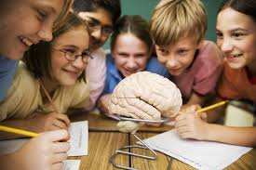](https://www.google.com.tr/imgres?imgurl=https://www.egitimpedia.com/wp-content/uploads/2014/07/Active-Learning-1.jpg&imgrefurl=https://www.egitimpedia.com/etkili-bir-ogrenme-ortaminin-10-temel-ozelligi/&docid=53X-F4yVlZkBbM&tbnid=_SVOXw2RpjwZ1M:&vet=10ahUKEwi68uTB4_7gAhXuy6YKHTW6CKMQMwhOKBowGg..i&w=640&h=427&hl=tr&safe=active&bih=589&biw=1295&q=aktif%20%C3%B6%C4%9Frenme%20resimleri&ved=0ahUKEwi68uTB4_7gAhXuy6YKHTW6CKMQMwhOKBowGg&iact=mrc&uact=8)

[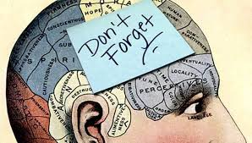](http://www.google.com.tr/url?sa=i&rct=j&q=&esrc=s&source=images&cd=&cad=rja&uact=8&ved=2ahUKEwiBz6fk5f7gAhXKGewKHTEjAVwQjRx6BAgBEAU&url=/url?sa=i&rct=j&q=&esrc=s&source=images&cd=&ved=&url=https://formulalingua.com/yabanci-dili-aktif-ogrenme/&psig=AOvVaw3l0EybWayHRkhHKAouwTp5&ust=1552554812793363&psig=AOvVaw3l0EybWayHRkhHKAouwTp5&ust=1552554812793363)

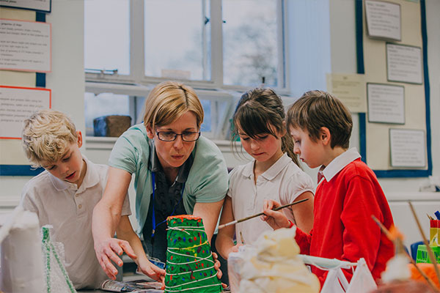

When applying any of these strategies for your course, be sure to ask yourself:

* Will this be engaging and exciting for my students?
* Can this activity deploy [formative assessment strategies](https://www.prodigygame.com/blog/formative-assessment-examples/)?
* Is the student placed at the center of this learning strategy?
* Will this encourage my students to discuss a topic with one another?
* Am I giving students the opportunity  to reflect on the learning process?
* Is this activity getting my students to think deeply and critically about  a topic or lesson or is it simply a comprehension exercise?

[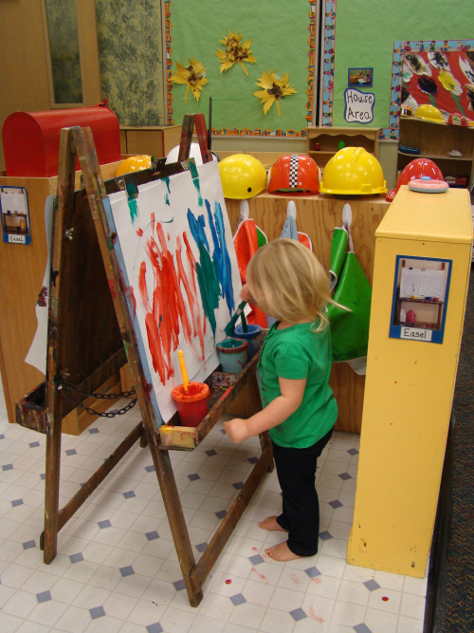](https://www.google.com.tr/url?sa=i&rct=j&q=&esrc=s&source=images&cd=&cad=rja&uact=8&ved=2ahUKEwjLhf667_7gAhUyMuwKHcG5BiQQjRx6BAgBEAU&url=https://zesray.wordpress.com/2011/11/14/aktif-ogrenme/&psig=AOvVaw3zp9y82V01FzLanOU9BBAm&ust=1552557726032083)

**Making Space for Active Learning Strategies**

While all of the active learning strategies outlined above can be deployed in traditional, lecture-oriented classrooms, the physical arrangement of your room and the number of students in the class can make some of them difficult to perform easily

[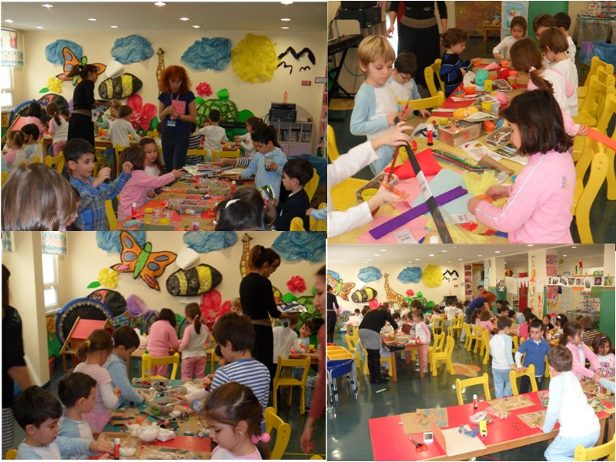](http://www.google.com.tr/url?sa=i&rct=j&q=&esrc=s&source=images&cd=&cad=rja&uact=8&ved=2ahUKEwjnzMri5P7gAhWCCewKHWn0DlEQjRx6BAgBEAU&url=http://5-6yas2012-2013istekbarisanaokulu.blogspot.com/2013/03/aktif-ogrenme-calismamiz.html&psig=AOvVaw3l0EybWayHRkhHKAouwTp5&ust=1552554812793363)

**Final Thoughts on Active Learning Strategies**

Active learning plainly puts the focus on the learner: what the learner does, what the learner thinks, and how the learner behaves.

But, crucially, active learning doesn’t simply happen with a few simple instructions: it occurs in the classroom where the teacher is committed to a learning environment that *makes active learning possible*.

Ultimately, these active learning strategies will help build understanding rather than memorization of facts, giving students the confidence to apply learning to different problems and contexts and achieve greater autonomy over their learning.

And, after all, that’s exactly makes active learning “active”:  putting students at the center of the learning process *as they take the initiative to learn*.

[](http://www.google.com.tr/url?sa=i&rct=j&q=&esrc=s&source=images&cd=&ved=&url=http://www.gazetemsi.com/yeni-bir-dil-ogrenirken-beynimizde-neler-oluy-15763&psig=AOvVaw3l0EybWayHRkhHKAouwTp5&ust=1552554812793363)

Active Learning Strategies

Active Learning Strategies help to initiate learners. Multiple active learning strategies may be used in each of the active learning designs. Here’s an annotated list of active learning strategies.

**1. Sit & talk with peers nearby**

**Think-Pair- Share.**

1. **Define “Think-Pair-Share.”** Explain to students that a Think-Pair-Share allows them to activate their prior knowledge and share ideas about content or beliefs with peers. This structure gives students a chance to organize their ideas—first in their own minds, then in a smaller group setting before sharing with the entire group. In a Think-Pair-Share, students Think individually about the question or idea(s) put forth, Pair up with someone to discuss their thinking, and then Share their conversation with their table group, and then finally with the whole group.

**2. Display Think-Pair-Share prompts about a concept or topic.** Give students 1-2 minutes to think about the prompt on their own. Then discuss with a partner for another few minutes.

**3. Facilitate a whole group discussion.**

* Listen to their responses.
* Ask students to elaborate on their thinking by providing explanations, evidence, or clarifications. Suggested probing questions:
  + What makes you think that?
  + Please give an example from your experience.
  + What do you mean?
* Try to stay neutral in your reaction to students’ comments.
* Invite others to react and respond to ideas by providing alternative viewpoints, agreements or disagreements. Suggested probing questions:
  + Can anyone add something to that comment?
  + Who would like to share an alternative opinion?

[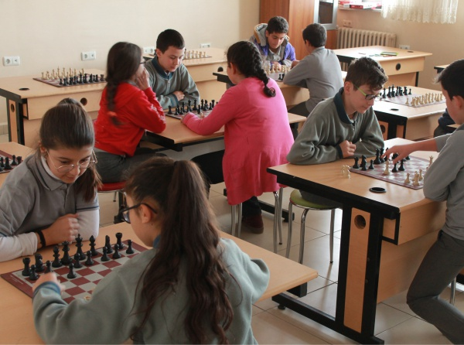](http://www.google.com.tr/url?sa=i&rct=j&q=&esrc=s&source=images&cd=&cad=rja&uact=8&ved=2ahUKEwi8yuXB7f7gAhUE2aQKHf-2ACEQjRx6BAgBEAU&url=http://ilkernarin.meb.k12.tr/icerikler/aktif-ogrenme-koseleri_6122290.html&psig=AOvVaw3zhC8roWslmDsf3a7_PJ-3&ust=1552557278353002)

**Quick write**

A prompt is posed for students to respond to in writing. Taking only 5 minutes or so, this is a quick way to accomplish one or more of the following: determine whether or not students have done the homework assignment, engage students in thinking about the topic that will be covered in the session, provides the opportunity for students to access their prior knowledge on a topic. The quick write can be graded to encourage students to do their reading assignment, or collected to serve as an attendance check.

[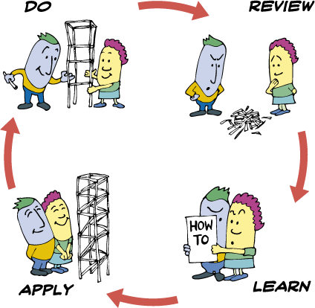](http://www.google.com.tr/url?sa=i&rct=j&q=&esrc=s&source=images&cd=&ved=2ahUKEwizpcPr7f7gAhXJ_aQKHWaMDZcQjRx6BAgBEAU&url=http://guilin2014.weebly.com/&psig=AOvVaw3zhC8roWslmDsf3a7_PJ-3&ust=1552557278353002)

**Turn and Talk**

In a turn and talk, a question is posed to the class and students simply turn to the person next to them to discuss. This can serve as a comfortable way for students to share their ideas with others and set the stage for them sharing with the larger group. The instructor doesn’t need to hear all (or any) of the ideas shared– the important aspect of this strategy is for the peers to share and for individuals to access their prior knowledge about a topic. Example prompt: Ask students to turn to someone next to them and discuss their responses to the following question. Tell them to take two minutes to discuss this with their partner with each person getting some time to talk.

* Part of the challenge of communicating climate change with the public is that there is disparity between what scientists and the non-scientist public think and know about climate change.
* Why do you think there is such a disparity

[](https://www.google.com.tr/url?sa=i&rct=j&q=&esrc=s&source=images&cd=&cad=rja&uact=8&ved=2ahUKEwi8quXh7P7gAhVR6KQKHSFUD7EQjRx6BAgBEAU&url=https://www.ozeldersimiz.com.tr/aktif-ogrenme-1/&psig=AOvVaw3zhC8roWslmDsf3a7_PJ-3&ust=1552557278353002)

**Polling**

Having students vote anonymously on what they perceive as the best explanation/answer to a question,followed by opportunities to discuss their ideas with peers, and then to vote again leads to greater learning of the material. It is important to have students discuss why they think their explanation is the most accurate and also why the other explanations proposed are not accurate. It is also important that the teacher looks at the polling results and listens to the reasoning of the students in order to determine what further explanations and summary might need to be made in lecture. There are various tools that can beused for polling, including Clickers, Socrative.com and Poll.Everywhere.com.

[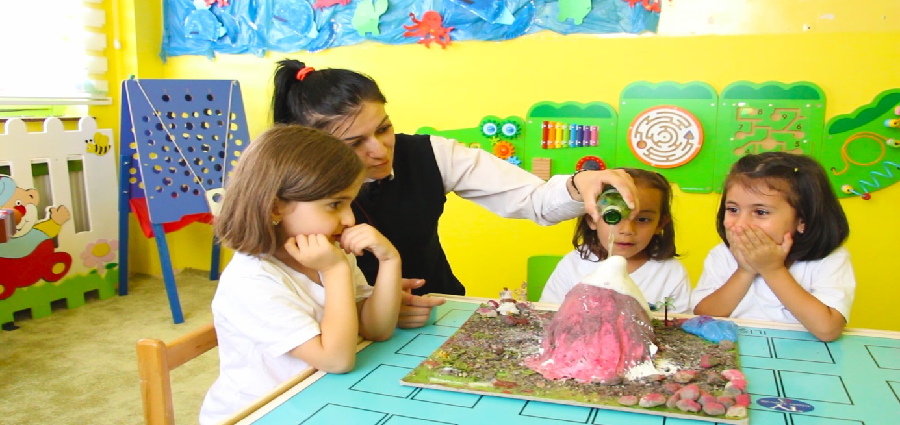](http://www.google.com.tr/url?sa=i&rct=j&q=&esrc=s&source=images&cd=&cad=rja&uact=8&ved=2ahUKEwi0pYfV7v7gAhWJyqQKHZuzBS4QjRx6BAgBEAU&url=http://www.erzurumneseerberk.com/etkinlikler-1.html&psig=AOvVaw3zp9y82V01FzLanOU9BBAm&ust=1552557726032083)

**Individual plus Group Quizzes**

Give students a quiz that they complete individually and turn in to be graded. Immediately following the individual quiz, put students in small groups and have them take the quiz again, but this time they discuss the answers in their group and turn it in for a group score. Both quizzes are graded and if the group score is higher, the two grades are averaged. The group score can’t hurt someone if they have a higher individual score. This encourages individual accountability, and also helps students to better understand the material as they discuss it with peers. In this way, they keep up with the material, rather than realizing they don’t totally understand it when they reach the midterm.



**Tests/Quizzes with common preconceptions as distractors**

Design assessments to include common preconceptions (or misconceptions) that students often hold. Allow students to answer the question on their own and then discuss their answer and rationale with a partner. Have them answer the question again after the peer discussion. Elicit a whole group discussion about why the correct answer is correct and why the others are not. Common misconceptions students have about STEM topics and concepts can be found at AAAS, and assessment questions including common misconceptions as distractors can be found at Braincandy.

[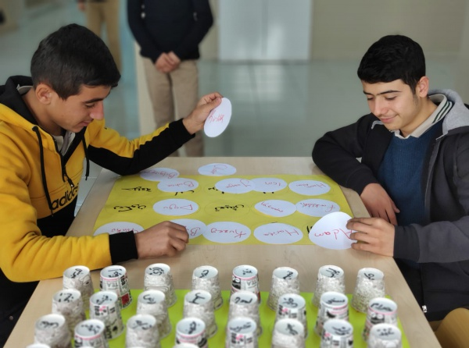](http://www.google.com.tr/url?sa=i&rct=j&q=&esrc=s&source=images&cd=&cad=rja&uact=8&ved=2ahUKEwiBxpDY8P7gAhUN26QKHZeYCu8QjRx6BAgBEAU&url=http://tatvansmakihl.meb.k12.tr/icerikler/okulumuz-ogrencileri-icin-aktif-ogrenme-ortamlari-olusturuldu_6237263.html&psig=AOvVaw3zp9y82V01FzLanOU9BBAm&ust=1552557726032083)

**Jigsaw Method**

[](http://www.google.com.tr/url?sa=i&rct=j&q=&esrc=s&source=images&cd=&cad=rja&uact=8&ved=2ahUKEwj2lrTk8f7gAhVFhqQKHYDpD7IQjRx6BAgBEAU&url=/url?sa=i&rct=j&q=&esrc=s&source=images&cd=&ved=&url=https://www.youtube.com/watch?v%3DeuhtXUgBEts&psig=AOvVaw0j9rE_e_oSYo2eXiNSnV49&ust=1552558611124987&psig=AOvVaw0j9rE_e_oSYo2eXiNSnV49&ust=1552558611124987)

[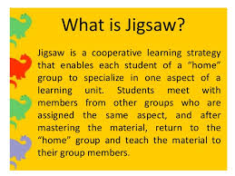](http://www.google.com.tr/url?sa=i&rct=j&q=&esrc=s&source=images&cd=&cad=rja&uact=8&ved=2ahUKEwig86DF8v7gAhVG16QKHU_eDRkQjRx6BAgBEAU&url=/url?sa=i&rct=j&q=&esrc=s&source=images&cd=&ved=&url=https://www.slideshare.net/lrebamonte/jigsaw-31889953&psig=AOvVaw2ipVWphtkDKdgGkofJKQo5&ust=1552558732969713&psig=AOvVaw2ipVWphtkDKdgGkofJKQo5&ust=1552558732969713)

[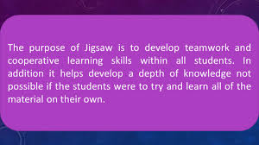](http://www.google.com.tr/url?sa=i&rct=j&q=&esrc=s&source=images&cd=&cad=rja&uact=8&ved=2ahUKEwiwje3L8_7gAhWE2aQKHbFXBisQjRx6BAgBEAU&url=/url?sa=i&rct=j&q=&esrc=s&source=images&cd=&ved=&url=https://slideplayer.com/slide/10796267/&psig=AOvVaw2ipVWphtkDKdgGkofJKQo5&ust=1552558732969713&psig=AOvVaw2ipVWphtkDKdgGkofJKQo5&ust=1552558732969713)

[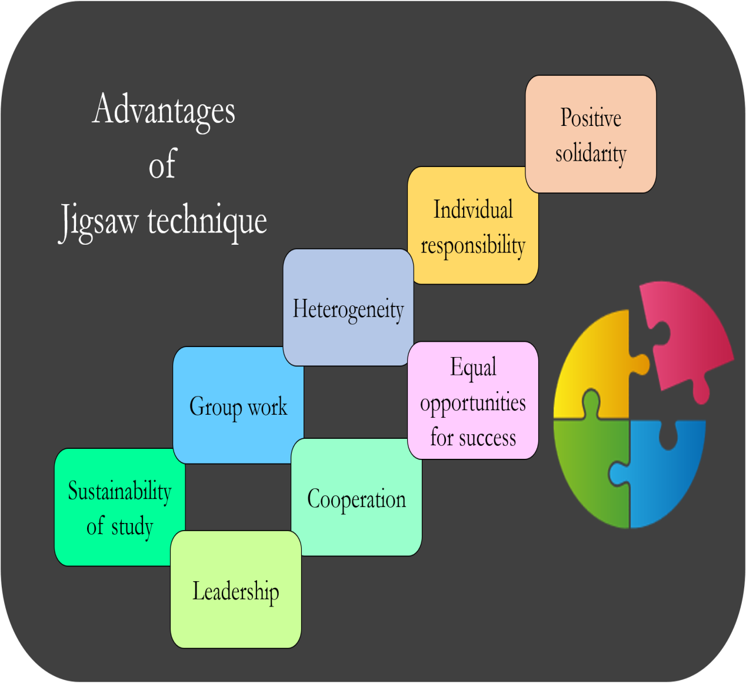](https://www.google.com.tr/url?sa=i&rct=j&q=&esrc=s&source=images&cd=&cad=rja&uact=8&ved=2ahUKEwimxbH98v7gAhUJDuwKHamoB8cQjRx6BAgBEAU&url=https://www.mededpublish.org/manuscripts/1009&psig=AOvVaw2ipVWphtkDKdgGkofJKQo5&ust=1552558732969713)

[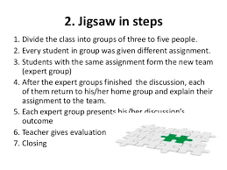](https://www.google.com.tr/url?sa=i&rct=j&q=&esrc=s&source=images&cd=&cad=rja&uact=8&ved=2ahUKEwjYwtel8_7gAhVNyKQKHYMXAtIQjRx6BAgBEAU&url=https://www.imagenesmi.com/im%C3%A1genes/learning-jigsaw-c1.html&psig=AOvVaw2ipVWphtkDKdgGkofJKQo5&ust=1552558732969713)

[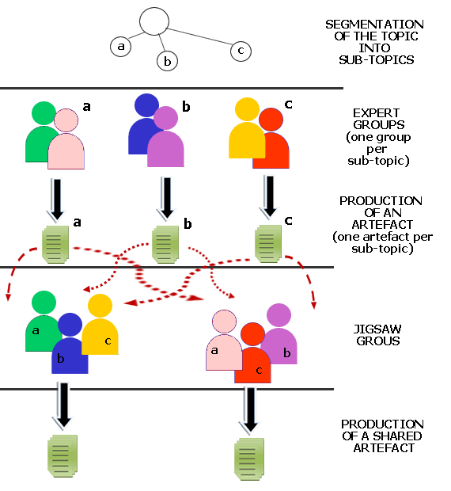](https://www.google.com.tr/url?sa=i&rct=j&q=&esrc=s&source=images&cd=&cad=rja&uact=8&ved=&url=https://www.kompasiana.com/www.etzcoy.blogspot.com/penerapan-metode-jigsaw-dalam-pembelajaran_5605f7b57fafbde10e17baec&psig=AOvVaw0j9rE_e_oSYo2eXiNSnV49&ust=1552558611124987)

[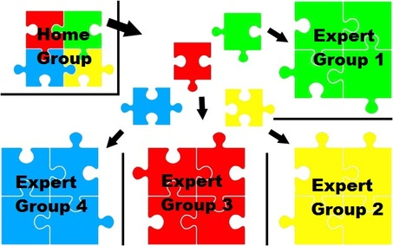](https://strategiesforspecialinterventions.weebly.com/jigsaw1.html)

[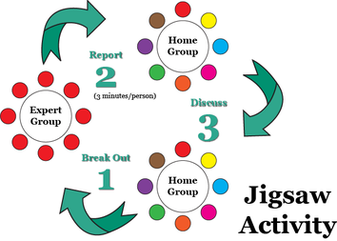](https://www.google.com.tr/url?sa=i&rct=j&q=&esrc=s&source=images&cd=&cad=rja&uact=8&ved=2ahUKEwiRlp2v8v7gAhWjM-wKHR6qBegQjRx6BAgBEAU&url=https://strategiesforspecialinterventions.weebly.com/jigsaw.html&psig=AOvVaw2ipVWphtkDKdgGkofJKQo5&ust=1552558732969713)

Students work in small groups to read information that has been organized into sections. Each student inthe group reads one section of the material and then shares that information with the rest of their group.As they read and share information, they refer to prompts such as: what do you think each idea means?What is the big idea? How can this idea be applied to help understand the concept(s)? What questions do you have about what you read? What do you agree/not agree with?

There are various permutations of jigsaws. One such model include expert and cooperative groups: Each group can be assigned a particular aspect/part of the overall information – they read it individually and then discuss in their small “expert” group to make sure they all understand it. Then new “cooperative”groups are formed made up of one-two students from each of the original expert groups. In this way, the new groups have an “expert” representative from each of the original groups so that all of the information is now represented in the new cooperative group. The “expert” has had a chance to practice sharing and hearing other viewpoints about the information in their original group, and therefore likely feels more comfortable sharing in the new group.

**Sorting strips**

Small bits of information are separated into strips so that students can sort the strips into various categories, or organize them into a sequence depending on the topic. This strategy encourages discussion of competing ideas or organizations or order in which a process would take place. In this case, it is often the discussion and sharing of ideas that is the most important outcome of the activity.

**Partial Outlines/PPTs provided for lecture**

Research has shown that students have a better understanding, do better on exams, and stay more engaged with the content during lecture when they are provided with partial, rather than complete lecture notes or Power Points.

**Pausing in lecture**

These strategies work towards inserting wait time in lectures for students to reflect on, discuss and apply ideas just presented and to encourage them to engage actively in the lecture rather than passively taking notes. These strategies also help students to understand what they do and don’t understand about the lecture.

* ask students to not take notes as you work through a problem on the board with the class, followed by 5 minutes for them to copy down board and discuss the problem/chemical reaction/process with peers
* pause 6-10 seconds after asking a question before calling on a student to respond  have students do a quick write about a concept just covered in lecture (e.g. their understanding, two questions they have about the concept as presented, what they would like to know more about etc.); optional, collect the quick write to help you better understand what they understood from the lecture and the questions they have and to keep them engaged
* turn and talks – ask peers to talk to each other about what they do and don’t understand and/or share with each other what they wrote down in their notes about a particular concept just covered in lecture. Encourage students to add to their notes from the discussion
* have students apply their understanding of a concept just covered by working with a small group around a huddle board. Optional, have a few groups share their work and elicit reactions and reviews from other students. Summarize findings and scientific normative explanations.
* Have students do think-pair-shares, polling to keep their mind engaged in the topic and to share their ideas with their peers for greater meaning-making opportunities.

**2. Requires students moving around**

**Posters & gallery walk**

Give groups of students an assignment that they need to work on together and present their ideas on a sheet of chart paper. Once they have completed their poster, have them display it on the wall, much like at a scientific poster session. One of their group will stay with the poster and help to explain it as the class circulates to look at all of the posters. Students take turns standing by their poster so that each of them have the chance to visit the other groups’ posters. This sets up a more interactive way of presenting as compared to ppt presentations.

**Fish bowl**

A fish bowl allows a small group of students to engage in a discussion about ideas or concepts that have alternative explanations while the rest of the class observes and takes notes. An inner circle of students engages in the discussion, while the rest of the class either sits in an outer circle, or remains in their regular seats and observes. If you have your class organized into small groups, then the members of each group can tap their respective teammate and replace them in the inner circle to expand on or provide additional evidence to support an explanation. Optional: the entire class needs to take part in the inner circle conversation by the end of the class period.

**Idea line up**

The idea line up is a structure that allows a teacher to use the diversity of perspectives in the classroom to generate heterogeneous groups of students for discussion. This diversity of thinking is a good place from which to develop a classroom climate that supports argumentation. More student-initiated science talk happens when students are connected with peers who have opposing perspectives. The question should be one about which students have enough prior knowledge/experience to have some evidence to bring to bear in the discussions which ensue.

*How it works:* The teacher provides a question that (s)he knows may have a continuum of responses, especially if it is asked prior to collecting significant amounts of evidence or before students have the opportunity to synthesize the evidence they have already collected.

The question is displayed prominently for students to consider. Students are directed to position themselves on a line to indicate their level of agreement in response to the question. After the students line up, have students talk to the person next to them so they can clarify their own thinking on why they positioned themselves on the line in a particular spot.

Student positions on the line typically indicate a diversity of thinking. The teacher can then use their positions to form groups of students with differing ideas about the question. Students then discuss their thinking and reasoning for their responses with the peers with whom they have been matched. Students should be prompted to listen carefully to each other’s claims and evidence and respond with evidence to counter or support the claims of other students in their group. A group claims and evidence chart or small whiteboards can be used to collect student thinking.

If the activity is used prior to an investigation, students can use the ideas from the initial discussion to continually weigh against the evidence they gather from their investigations. If the activity is used after an investigation, but prior to a whole-group meaning-making discussion, ideas from the small group discussions can be used to prepare for a whole group discussion.

**Four corners**

Four corners is used for the same reasons as the idea line up. The only difference is that students are considering several claims (responses to a question). For example, a teacher might ask, “Where does most of the mass in a plant come from?” Claims for consideration might include, “soil,” “air,”“water,” and “sunlight.”

*How it works:* The teacher displays the question prominently for all to consider. Each corner of the classroom is assigned one claim, also prominently displayed. Students are asked to go to the corner of the classroom that has the claim they agree with most. If they think more than one answer is correct, they should just pick one of the corners they agree with. If they don’t agree with any claims, they should go to the middle of the room. Once in their corners, students should discuss with others why they chose that corner to help clarify their thinking. Have them share and record evidence that supports that claim and why the other claims are not supported. Optional: have them visit the other corners to see what others thought about the ideas and the evidence they put forth.

Just as in the idea line up the teacher can use the student positions around the room to form groups with a diversity of ideas. The rest of the instructions are the same as for the idea line up.