STONEHENGE - by Jessica
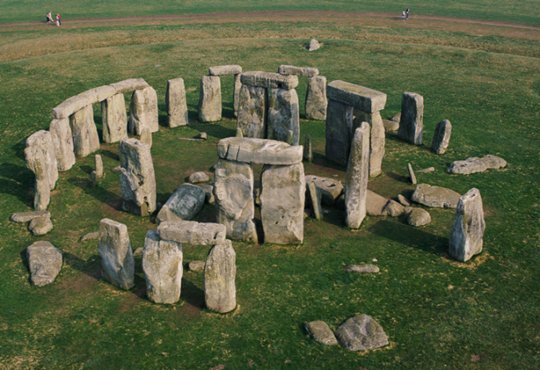
Stonehenge is a circle of ancient stones that was built around 5,000 years ago. It was built near Amesbury, Salisbury. It took 1,500 years to build and different cultures and generations took part in this extraordinary build. Originally it was believed to be a graveyard. That theory is proved by scientists digging up and discovering skeletons buried, scattered around the stone circle.
Stonehenge used to be a perfect circle, but over the years some have fallen, broken with age or been removed. Stonehenge was roped off in 1977 because there had been injuries when the rocks had fallen down. Now you can only walk around the outside.
Stonehenge is visited by 800,000 people a year. They come from all over the world.
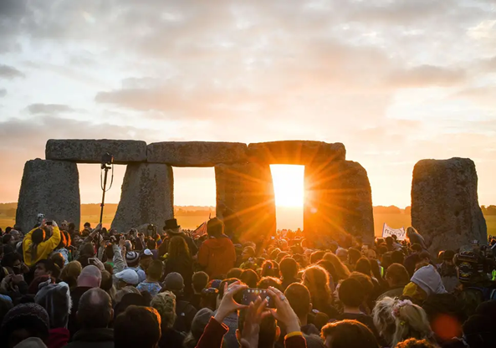
Summer solstice happens on June 21st every year and thousands of people celebrate the magic of nature on the longest day of the year.

