LAS TABLAS DE DAIMIEL  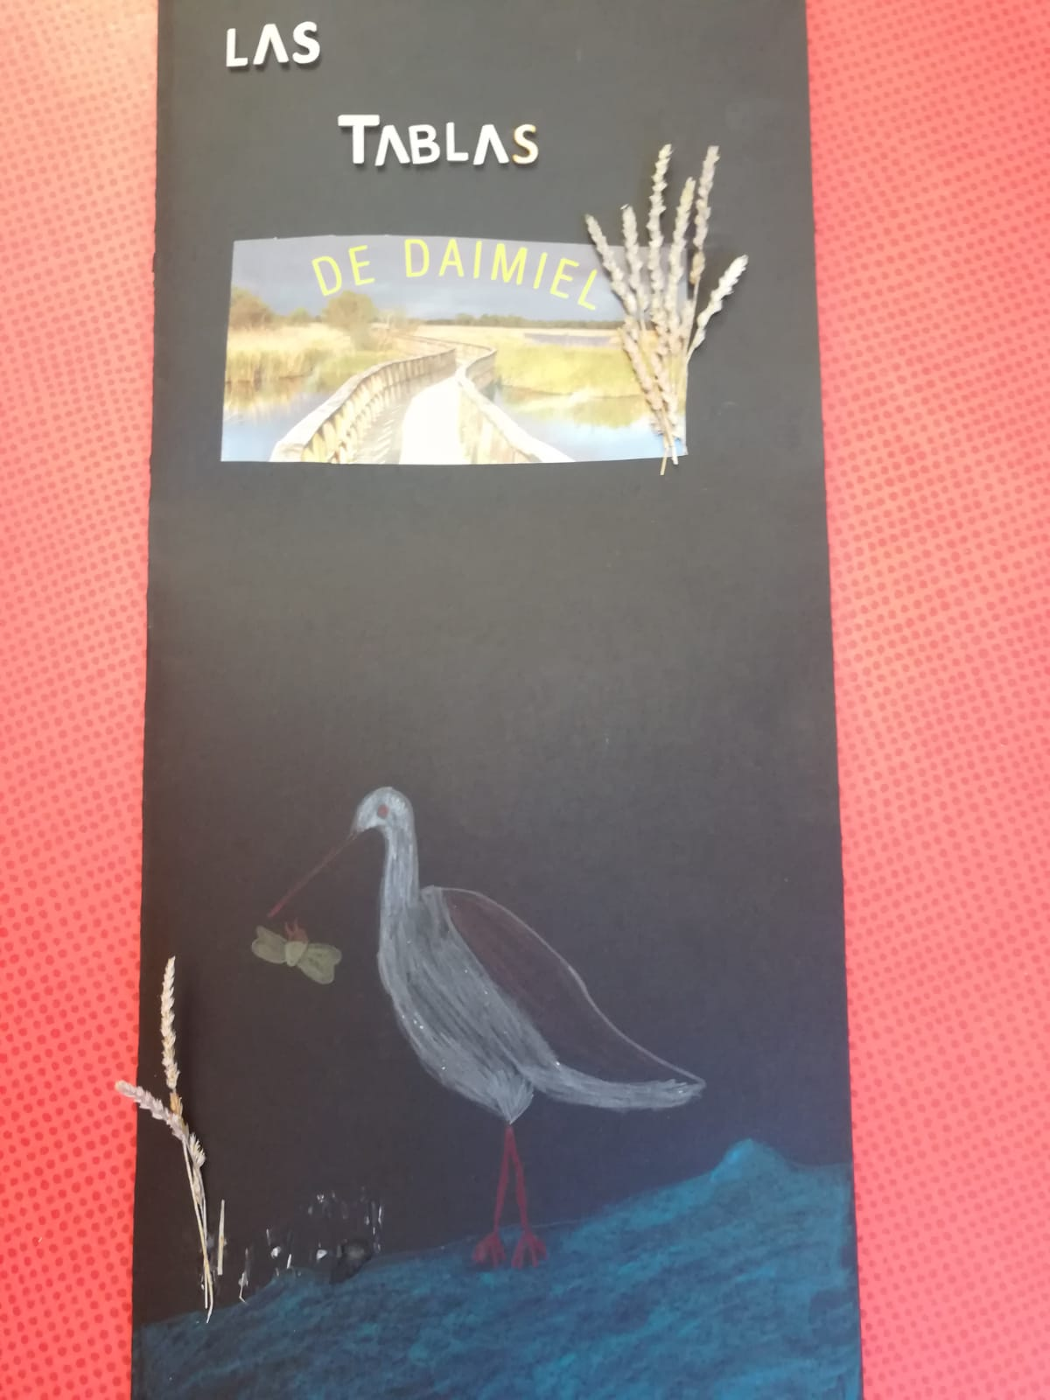 | - We have chosen “Las Tablas de Daimiel” because is a good example of natural wildlife.  - It is a wetland on the La Mancha plain, a mainly arid area in the province of Ciudad Real. It is the last example of this ecosystem in our country.  - The flora and the fauna of this area are protected.  - The Tablas de Damiel were declared a National Park in 1973.  - In 1980 the national park was extended and UNESCO included Las Tablas in a biosphere reserve.  - In 1987 Las Tablas were declared a Special Protection Area for birds.
