The peace treaty of Roskilde 1658
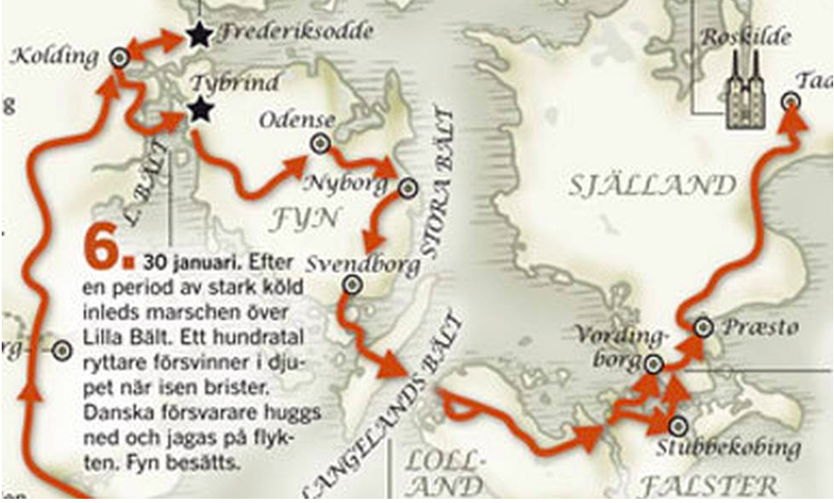
The part of Sweden that we live in is called Scania, it used to be Danish.
In January 1658 the Swedish army came from Germany and marched north on their way to Copenhagen.
They first crossed over the ice at Lilla Bält and then they crossed the ice at Stora Bält (13 km). The ice broke and at least 200 soldiers disappeared in the water.
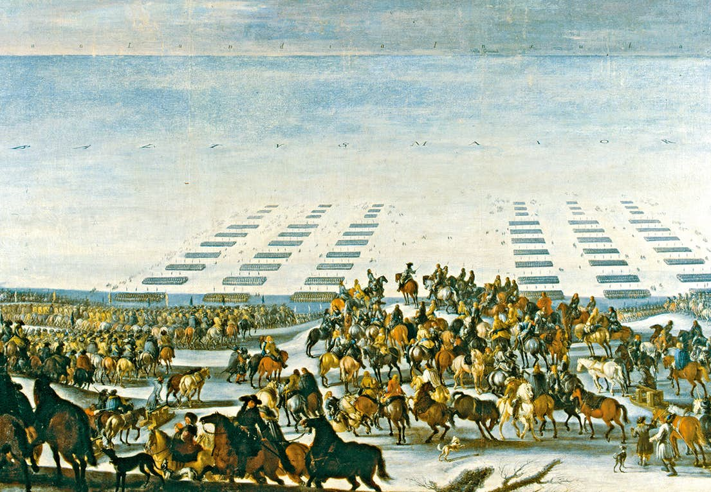
The king Karl X Gustav was close to die when his sleigh with three horses and the driver went through the ice.
The army managed to reach Copenhagen and the Danish were defeated.
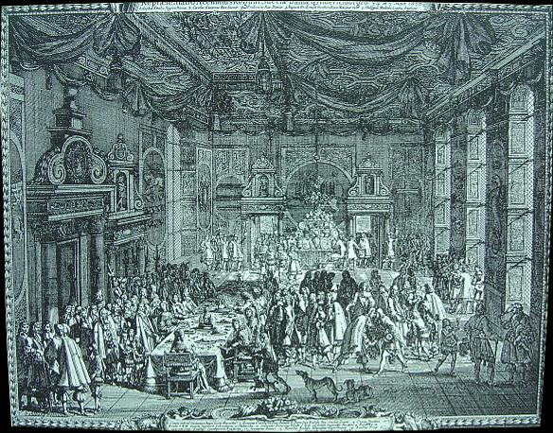

The 26th of February the peace agreement was signed in Roskilde and the Swedes got Scania and some other areas of what was then Denmark.

