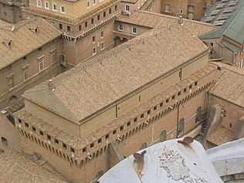
SISTINE CHAPEL
The Sistine Chapel is a large chapel located in the Vatican’s Apostolic Palace. It is named after Pope Sixtus IV, who oversaw its restoration in the late 15th century. Historically, the chapel has had various important functions. Today, it retains its religious role, as it serves as the site where cardinals meet to elect the next pope.
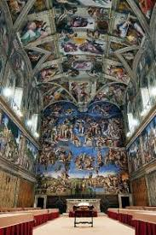
What the Sistine Chapel is most well-known for, however, is its ceiling. Painted by Florentine fine artist Michelangelo between 1508 and 1512, the complex and colorful fresco is celebrated for its realistic figures, vast size, and innovative process.
The narrative begins at the altar and is divided into three sections. In the first three paintings, Michelangelo tells the story of The Creation of the Heavens and Earth; this is followed by The Creation of Adam and Eve and the Expulsion from the Garden of Eden; finally is the story of Noah and the Great Flood.
Do you know? In order to reach the chapel’s ceiling, Michelangelo created special scaffolding.
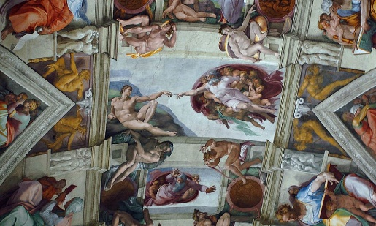
Rather than build the structure from the floor up, he installed a wooden platform held up by brackets inserted into holes in the wall. As he completed the painting in stages, the scaffolding was designed to move across the chapel.
Like many other Italian Renaissance painters, he used a fresco technique, meaning he applied washes of paint to wet plaster. In order to create an illusion of depth, Michelangelo would scrape off some of the wet medium prior to panting. This method culminated in visible “outlines” around his figures —a detail considered characteristic of the artist.

