The battle of Lund 1676
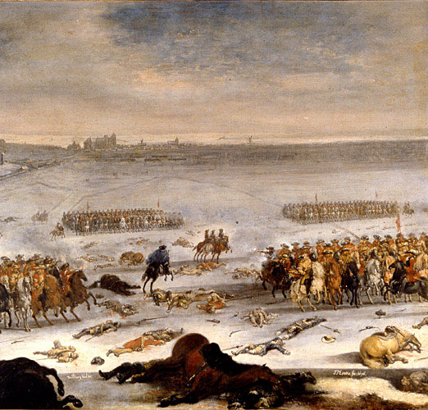
Just north of Lund there was a big battle at the 4th of December 1676 between the invading Danish army and the Swedish army led by king Karl XI.
The Danes wanted Scania back because it is a rich part of Sweden so they came with 13000 soldiers against the Swedish 8000.
It was difficult for the Swedish army because the people of Scania were tired of war and felt occupied by the Swedes. There were freedom fighters called “Snapphanar” that attacked Swedish soldiers leaving their camp trying to get supplies.
The armies raced to be the first one to reach a hill to be able to attack from a better position. The Swedes won that race.
Once again the Swedish king was lucky and he managed to lead his army to victory.
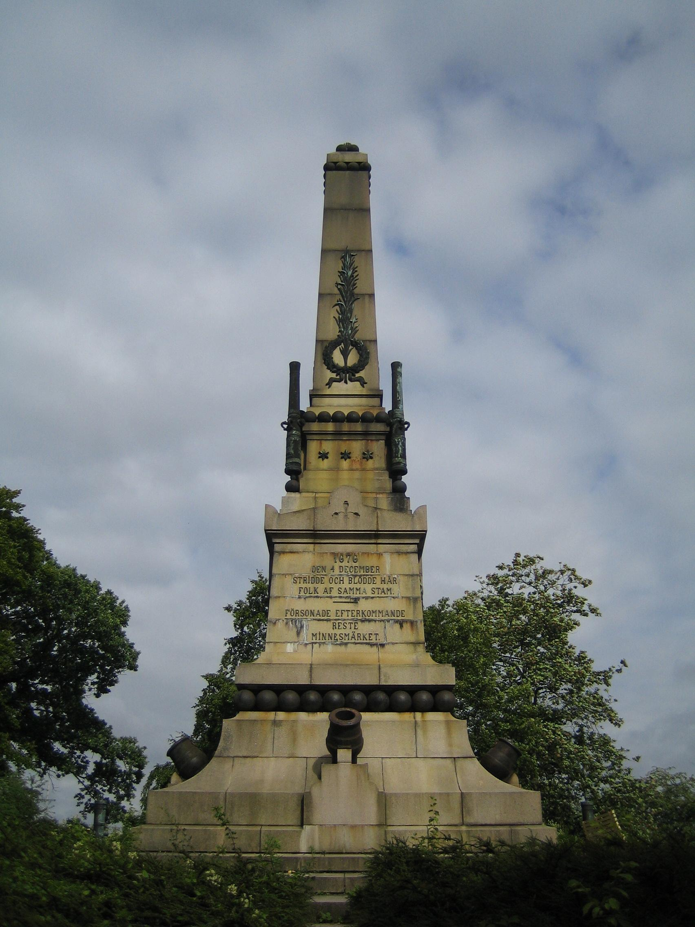
The battle was one of the bloodiest battles in percent of casualties on both sides ever fought on European soil about 42 percent of all the soldiers died.

This was the end of the Scanian war that lasted four years.

This is a monument in Lund that we have visited.

