Shipka
Bulgarian Monument of Freedom
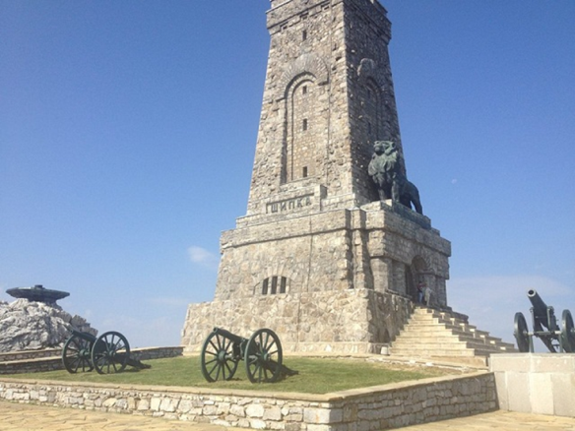
The Shipka Monument is a monumental sculpture on Mount St.Nicolas. The monument is derived from the purpose of introducing data about the freedom of Bulgaraia. At this place has happened the Russo-Turkish War and the Liberation in summer of 1877.
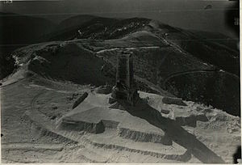
The monument was officially opened in 1934. It is a large dolomite-shaped pyramid-shaped tower with a height of 31.5 m. Above the entrance of the tower stands a huge bronze lion, 8 m long and 4 m high, and on the other sides of the tower are marked the places of the big battles - Shipka, Stara Zagora, Sheynovo. A female figure embodies the victory over the Turkish troops. On the ground floor of the monument there is a large marble sarcophagus, which holds part of the bones of the Russian wars and the Bulgarian volunteers. Above it there are four more floors where some copies of Bulgarian battle flags and other relics are located. At the top of the tower there is a magnificent view of Shipka peak and the surrounding area.
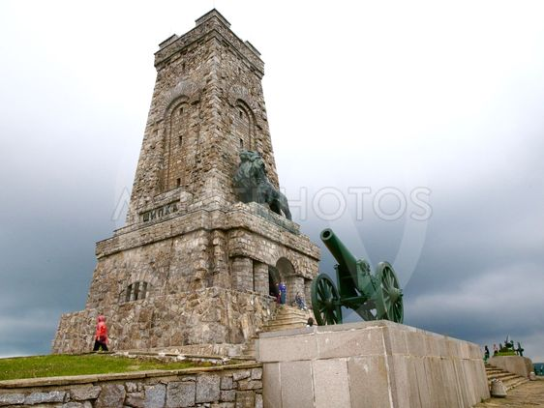
Every year on March 3rd on Shipka peak is celebrated the National holiday of Bulgaria. On this heroic place took place the most epic battle for the freedom of Bulgaria. About 7500 Bulgarian volunteers protect the peak from thousands of heavily armed Turkish armies with trees, stones and even carcasses, when their weapons finished. So the heroes stopped the path of the Ottomans to North Bulgaria sacrificing their lives.

