CATEDRAL DE BURGOS

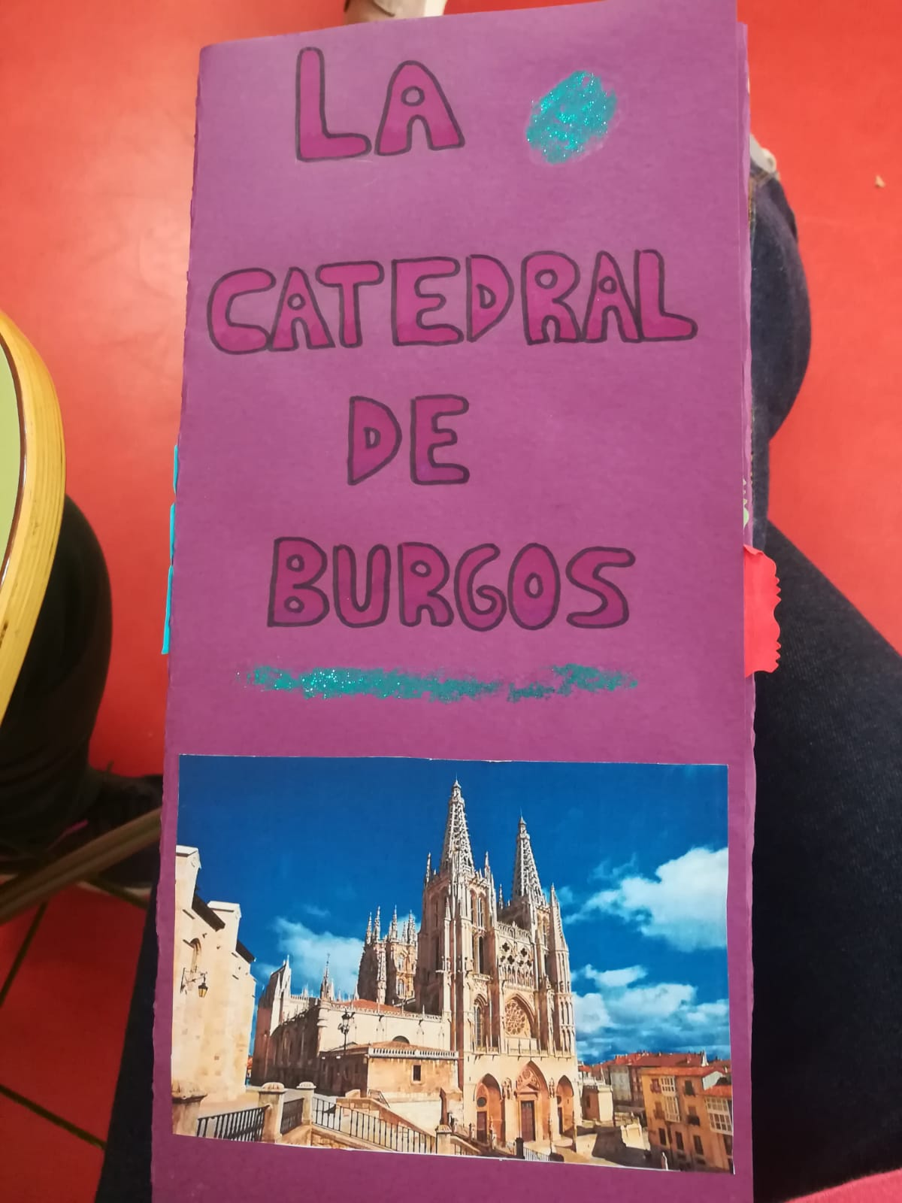
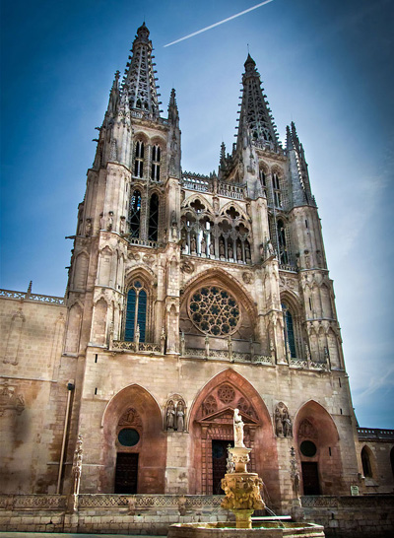 | We have chosen “The Cathedral of Burgos” because is one of the best example of the Gothic style in Spain.  - It is a Catholic Church.  - The works started in the 13th century and continued during many years later.  - The style of the cathedral is the Gothic, but it has several decorative elements from other styles, like the Renaissance and Baroque.  - We can find several works of many extraordinary artists.  - The cathedral was declared a World Heritage Site by UNESCO on 1984.

