Palácio Nacional da Pena

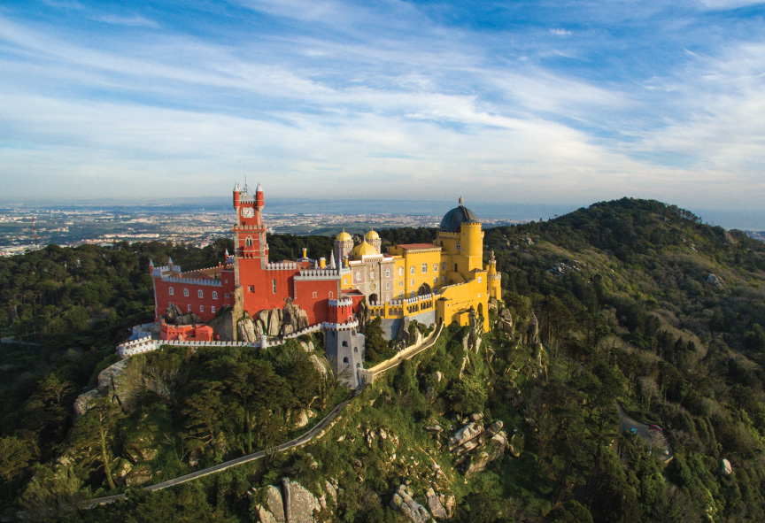
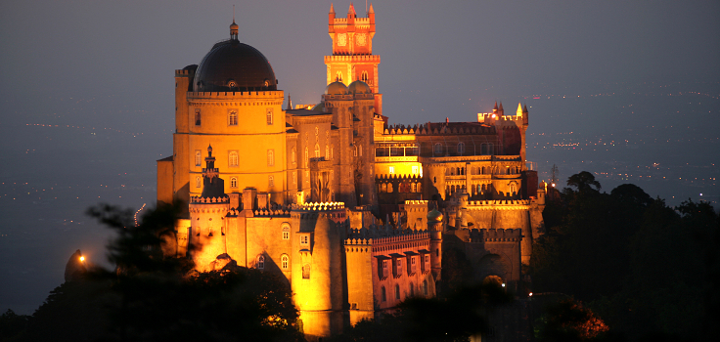
The Palácio Nacional da Pena is located in Sintra, Lisbon, and it represents one of the main expressions of Architectonic Romantism in the 19th century. This palace was classified as world Heritage by UNESCO. In 7th July 2007 it was elected as one of the 7 Wonders of Portugal.
It has a very long history. Before the palace even existed, the top of the mountain was occupied by a small chapel, built in worship of a saint. In the 18th century part of the tower, chapel and sacristy were destroyed by a thunder and then the damages were aggravated by the 1775’s earthquake.
In the year of 1838 the king, D. Fernando II, decided to buy the destroyed chapel, the wall and the Castle of Mouros. He then started a project to build the palace and it was predicted that it would be finished by the year of 1847. Many details in the building and decorative plans of the palace were due to the romantic temperament of the king himself. Like, for example, the ogival arches, medieval style towers or the elements of Arabic inspiration that were designed and ordered to reproduce. After the king’s death the palace was left to his wife Elisa Hendler, Countess of Edla, which created lots of controversy. Later that year the queen sold the castle to the Portuguese State, and she continued to live in Edla’s Chalet.
Actually, this palace was one of the favourite places of the royal family of Bragança, and it was where queen D. Amélia, the last queen of Portugal, went to live after the Regicide of 1908, before, of course being exiled along with her son.

