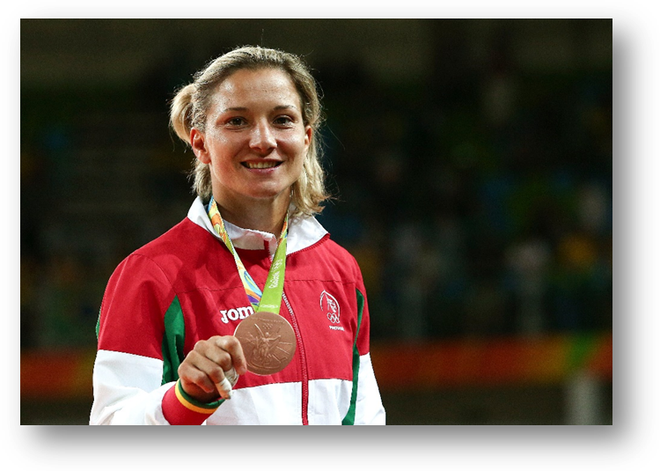
Telma Monteiro

Telma Monteiro is a Portuguese judo player who is recognized worldwide. In fact, she won an Olympic medal in 2016 in the category of 57 kilos. She has 5 European Champion titles and 4 World Champion titles.
She studied at the Faculty of Physical Education and Sport of the Lusófona University of Humanities and Technologies, in Lisbon, where she concluded her studies on physical education and sport in 2011.
Before the Olympics, Telma had a knee injury and had to undergo surgery.
Telma is now one of the most prestigious athletes in the world and especially in Portugal. Nowadays she trains at Sport Lisboa and Benfica.

