Notre Dame de Paris
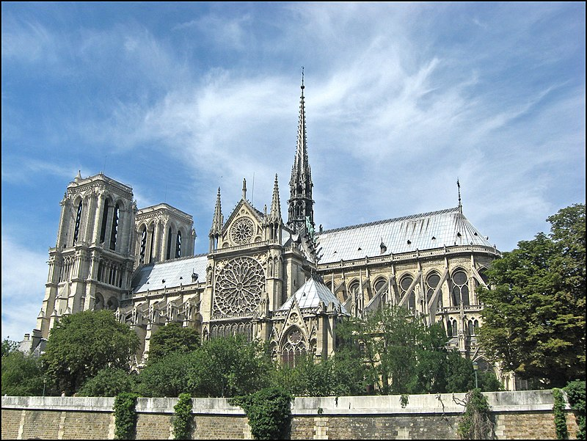
Notre Dame is a very old cathedral in Paris. It is one of France's most famous landmarks and many people visit it each year. The cathedral is on a small island on the Seine River It is a good example of gothic architecture in France. People started to build it in 1163 and it was finished in 1345.
The cathedral is 130 meters long and 48 wide. The two towers rise to 69 meters. Its arrow rose to 96 meters in height. The area is 5.500 m² can accommodate 9.000 people, One of its rose windows is 12 meters in diameter.

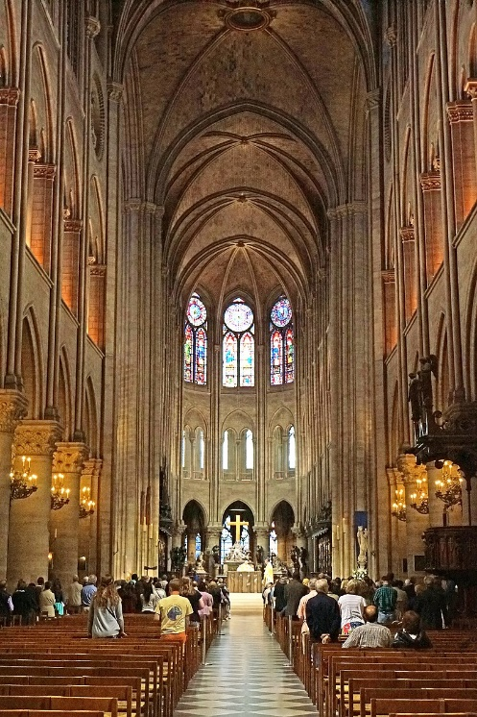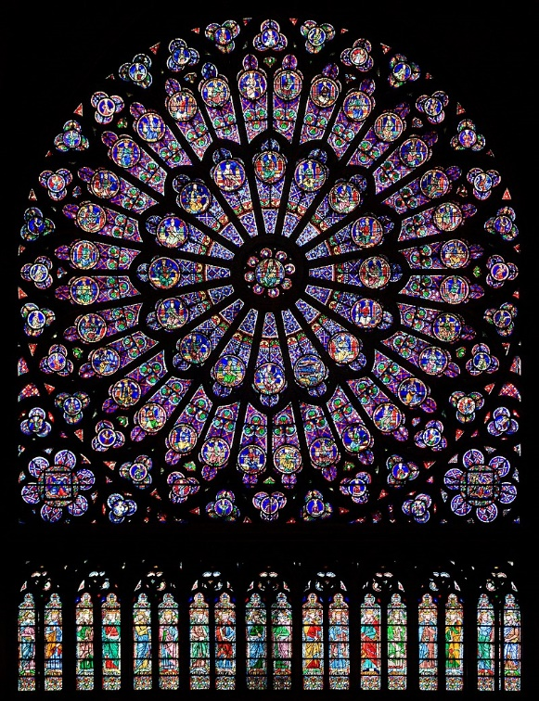

On 15 April 2019, the Cathedral was declared to be on fire. The fire burnt for over half a day and caused massive damage. Luckily most works of art in the cathedral could be saved. The French government announced that the damage would be repaired and the cathedral would be rebuilt.

