3rd March

The Bulgarian National Holiday

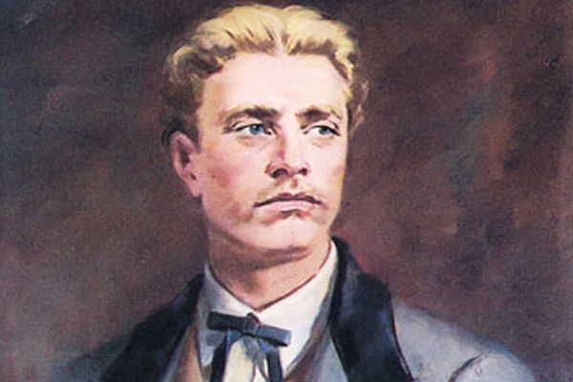
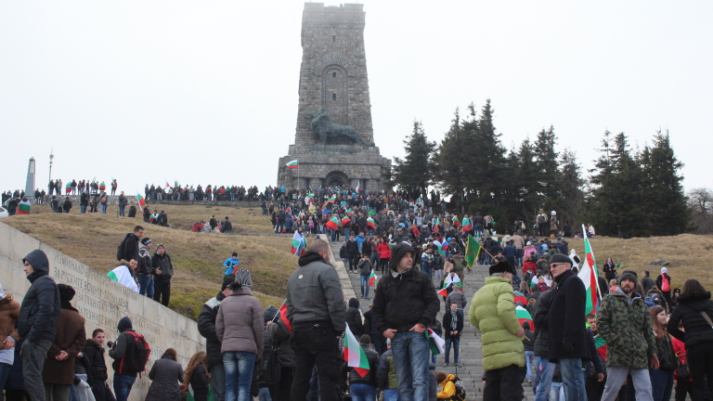
March 3rd. is our national holiday in Bulgaria. We celebrate liberation of Bulgaria from Ottoman rule. On 3rd March 1878 the Peace Treaty between Russia and the Ottoman Empire was signed in the village of San Stefano and that was the end of Russo-Turkish War. Traditionally, thousands of Bulgarian people climb the historic Shipka Peak in the Stara Planina to attend ceremonies on 3rd March every year. There an impressive monument stands to remember the great heroism of Russian soldiers and Bulgarian volunteers killed in the crucial battle in August 1877. Ceremonies are also organized in all cities of the country.

The Bulgarian revolutionary and national hero Vasil Levski made a great contribution to liberation from Ottoman rule. He founded the Internal Revolutionary Organisation. He travelled around the country to form a network of secret regional committees that had to prepare suffered Bulgarian people for an uprising.
Vasil Levski is called the Apostle of Freedom for his progressive concepts of human rights.

