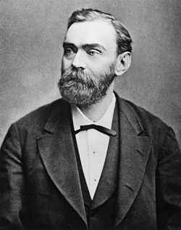
Alfred Nobel

Alfred Nobel (1833-1896) is known worldwide as the inventor of the dynamite and creator of the Nobel Prize. But he was also a businessman who in a number of countries built up companies around his inventions. He lived most of his life abroad and was often on the move. Alfred Nobel was a world citizen who mastered five languages.
Alfred Nobel was a man born in Stockholm on October 21, 1833. His father Immanuel was inventor just as Alfred became when he was an adult.
San Remo in Italy became Alfred Nobel's last home. Here he settled down at the end of his life and it was here he died on December 10, 1896.

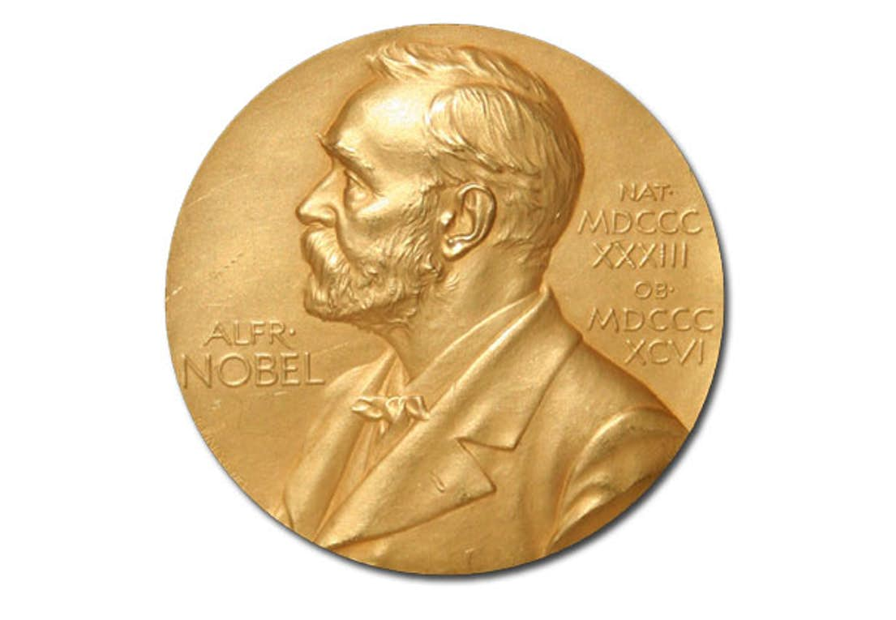
The Nobel prize

You can win the prize in literature, economics, medicine, peace, physics and chemistry.
The award ceremony is held in Stockholm apart from the Peace prize ceremony which is in Oslo, Norway.
It was Alfred Nobel who had written in his will, that he wanted a prize in his namn.

We have a Nobel dinner (our lunch) at our school on the 10th of December, some pupils dress up and we act as if we are at the real Nobel dinner in Stockholm.
is a monument in Lund that we have visited.

