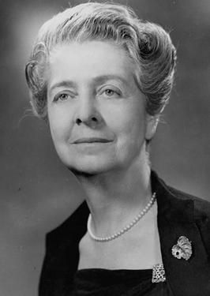
A famous Italian scientist
Rita Levi Montalcini was an Italian Nobel Laureate honoured for her work in neurobiology.
Rita Levi Montalcini was born on 22 ^{nd} April 1909 in Turin, Italy. In her teenage years she considered becoming a writer, but after seeing a close family friend die of stomach cancer she decided to study medicine and graduated from Turin University.
During World War II Rita Levi studied nerve cells in a home-made laboratory. This work contributed to her later discovery of nerve growth factor. She worked throughout World War II even when bombing forced her with her family to leave Turin and move to the countryside. When the war ended, she served as a doctor in a refugee camp.
Rita Levi’s life changed when Professor Hamburger invited her to work at Washington University in St. Louis, USA. As a professor she began working with Stanley Cohen, a biochemist at Washington University. Together they isolated nerve growth factor, a protein that promotes nerve growth in nearby developing cells. They were awarded Nobel Prize for their discovery in 1986. After that Rita Levi was honoured with many awards for her medical research.
Thirty years later, Rita Levi returned to Italy and lived and worked in Rome. Rita Levi was also a politically active person. She served in the Italian Senate as a Senator of Life.
Rita Levi never married and had no children. In an interview in 2006 she said: “My life has been enriched by excellent human relations, work and interests. I have never felt lonely.”
She died in Rome on 30 th December 2012 at the age of 103.

