This document is about interesting places in Wroclaw, created by Joanna, Magdalena, Barbara and Katarzyna

WROCŁAW – Poland In UNDISCOVERED

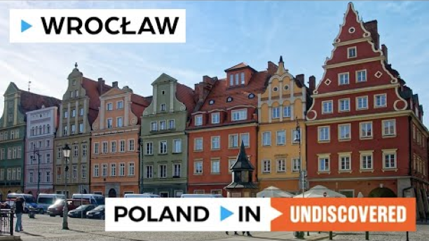

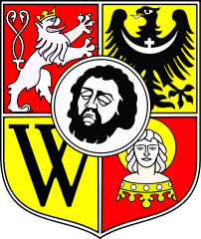
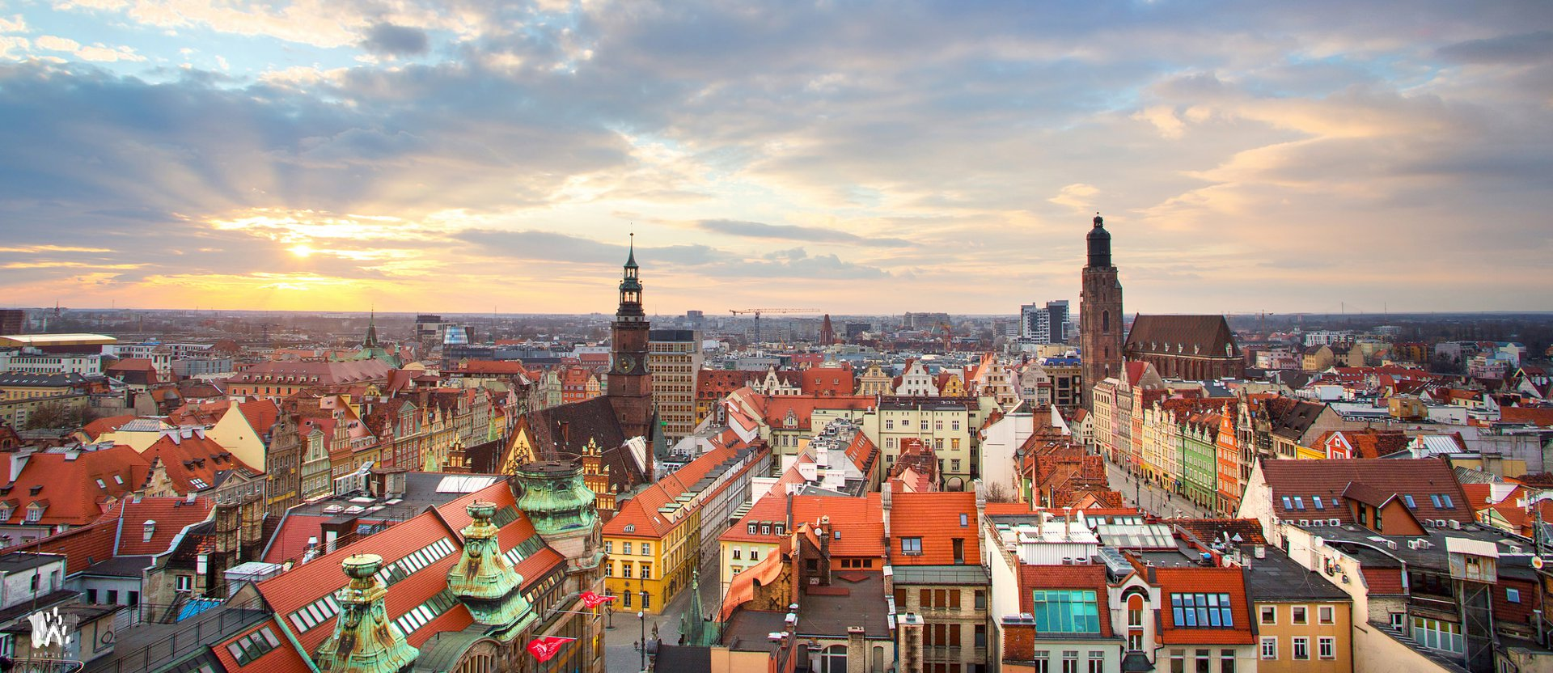

Wrocław, city, capital of Dolnośląskie województwo (province), southwestern Poland. It lies along the Oder River at its confluence with the Oława, Ślęza, Bystrzyca, and Widawa rivers. Having successfully stewarded the Euro 2012 football championships and presided as 2016’s ‘European Capital of Culture,’ more and more people are discovering that Wrocław is the most exciting destination.

Did you know...

Rynek of Wrocław
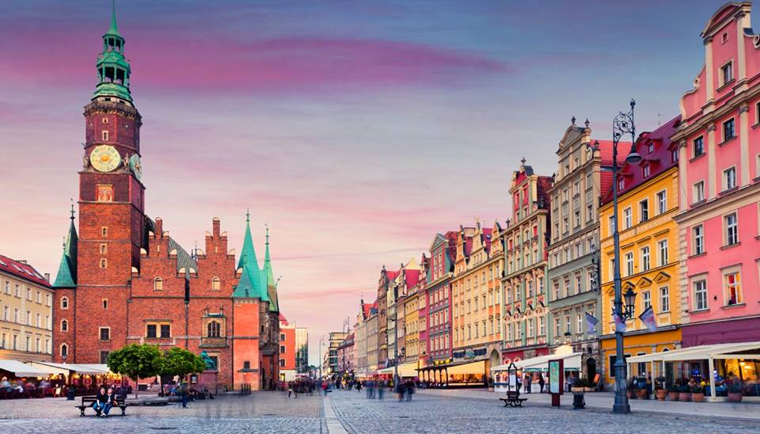

1. Rynek of Wrocław has 3.8ha of surface and belongs to the biggest market places in Poland.
2. After World War II Rynek went through several changes. In 1956 the statue of Aleksander Fredro was moved from Lvov.
3. Another interesting spot are Jaś i Małgosia two tenement house of the altarists in the North Western part of Rynek
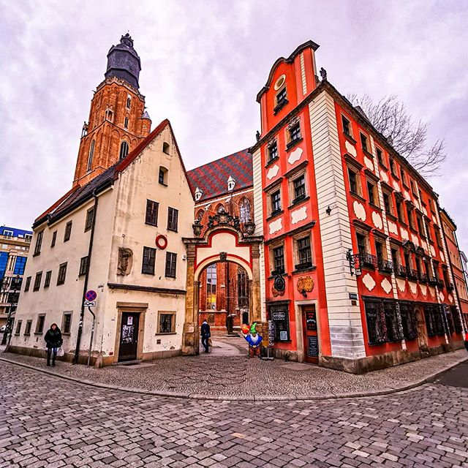

4. Rynek is also a place of Christmas Fairs, New year a eve celebration religious academic and military events.
5.In 2012 Rynek was a big Euro fan zone gathering as much as 30 thousand people

Zoo in Wrocław

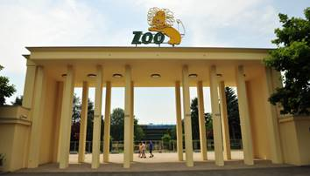

1. The Zoo in Wrocław was created in 1865 and gad a dozen hectares of surface.
2. Zoo in Wroclaw is the oldest and richest in fauna i Poland. It is possible to see the animals from every continent and environments for example in Madagaskar or Pavillons Europe.
3. For many years the Zoo was directed by Hanna and Antoni Gucwińscy.They used to talk about the inhabitants of the Zoo program "with camera among animals.
4. In the last few years many new enclosures have been buit, for example for bears and wolves. There are also new animals, among which very rare species like okapi.

Hydropolis

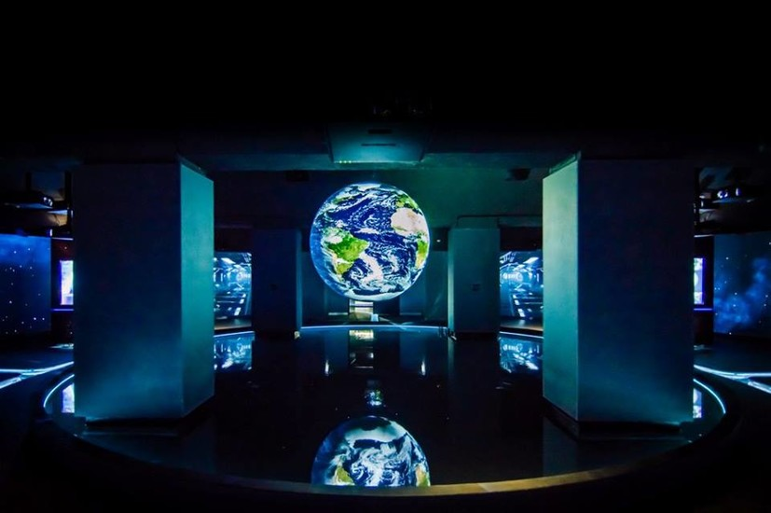

- Hydropolis, centre of knowledge about water, was opened in December 2015.
- Modern multimedia ideas were applied during the construction. The whole exhibition has over 4 thousand square metres.
- Every room has multimedia tablets with interesting details about ground-breaking discoveries of the underwater world, the nature of water and its use in the human life.

Sky Tower Viewpoint

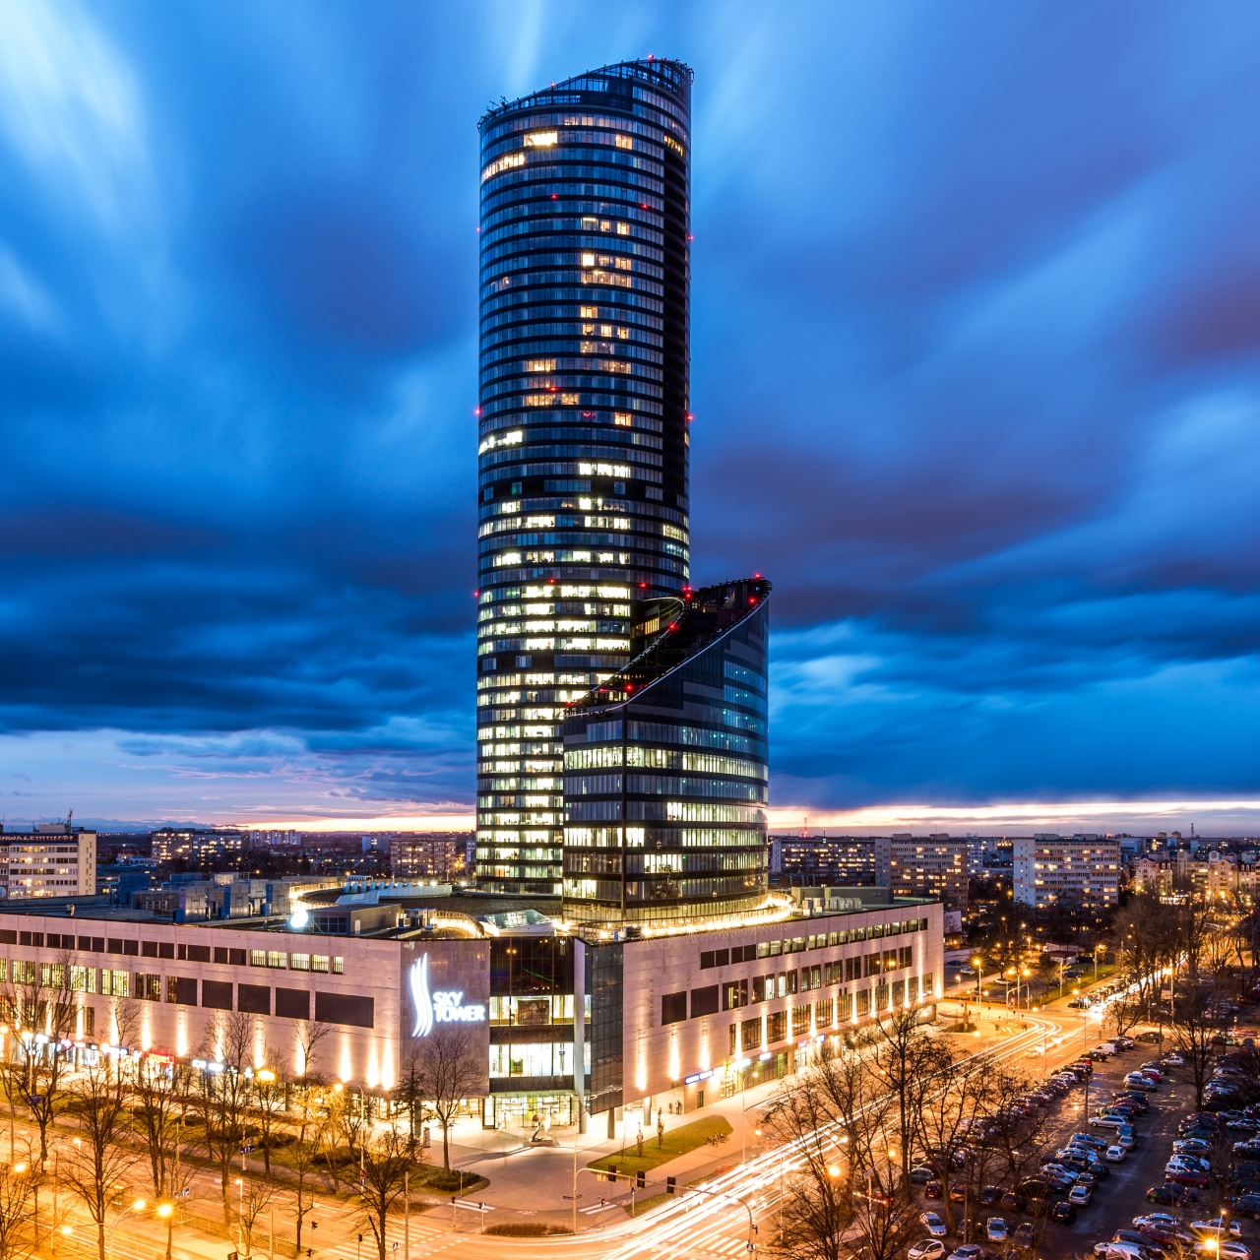

The tourists can get on the top 49th floor in 1 minute with the lift. From 49th floor in Sky Tower you can see the all city.

Ostrów Tumski

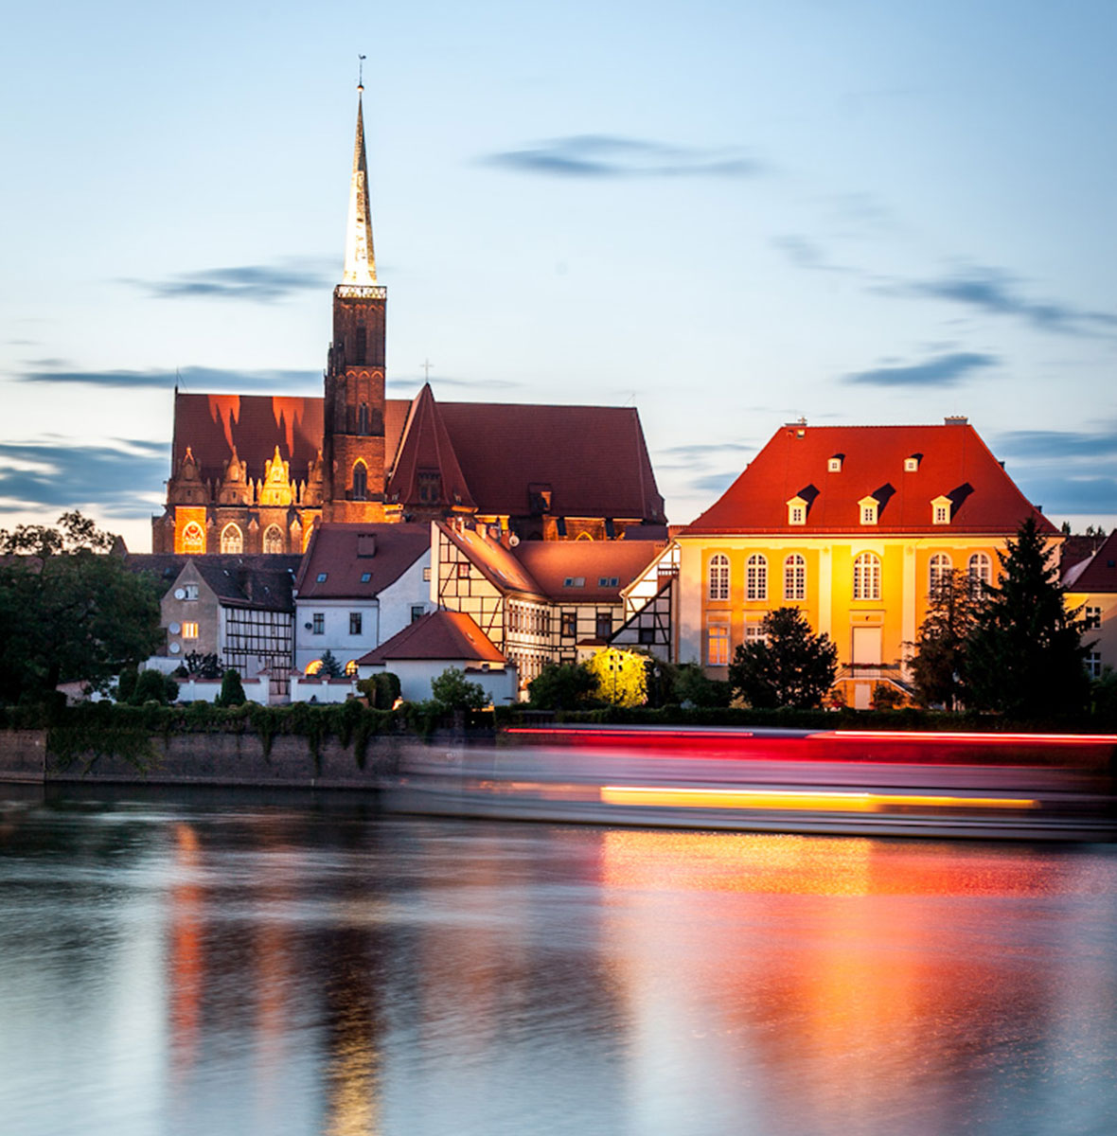
- Surrounded by the river Oder, the old burgh, the origin of the city, has fantastic architecture.
- The greatest ones are the Gothic St. John Baptist cathedral, rebuilt after World War II and Holy Cross church.
- Archdiocese Museum there, the oldest historically continuous museum in Wrocław - for over 100 years it has gathered sacral art.
Japanese Garden

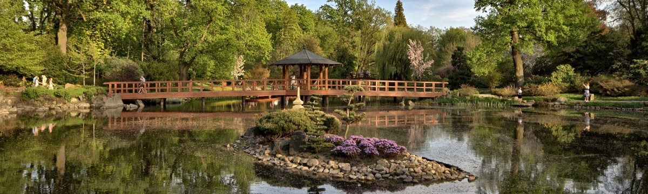
It is one of the most popular places for walks. Apart from a few hundreds of original plants, trees, bushes and flowers, there are also Japanese buildings: the gate and the tea pavilion.

Centennial Hall

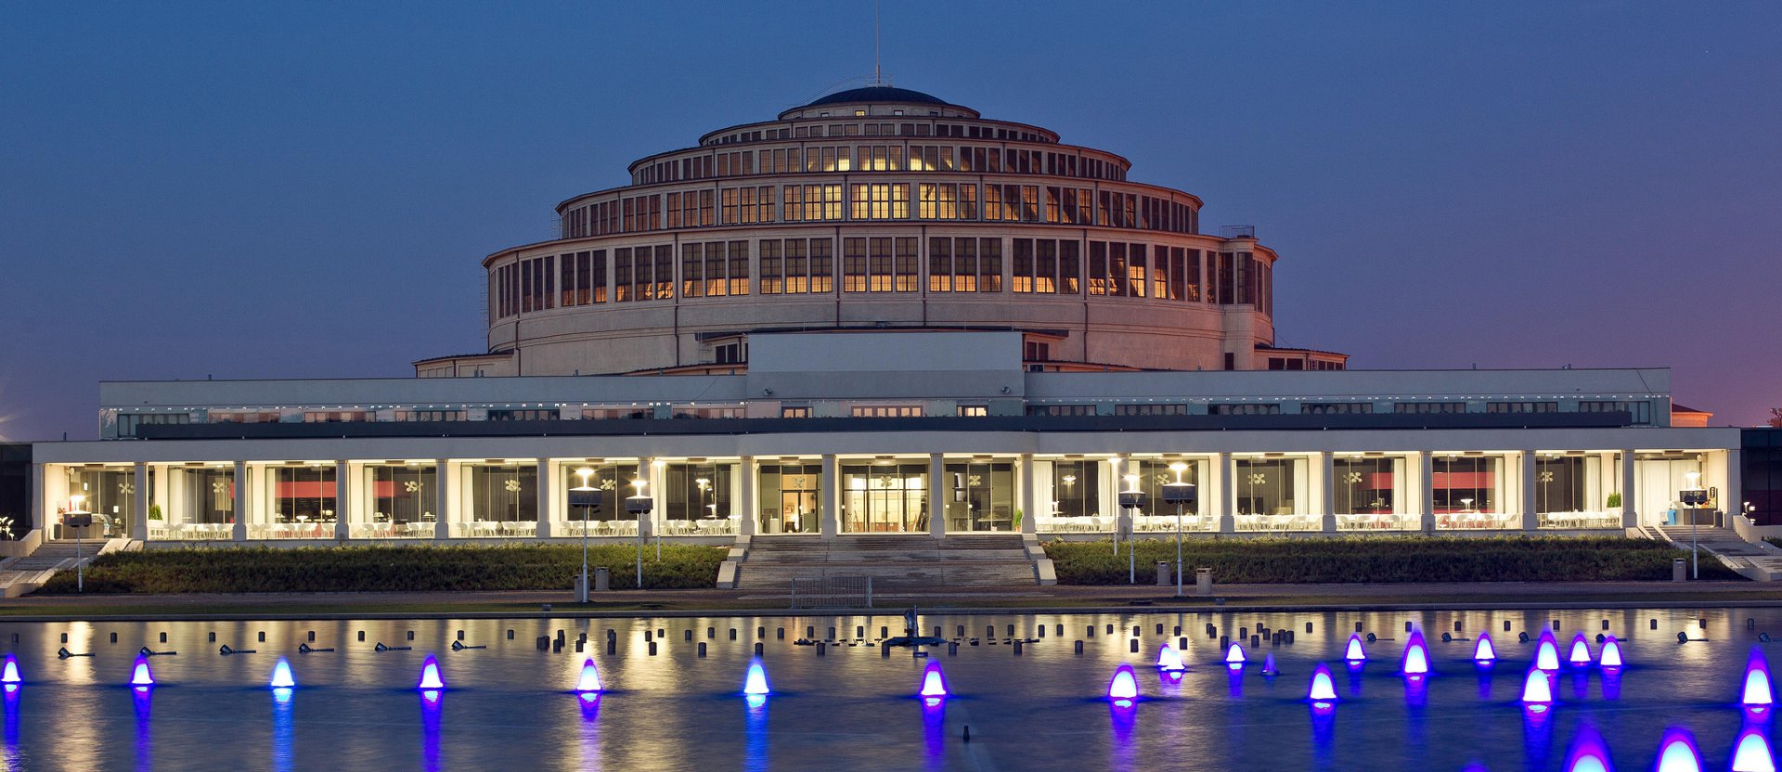
Centennial Hall was recognised as one of the greatest architectonic achievements of the 20th century.
It was designed to serve the citizens of Wrocław and the guests visiting the capital of Lower Silesia.

Wrocław Opera

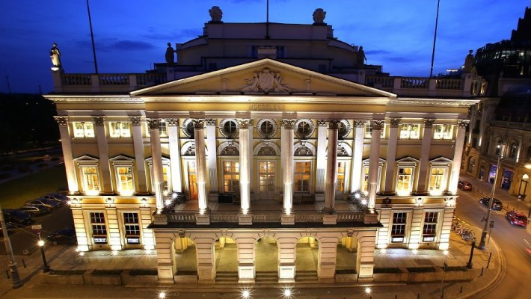

The Wrocław Opera is one of the biggest and one of the most important operas in Poland. Since 1995 it is directed by prof. Ewa Michnik.

