Online tools to learn English (for self-study)
Leticia Herzog Simancas and Pablo Marín Junguito

Title of the resource: Interpals
URL: https://www.interpals.net/
Description: It is a website where you can register for free and start looking for profiles of people from other countries. The aim of Interpals is for you to meet people from many different countries and learn the language, the culture or just to make new friends. The main focus is on language exchange so you can indicate in your profile the language you can offer and the language you are interested in. You can also see other profiles' interests so that you can find the person that is going to be able to help you and viceversa.
Why is this resource useful: It is useful because, first of all, you are seamlessly dealing with real people from all over the world. In addition to that, the way the website and profiles are designed allows you to easily find someone that matches with you interest-wise.
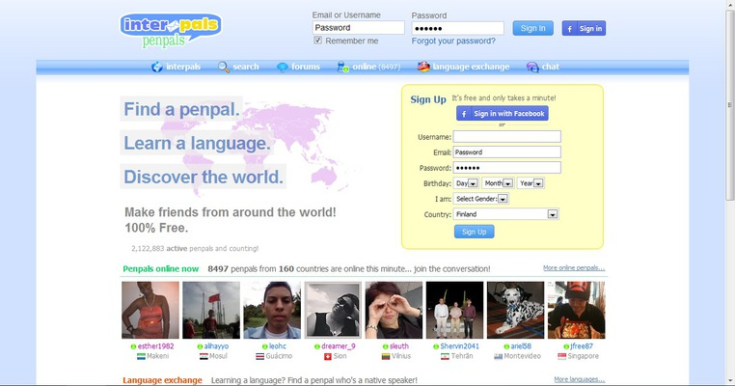

Title of the resource: Dreamreader
URL: http://dreamreader.net/
Description: This site has hundreds of texts to practise your reading and comprehension skills. There is a very wide range of content (academic english, easy english, interesting english...) depending on what your objectives are. All of the texts come with a set questions and an audio file of a person reading them.
Why is this resource useful: Thanks to the variety that it offers and the amount of interesting texts that it has (there are not only texts that are specifically designed to teach english) it turns out to be a pretty entertaining resource to practise your english. We also believe reading is one of the most effective ways of learning a language.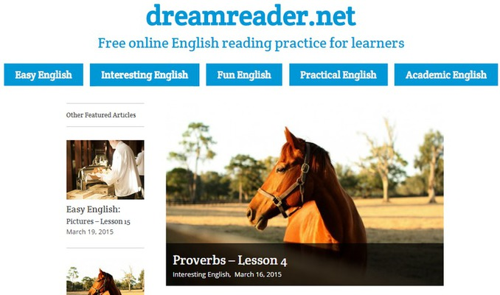

Title of the resource: HelloTalk
URL: https://www.hellotalk.com/
Description: This page lets you contact with natives from all around the world so that they can teach you their mother language and you would do the same with yours. It's one of the biggest community of language exchange. You also have the option to send voice messages, translation of words and hear the pronunciation of the texts sent by your native friends and help with grammar. When you have a reliable partner of conversation, you also have the opportunity to call him or her for free to practice on the phone!
Why is this resource useful?: You can make friends from any part of the world while learning English. It's one of the funniest ways to learn all the skills which involve the language. And the most important thing is that you will learn about the culture of a country. It means that you will know the day-to-day of native speakers and the informal English which is talked real life. Furthermore, this resource is very comfortable because you can use it on the computer or the phone, so you can learn English whenever you want.
