1. Grammar - Translation method
https://www.tefl.net/methods/grammar-translation.htm and http://www.onestopenglish.com/methodology/teaching-articles/teaching-approaches/teaching-approaches-the-grammar-translation-method/146493.article

This method consists in teaching a language based on the analysis of the grammatical rules and then, apply the acquired to the translation of sentences or texts. The vocabulary is taught through wordlists with their translations. It is a teacher-centred method in which students have a passive role. This method emphasizes literacy, so communicative skills were very underworked.

Grammar - Translation method is useful because it allows students to learn new words in English and develops their reading comprehension. Also, it can provide us an essential base (with the vocabulary and grammar learnt) from which children can increase their communicative skills. For teachers, it is easier to teach with this methodology due to the necessity of few resources (only texts, dictionaries, lists of words,...), and the contents who are taught are easy to acquire by students.

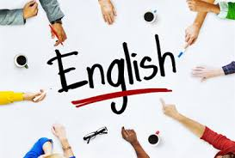

2. Audiovisual method
https://ekayantipt.wordpress.com/2012/06/07/audio-visual-method/ and https://dialnet.unirioja.es/descarga/articulo/4779301.pdf

This method was based on a behaviourist approach, which held that language is acquired by habit formation. It relies on a mechanical process and it is more effective if spoken form precedes written form. Both songs and movies with subtitles, naturally encourage the learning. From our point of view, it is the most dynamic way to perfect the language.

Music or movies have a big potential in teaching languages like English. Listening to songs and watching movies or series in English allow people to develop their learning about this language. Because of that, it is a very useful method and can help us a lot as teachers. Due to audiovisual method, we can improve our listening and pronunciation. Also, our students can increase their vocabulary too. Because it is a dynamic teaching method, we have the chance to catch the interest and motivation of our students. Achieving this, we can ensure us that they present a positive predisposition to the learning of English, making effective and facilitating the teaching-learning process.

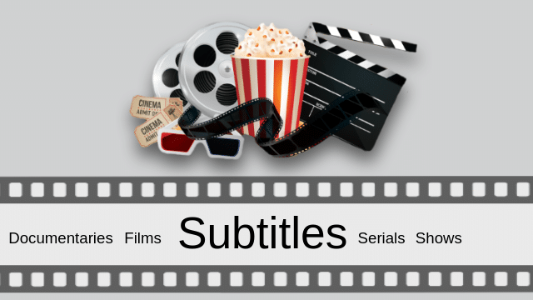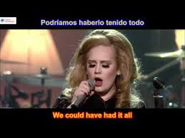

3. ‘Suggestopedia’ method
https://www.tefl.net/methods/suggestopedia.htm and https://dialnet.unirioja.es/descarga/articulo/4779301.pdf

Georgi Lozanov was the creator of this method in 1978. The main goal of this method is to achieve fast and effective learning. Through relaxation, fear and shame disappear in this process. On the one hand, it uses means such as audios, translations, mimes, etc., in order to activate the two halves of the brain. On the other hand, the employ of external stimuli, such as drawings and posters with grammatical information explained in the language to be learned, can help students in their learning of that language.

From our point of view, this method is very useful above all in the beginning of learning a new language. It allows students to learn both passively (listening to audios) and actively (designing vocabulary posters). Among the features of a Suggestopedia lesson we can highlight that, despite being a teacher-centred method, it has a lot of classroom activities based on dialogues, for example questions & answers, songs and games. Due to this, we think that it is an entertaining, dynamic and effective approach to learn a language.

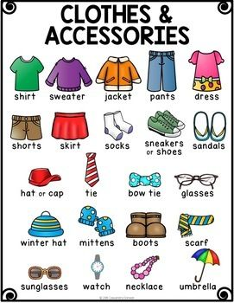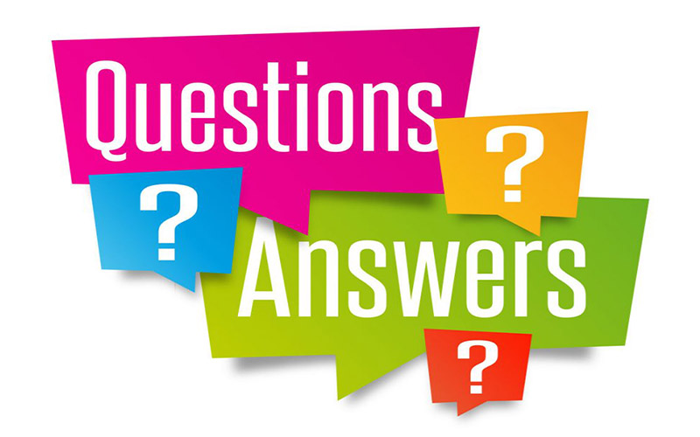
Made by: Juan Pedro Macario Espinosa and Rafael Torres

