MARTA MARTÍNEZ ARANDA, PILAR PACHECO VILLAITODO
ONLINE-TOOLS TO LEARN ENGLISH (SELF-STUDY)
- DUOLINGO
- Url: https://www.duolingo.com/
- Description: It is a resource in which you can learn a wide variety of languages (English, Spanish, German, Italian…). It provides many different online lessons in a very attractive and interactive way. These lessons are not very theoretical, in fact, they are more oriented towards implicit learning. That is to say, instead of focusing on the grammatical rules, this app aims that users interiorize these rules while practising the language. Finally, the format of this app is very similar to a video game. The users of this platform are constantly tested and if they answer correctly, they pass to the next level.
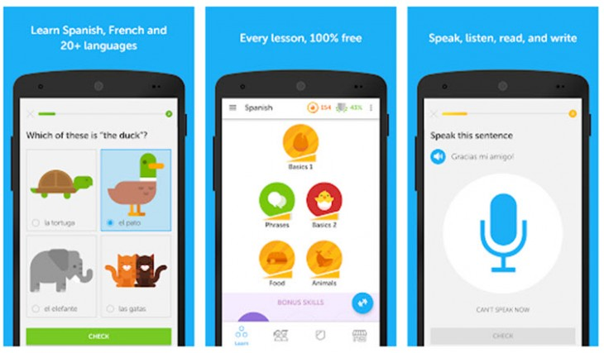
- Why is this resource useful? This resource is quite useful for learning a foreign language because it aims at teaching it in a functional way, that is to say, its main target is to provide with knowledge that can be used in real situations. It is a competent act which works with grammatical rules, vocabulary, reading skills… Moreover, this app is constantly testing its user and aspires to foment constant progression. What is more, it has a motivating strategy based on points. As long as you are passing higher levels, you obtain extra points. All these rewards push its users to keep learning and never give up on it.
- BBC LEARNING ENGLISH
- Url: https://www.bbc.co.uk/learningenglish
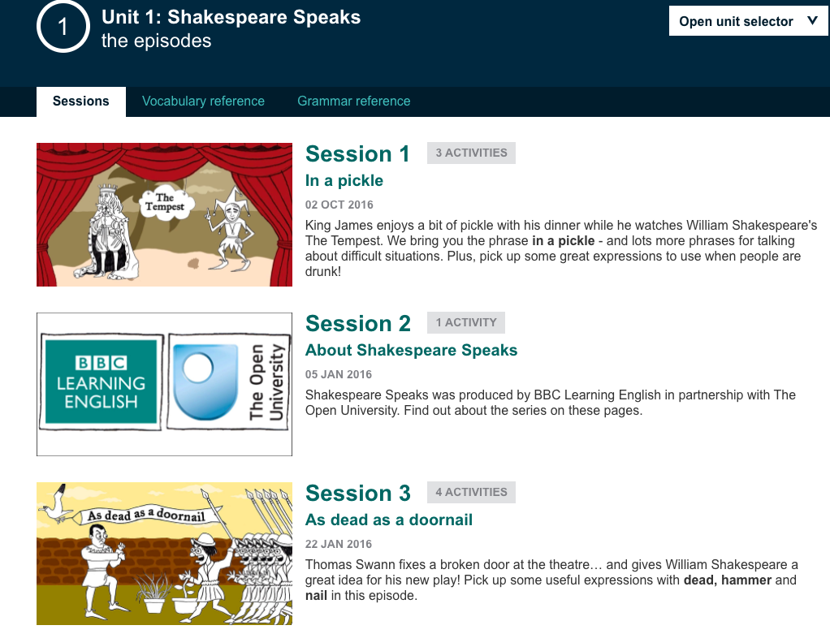
- Description: This website has a big quantity of free resources, in which English learners can practise their vocabulary, listening, pronunciation and grammar skills. You can also find plenty of enriching courses related to English culture, such as Shakespeare Speaks. Likewise, it has different levels of English, and there are sections for all the areas: for business, for teachers and for kids.
- Why is the resource useful? The BBC app can be really useful as it has resources aimed at kids, teenagers and adults, with a level of English and attractive activities completely adapted to their ages. What is more, this resource offers such educative lessons, in which learners will use phrases and vocabulary that can use during an everyday conversation. In order to engage and motivate learners, BBC Learning English offers daily updates of quizzes and new lessons daily. Likewise, the app will send notifications to motivate learners to continue their learning process.
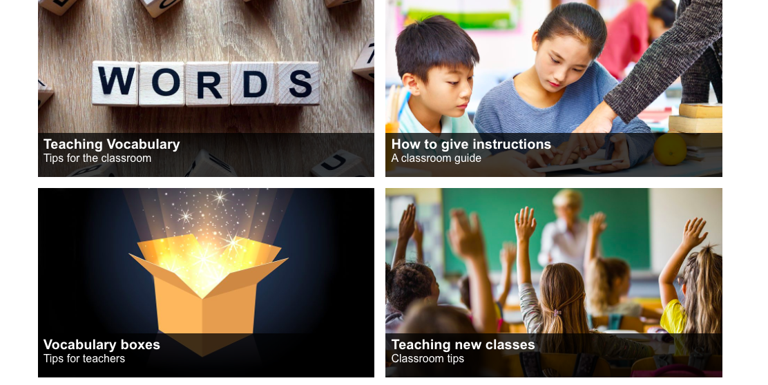

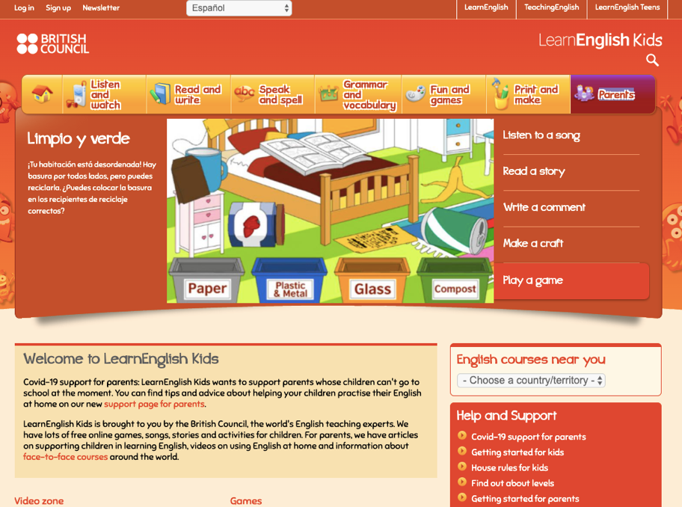

- LYRICS TRAINING
- Url: https://es.lyricstraining.com/
- Description: This a karaoke webpage with which both children and adults can improve their foreign language skills tremendously. Lyrics training consists on a webpage in which you can select the song you want to listen to and you are asked to fill the missing gaps of the song you are listening to. Furthermore, you can freely select the level of difficulty, which goes from beginner to expert. So, in this way, you are able to develop your listening skills in a progressive way and it also encourages you to do your best and go beyond your limits.
- Why is this resource useful? This webpage seems to be one of the most attractive ones for people who are learning a foreign language, as it makes use of music, a key part in our lives. Listening to music can be quite enriching for people who are learning a foreign language, as they don’t even realize they are learning. Likewise, it is a perfect tool for acquiring a wide variety of vocabulary, grammatical structures, idioms and so on. Generally, songs use a non-formal format. So, in this way, songs can be very significant for getting to know daily life expressions.
However, the skill that is highly developed is listening. Your ear will get used to listening to very different accents and pronunciations and you will also get better in listening to quick speakers.
