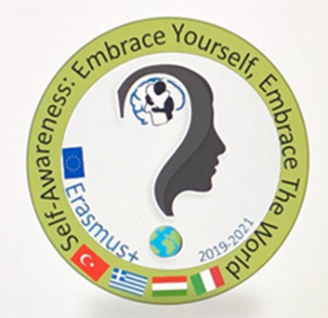
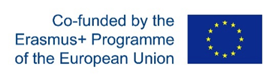
Erasmus+ Project 2019-1-HU01-KA229-06100
Self-awareness: Embrace Yourself, Embrace the World

Title:cyberbullying
AGE: 14-16 SECONDARY SCHOOL STUDENTS
LESSON AIM :
- Identify good habits to limit the damage of the mobile Phones and social media
- Acquire a conscious behavior for a responsible use of the mobile phone
- reflect on the use of the phones and social media to understand what advantages they offer and what dangers they hide

TIME: 55 MINUTES

TASK 1: WATCH THE VIDEO ON YOU TUBE
https://youtu.be/JfAFQ7ascuM

ACTIVITY 1
After watching the video, the students reflect on what they have just watched and give answers to a set of questions with a given score (0-5)
- WHAT DO YOU HAVE IN COMMON WITH THE PROTAGONISTS OF THE VIDEO?
- DO YOU USUALLY DO THE SAME IN SIMILAR SITUATIONS?
- WHY DO YOU NEED TO POST PRIVATE LIFE MOMENTS?
- DO YOU FEEL LOST WITHOUT A 24-HOUR CONNECTION?

ACTIVITY 2
The students compare their answers, sum up the points and discover the addiction level to phones and social media.
ACTIVITY 3
The students first analyse the results of the survey, then, in groups, prepare a chart containing the advantages and the dangers of social media
Advantages  1.  2.  ……………… | Disadvantages  1.  2  ……………..
TASK 2
The teacher elicit students to think about the negative aspects of social media and in particular on cyber-bullying
ACTIVITY:
WATCH THE FOLLOWING VIDEO ON YOU TUBE
https://vimeo.com/119144265
In groups, write a brief rap song about cyber-bullying

