Fair Ilonka

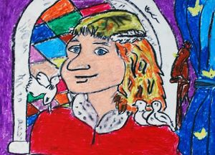
Matthias Corvinus (Matthias the Just) (February 23, 1443 – April 6, 1490) was king of Hungary and Croatia, ruling between 1458 and 1490. Corvinus is derived from the Latin for "raven," thus he is also referred to as "the Raven King".

Matthias was 15 when he was elected King of Hungary. He was young and really handsome. He was the fairest king of Hungary, who liked went hunting incognito. He was often disguised to see the true affairs of the Hungarian Kingdom.
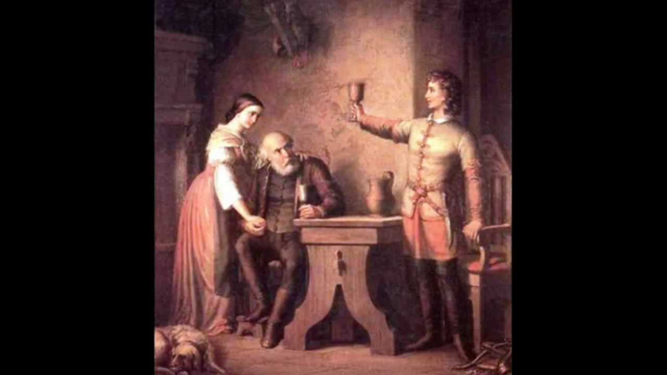
Once during a hunting, he wasn’t able to hunt anything. He was alone in the deep forest, far away from his servants and friends. While waiting for a noble deer to shot his eyes glanced at a beautiful fair-hair girl, Ilonka (Helen in English). They fell in love at first sight. As they were near the house of the girl’s grandfather, she invited the handsome, young hunter to have dinner together with her and her old grandpa. They had an amazing evening together. The old Peterdi was the name of the girl’s grandfather offered a great dinner for the young hunter and make him say a toast to the King Matthias, who sits there unrecognized, and has come perhaps with adventure in mind. But the honesty and honour of the old noble man and the childish innocence of Ilonka touch the disguised King; The young hunter's longing gaze and gentle farewell kiss at the end of their encounter of just a few hours kindled the fire of love in the girl's heart.
After some time, upon the invitation of the hunter, Ilonka and her grandad travelled to Buda to meet him, as they were standing admits the celebrating crowd they recognised their guest of the other day in the mighty figure of King Matthias returning victoriously from his military campaign on Vienna. When Ilonka saw Matthias in full regalia on horseback, she was shocked to discover she had fallen in love with thee king. Being a simple poor girl, she was convinced that she could never marry him and returned sadly to her home in the wilderness and her sorrow over her unrequited love wasted Szép Ilonka’s life away, she died from a broken heart.
Two weeks later the king, who hadn't noticed Ilonka in the crowd, went back to her house in the deep forest, but no one was there just silence and emptyness.

Vörösmarty Mihály: Szép Ilonka
The huntsman waits with watchful eye
in ambush, holding shaft on string,
as ever upward through the sky
the ardent sun is journeying.
He waits in vain - in coverts cool
the stag still rests by some distant pool.

Long, long he sits in ambush yet
and hopes for game at close of day;
then, as he prays the sun to set,
behold good fortune comes his way -
it is no stag, but a butterfly,
with a girl pursuing, flutters by.

"Merry flyer, fair golden moth,
rest on my finger, do not flee!
Or I will follow, by my troth,
where red sunset gilds bush and thee! "
She speaks, and nimble as a roe,
she hastens on with heart aglow.

"Gad!" says the huntsman, "is this not
most royal game?" - and up he leaps,
pursuing, all things else forgot,
the path the flying maiden keeps.
Thus man and maid, in eager flight,
each seek a vision of delight.

"I have you!" - cries the happy miss,
and pauses, butterfly in hand.
"I have you!" - cries the man with bliss,
and so the graceful couple stand.
Caught in his eye's admiring glow,
the maiden lets the insect go.
II.
Stands yet the house of old Peterdi?
Lives that old son of battle still?
That house, though in decay, I see;
the old man sits and drinks his fill.
By him the girl; their huntsman-guest
looks on with eyes of warm unrest.

For Hunyadi, their chief who died,
the men have drained their glasses deep.
For that great hero, Hungary's pride,
the veteran is forced to weep.
His blood flowed free in days of yore,
his tears in equal measure pour.

"Drink to my old chief's royal son!" -
the patriarch cries, "Long live the King!"
The blushing huntsman seems undone,
he lets his glass stand, faltering.
"Why won't you drink? What seems amiss?
Accept a father's will in this!

I could, in years, be twice your sire;
I drink, believe me, without blame -
the King's a man of faith and fire,
who will not put his blood to shame!"
Stirred by the greybeard's earnest plea,
the youth stands up in fealty.

"Long live the son of that old chief!
As long as Hungary may he live!
Yet may his days be black and brief
if e'er his best he fails to give!
Better no King than one disloyal,
who plagues the land unsound, unroyal. "

In deepening ardour and applause
the fleeting hours swiftly soar;
and still the maid's affection draws
more closely to the visitor.
"Ah, that I knew his name and home!"
Her warm heart speaks, her lips are dumb.
"Fair flower of the forest, you,
I also praise the pledge in wine!
And should God e'er direct you two
to Buda, you with me must dine.
In Buda's lofty tower I dwell,
At Matyas' court they know me well..."

The huntsman speaks, and takes his leave.
A far-off slug-horn bids him go.
Although his hosts entreat and grieve
and seek fresh kindnesses to show.
"Come back to see your friends once more,
in case we do not come before!"

Reluctant on the threshold now
she speaks in modesty polite.
He prints a kiss upon her brow,
then marches through the moonlit night.
The house is still, but not her breast,
where love won't grant a moment's rest.
III.
Peterdi and his grandchild sweet
go up to visit Buda-town.
The old man's wonder is complete
to see new mansions of renown.
The maiden waits in anxious pain
to meet her handsome youth again.

Glad crowds are thronging Buda's streets;
they watch to see their monarch ride
in triumph from the warlike feats
that humbled vile Vienna's pride.
Real subjects long to see their King -
no smiles on the maid's features cling.

"Where is our gentle friend today?
What fortunes has he followed here?
Is he at home, or far away
in shady coverts of the deer?"
She speaks to herself silently,
with cheeks now blushed, now blanched to see.

And now with warlike shouts ride by
Ujlaki and the Magyar lords;
the king himself with noble eye
surveys the escort of their swords.
Old Peterdi in wonder peers,
perceives his guest, and joins the cheers.

"God save the King! God bless his fame!"
Ten thousand throats around him shout;
ten thousand echoes greet his name,
hill, vale, and rampart ring it out.
But whiter than white marble there
Ilonka stands in mute despair.

"Shall we go on to Matyas' hall
to see our friend once more, my lass?
Methinks our forest mansion small
will give us greater peace, alas!"
The greybeard speaks in pained dismay,
and back they plod their weary way.

As droops a radiant summer flower
that withers from an inner blight,
so drooped Ilonka from that hour
and sickened towards eternal night.
Within her heart a cancer fed
on passion's hopes forever dead.

The brief but anguished life is o'er,
a girl has faded to her death,
a tender lily suffering sore
in innocence and anxious breath.
And when at last their royal guest
came back once more, she lay at rest.

Kirkconnell, Watson

