THE ARGONAUTIC CAMPAIGN
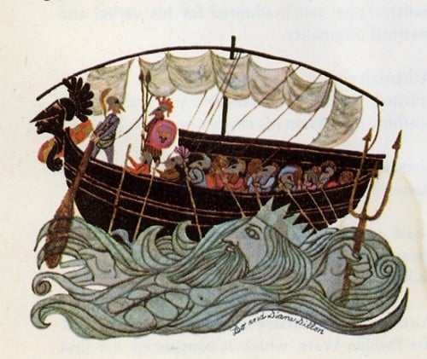

In this myth one can find a series of themes that are common in ancient Greek mythology: people who are willing to do anything for the throne, long and perilous journeys, supernatural creatures, oracles, labours, a prize, love story and, of course, the 12 gods of Mount Olympus who always interfere.

From Iolcus to Colchis
So, the story begins at Iolcus (Volos, Thessaly) where Pelias usurped the throne from his brother, Aeson, and forced him out of the palace. Aeson’s son, Jason, was smuggled to Mount Pelion and was raised by centaur Chiron, the trainer of heroes (half human, half horse). When Jason grew up, he returned to Iolcus and claimed the throne from his uncle. Pelias replied that he would give up the throne of Iolcus only if Jason fetched him the Golden Fleece.
The Golden Fleece was far away in a place called Colchis (present-day western Georgia), ruled by king Aeëtes. Aeëtes had once offered hospitality to Phrixus, who was brought to Colchis on the back of a golden-wooled winged ram. Phrixus gave its fleece to King Aeëtes who kept it in a sacred grove.
Jason rigged a big boat, Argo, and along with his crew-mates, the Argonauts, sailed off from Iolcus to Colchis to retrieve the Golden Fleece.
Homecoming
Aeëtes became aware that the Argonauts had stolen the Golden Fleece and chased them as they fled. However, his daughter distracted him and escaped with Jason. Later, Argo reached a place that was forbidden according to the oracle. Therefore, the Argonauts had to carry the boat over land for days to get back on course. They went through a lot of perils, sea monsters…and eventually came back to Iolcus. Pelias, though, refused to give up the throne as he had promised. Medea, using her sorcery, killed him and was driven into exile with Jason for the murder.
The couple settled in Corinth and Jason dedicated Argo to Poseidon. One day, however, Jason was asleep under the stern of the rotting Argo when it fell on him, killing him instantly.
Medea then left to Athens, where she met and married king Aegeus. Later she had to flee from Athens, too, and landed in Asia where she married another king and bore a son named Medus, after whom the people took their name.

