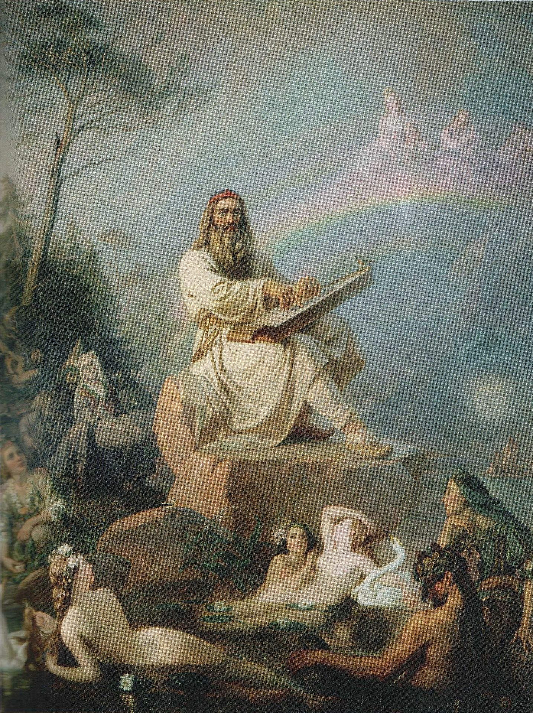

The Myth of Väinämöinen

Väinämöinen (Finnish pronunciation: [ˈʋæinæˌmøinen]) is a demigod, hero and the central character in Finnish folklore and the main character in the national epic Kalevala. His name comes from the Finnish word väinä, meaning stream pool. Väinämöinen was described as an old and wise man, and he possessed a potent, magical voice.

The first extant mention of Väinämöinen in literature is in a list of Tavastian gods by Mikael Agricola in 1551. He and other writers described Väinämöinen as the god of chants, songs and poetry; in many stories Väinämöinen was the central figure at the birth of the world. The Karelian national epic, the Kalevala, tells of his birth in the course of a creation story in its opening sections. This myth has elements of creation from chaos and from a cosmic egg, as well as of earth diver creation.

And the story begins:

At first there were only primal waters and Sky. But Sky also had a daughter named Ilmatar (Air Goddess). One day, seeking a resting place, Ilmatar descended to the waters. There she swam and floated for 700 years until she noticed a beautiful bird also searching for a resting place. Ilmatar raised her knee towards the bird so it could land, which it did. The bird then laid six eggs made of gold and one made of iron. As the bird incubated her eggs Ilmatar's knee grew warmer and warmer. Eventually she began to be burned by the heat and responded by moving her leg. This motion dislodged the eggs, which then fell and shattered in the waters. Land was formed from the lower part of one of the eggshells, while sky formed from the top. The egg whites turned into the moon and stars, and the yolk became the sun.

Ilmatar continued to float in the waters for several hundred years, admiring the results of these events, but she could not resist an urge to continue creation. Her footprints became pools for fish, and simply by pointing she created contours in the land. In this way she made all that is. Then one day she gave birth to Väinämöinen, the first man, whose father was the sea. Väinämöinen swam off until he found land, but the land was barren, so he asked the Great Bear in the sky for help. A boy carrying seeds was sent down to him, and this boy spread plant life across the land.

In the eighteenth century folk tale collected by Cristfried Ganander, Väinämöinen is said to be son of Kaleva and thus brother of Ilmarinen.

