THE FOUR BARS
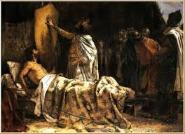
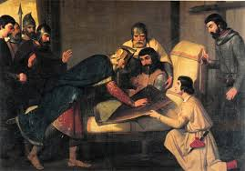

The flag of the four blood bars unites all the Catalan lands. This story tells us where it comes from and how necessary it is to look for the origin in the Frank Count “Charles the bald” and his nephew “Guifré el Pelós”, Count of Barcelona.
In his castle, “Guifré el Pelós” is sad. He looks at his weapons, his shield, his hosts banners and his eyes get full of tears.
His knights approach him to ask:
- What’s the reasion of your sadness?
They organize dances and hunts, but the mood of the Count of Barcelona, doesn’t improve.
- My sadness is to see my shield. It is all gold, yes, but in this field of gold doesn’t grow any flower.
When he says this, he sighs, and his friends loosen their shoulders. They already like that golden shield.
Suddenly, there is a big noise of men and horses at the castle door. They are the messengers of “Charles the bald”.
- “Dear nephew -writes the Count of the Franks- the Normans have invaded the lands of France and I need your help. Each arm, each weapon will have the value of two.”
When “Guifré el Pelós” reads this message, he feels full of joy:
- Knights! Hurry up! We have to help my uncle!
After some days travelling, suddenly, they hear blows and shouts from a big battle. They aret he Normans, who move foward without stopping. The fighting axes raise and spears shine under the sun.
“Guifré el Pelós” and his knights start fighting. They raise their swords, ride the horses and get ready to fight against the enemy. Soon, Normans lose land and run away without even taking their injured partners.
Franks are wondering:
- Who is this warrior who get the Normans run away?
- He is “Guifré el Pelós”, the Count of Barcelona.
Everybody hailed and applaud him. “Guifré el Pelós is happy and waves the other knights. But in that moment, a lost arrow hurts his heart.
He is injured and the knights move him to his tent. They try to heal him but everybody knows that he will die very soon. “Charles the bald”, his uncle, is the first to make him a visit. He sees his nephew crying.
- Don’t cry -he says- my doctor will come to heal you.
- It’s not for my wound that I am crying, but for my honor. Despite today’s triumph, my shield is still a field without flowers.
- But on your chest –answers “Charles the bald”- there is a flower of blood!
The Count has understood “Guifré el Pelós”.
“Guifré el Pelós” put four fingers in the wound that still bleeds and make them slide on the golden shield, where four bars of blood get engraved.
- Are you still crying, “Guifré el Pelós”?
- Yes, I am crying. But this time is about happiness. Four red flowers have grown up on my shield. From today, it will always wave above Catalan lands.
And then, the Count “Guifré el Pelós” thanks his uncle “Charles the bald” who helps him to recover.

