The Myth of Daedalus and Icarus
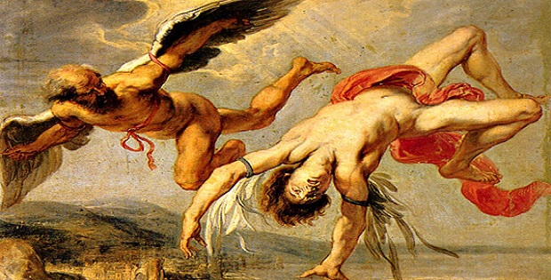
The myth of Daedalus and Icarus tells the story of a father and a son, who escaped exile on the island of Crete by making wings for themselves.
Daedalus was a highly respected and talented Athenian artisan who descended from the royal family of Cecrops, the mythical first king of Athens. Daedalus was a genius artist, sculptor, architect and a great inventor of his time; it is said that he invented the masts and sails used in vessels as well as many other tools.
Despite his great intellect and craftsmanship, Daedalus committed a crime out of envy against his nephew and apprentice, Talos, the inventor of the saw. When he realized that Talos may exceed him in skill and talent, he killed him by throwing him off the Acropolis. The crime was soon out and Daedalus was forced to banish the city; Areos Pagos, the Athenian court of judges of the time, convicted Daedalus to exile in Crete as an official punishment for his deed.
Daedalus’ fame as a great artisan had already spread, before him reaching the island. He worked for King Minos of Knossos in Crete. King Minos put Daedalus in charge of all technical works in his Palace and it is said that he was the inventor of most innovations of his time. He also built the Labyrinth, an excessively complicated, maze-like building where King Minos imprisoned a legendary monster, the Minotaur.
Meanwhile, Daedalus had a son, Icarus, with the beautiful Naucrate, who also worked in the service of the King.
However, Daedalus enraged the King when he revealed the mystery of the Labyrinth to Minos’ daughter, Ariadne, who in turn advised Theseus, the Athenian hero, thus enabling him to kill the Minotaur and escape from the Labyrinth. King Minos punished Daedalus by imprisoning him and his son Icarus in the inescapable maze that Daedalus himself had once constructed.
During their imprisonment, Daedalus conceived the idea of making wings, sticking them together with wax and adjusting them to their shoulders, since the only way for them to escape was the sky.
Father and son were ready for this unbelievable, first flight in human history, which was against the natural order of things. Young Icarus didn’t follow his father’s advice though: “Son, don’t fly too low because your wings will get wet by the waves of the sea, and don’t fly too high, because they will get too warm by the sun”. Despite Daedalus’ advice, Icarus, out of vanity, flew so high that the sun soon melted the wax and destroyed his wings. The sea where Icarus fatally fell from the sky is still called after his name; Icarian Sea. Icarus’ body was carried ashore by the current to an island, where it was found and buried by Heracles, the famous hero. This island today still carries the name of the fallen Icarus; it is called Icaria.

