Guy Fawkes and the Gunpowder Plot
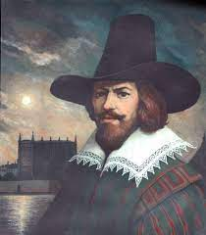
The Gunpowder Plot was one of the most famous attempts to kill a king in British history. A group of men, including one named Guy Fawkes, planned to blow up the Houses of Parliament. They were caught before they could carry out the plot, however, every year on the anniversary of the plot, people in the United Kingdom celebrate the fact that the plot failed. The celebrations include bonfires and fireworks.
The men who planned the Gunpowder Plot were Roman Catholics who were unhappy with the way they were being treated. James I, the first of the Stuart kings of England, came to the throne in 1603. At the time, there were many conflicts between Protestants and Roman Catholics. James succeeded Elizabeth I, a Protestant, who did not allow Catholics to practice their religion as they wished. Roman Catholics in England expected James to treat them well because his mother was a Catholic. Instead, he ordered all Catholic priests to leave England. The men were furious that their hopes of religious tolerance had been dashed.
The men plotted to kill not only the king but also the queen, their son Prince Charles, and every member of the government during the state opening of Parliament on November 5, 1605. The leader of the group was a man called Robert Catesby. Cellars beneath the Houses of Parliament were rented out as storage spaces to people such as coal merchants, and the gang leased one of these cellars. They gradually moved in 36 barrels of gunpowder and hid them there. It was enough gunpowder to blow up hundreds of people.
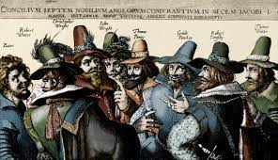
The night before the opening of Parliament, soldiers caught Guy Fawkes in the cellar. They arrested him and took him to the Tower of London. After three days of torture, Fawkes told his captors the names of his fellow plotters. They were all arrested for treason—plotting against the king and the country—and were imprisoned in the Tower.
On January 30–31, 1606, the whole gang was executed as hundreds of people watched. Afterward their heads were cut off and displayed on poles throughout London, to warn others what would happen to them if they plotted against the king. In celebration of his survival, James ordered that the people of England should have a great bonfire on the night of November 5, which is now known as Guy Fawkes Day.
In memory of this, On the 5th November every year there is an annual evening of fireworks and bonfires held across England. This night is called Guy Fawkes Night, Bonfire Night or Fireworks Night. People love to wrap up warm in scarves and woolly hats and head out with loved ones to ‘ooh’ and ‘aaah’ at the colourful displays.
Most Brits grow up learning this simple Bonfire Night rhyme and you may hear people reciting the first line at one of the celebrations.
Remember, remember, the fifth of November!
Gunpowder treason and plot
We see no reason why Gunpowder treason
Should ever be forgot.

