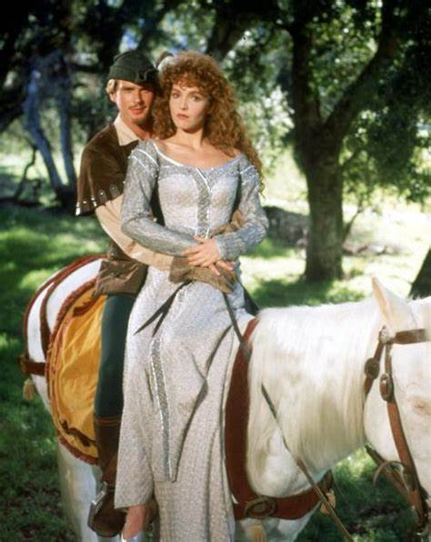
Robin Hood and Maid Marian
This is the story of how Maid Marian came to join Robin Hood and his men in Sherwood Forest. There's an old saying that behind every great man is a great woman. Maid Marian is Robin Hood's true love and truly a great woman. Local legend says Robin and Marian were married in St. Mary's church in the village of Edwinstowe.
More than 800 years ago, a coach and horses were passing through Sherwood Forest. The passengers inside the carriage were a rich and important family. They came to the part of the forest known as Greenwood, the father became nervous, because he knew that it was thick with thieves and bandits.
Then, what he feared happened. At first, the family did not even realise that they were being attacked. The robbers jumped down from the trees above, and pulled the soldiers off their horses and onto the ground.
There was a polite tap on the door of the carriage, and a voice said, “Dear Sir, be so kind as to step outside.”
“Here,” said the father, “Take this purse of gold. Only I beg you, do not touch my wife or daughter.”
"Good Gracious!" said the leader of the bandits. “What do you take me for? I would do no harm to a lady!”
At that moment, Maid Marian jumped down out of the carriage.
What are you doing?" cried the father. "Get back dear. This instant."
But Maid Marian was a high-spirited young lady with a fiery temper. She went up to the bandit leader and slapped him around the face.
“Take that you coward,” she said. “Give me a sword and I’ll show you a fight.”
The father was horrified, for he had no idea that his daughter practiced fencing with her brothers, and was more skilled with a sword than any of them.
The robber touched the side of his face where she had swiped him. “I wish that it were a kiss,” he said, "But your hand stings sweetly all the same. In return for the gold your father has just given me – and for which I am truly grateful – my men shall ride behind your carriage to the edge of the forest and ensure that no criminals attack you.” The bandits were true to their word, and gave the family their protection to the edge of the forest.
“And my lady,” he said to Maid Marian, “I so desire to have the pleasure of setting eyes on you once again. Pray, do tell me your name.”
At first she did not want to reply, but then she said softly, “Marian.”
The robber said, “Well dear Marian. This evening in Greenwood you have won the heart of Robin Hood,” and with that he jumped on his horse and sped away.
Two months went past, and Marian’s father and mother decided that it was time for her to wed. When they told Marian that she must marry him, she was furious.
But Marian’s character was not the sort that could be forced to do anything unless she wanted it herself. She resolved to run away. She cut her own hair, dressed herself as a page boy, armed herself with sword and a longbow, and rode off on the fastest horse in her father’s stable.
Nobody knew better than her that it was dangerous to ride through the forest, especially alone, but she did not care because she was so angry at thought of marrying a man she did not love, or even like.
She rode deep into the woods. A man appeared, dressed in green, and she recognised him right away as Robin Hood who had attacked her family.
“Hold back,” she called out, pointing her sword at him, “for if you try to rob me it will cost you your life.”
Robin was interested to find this spirited lad with no sign of any bristle on his chin.
“Young boy,” he said, “Put down your sword, for I mean you know harm. I am just an innocent forester, and I came here to mend my cabin.”
“No you’re not,” said Marian, “You’re Robin Hood, the notorious outlaw. Take one step closer, and I’ll run you through.” For in truth, what made Marian so angry was that he had not recognised her.
Seeing the sword painting dangerously towards him, Robin drew his own sword, meaning to use it to push Marian’s aside, but she saw what was happening and thrust forward. He only just managed to deflect her sword from cutting his ear.
And then they fought. Robin managed to get behind her and wrestle her to the ground.
“Gently, gently,” he was saying. “Calm yourself now. Time to stop fighting and be friends. I could use a boy like you in my band of followers.”
He allowed Marian to turn round and now he was looking into her face.
“You faithless man,” she said, “You do not know me.”
But he did, and he kissed her on the lips.

