Tower of London Legends
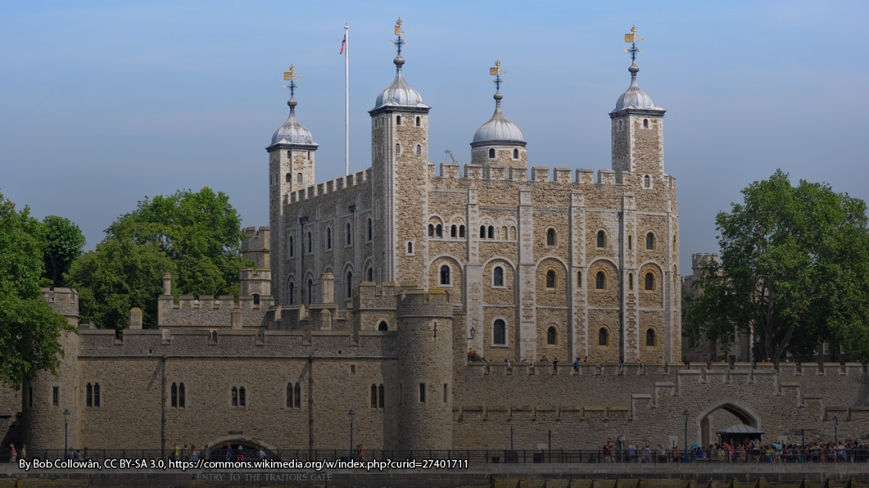
In 1078, William the Conqueror built a white tower on the north bank of the River Thames that would become the most prominent part of the Tower of London. But there is more to the tower than just a tourist attraction. From the ghosts that are said to haunt its walls, to the ravens protecting both the castle and the city itself, there are many stories and superstitions surrounding the Tower of London.

The Ravens of the Tower
One of the most famous stories about the Tower of London concerns the ravens that live within the walls.
“If the Tower of London ravens are lost or fly away, the Crown will fall and Britain with it.”
Ravens are referenced in mythology across the world, including stories in Greek mythology where they were said to be a symbol of bad luck, and in the Hebrew Bible, where they are the first species of bird to be mentioned. They are believed, by some, to represent a symbol of vice (as opposed to the dove as a symbol of virtue).
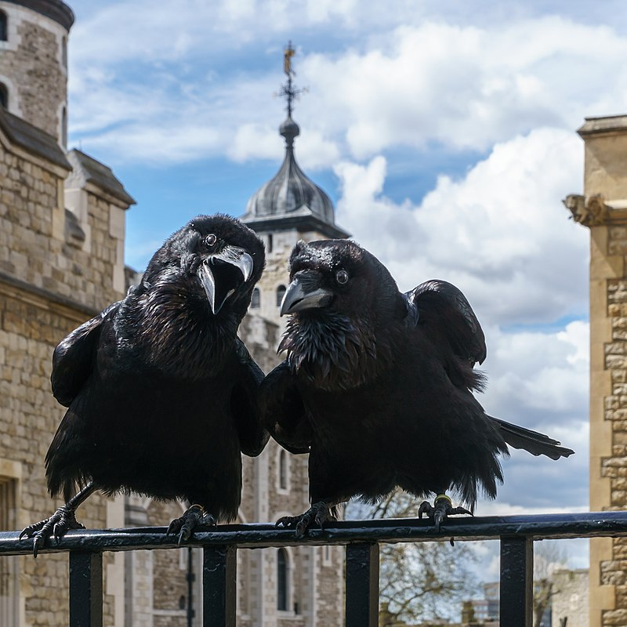
Allegedly, at the execution of Anne Boleyn in 1536, “even the ravens of the Tower sat silent and immovable on the battlements and gazed eerily at the strange scene”. Stories say that during the execution of Lady Jane Grey in 1554 they pecked the eyes out of her severed head.
During the Second World War, many of the ravens living in the tower were killed during bombing raids. Only two survived – Mabel and Grip – but when Mabel flew away, Grip was left despondent. A few weeks later, Grip also flew away. The incident was reported in British newspapers, and the stories contained references to the legend of Britain’s potential fall. Soon after, the decolonisation of the British Empire (as it was then) began, leading some to take this as confirmation of the legend.
Today, the ravens have their wings clipped in a way that allows them to fly, but prevents them from travelling far enough to leave. A minimum number of six ravens are now kept at the Tower, cared for by the Ravenmaster, Chris Skaife, who has a close bond with each of the birds. One of the current ravens, Merlina, is known to fly as far as the wharf on the River Thames, but she always returns, thanks to her bond with her carer.

There are many more legends associated to The Tower of London. Can you find any more?

