Tombs of the Kings  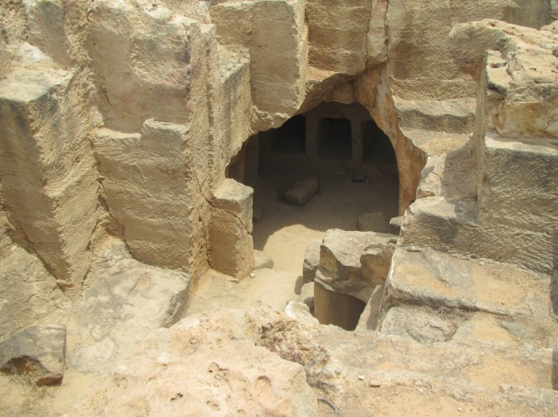  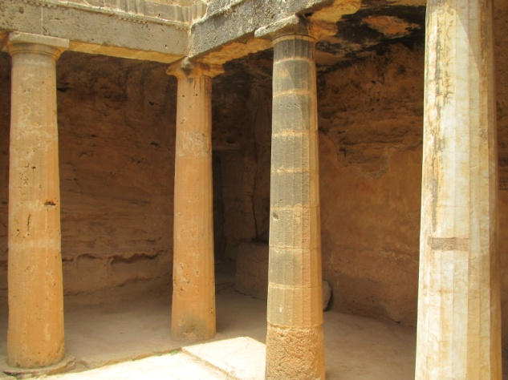  The Tombs of the Kings is a large necropolis lying about two kilometers north of Pafos harbor. It is a UNESCO World Heritage Site. The underground tombs, many of which date back to the 4th century BC, are carved out of solid rock, and are thought to have been the burial sites of Pafitic aristocrats and high officials up to the third century AD. Some of the tombs feature Doric columns and frescoed walls. Archaeological excavations are still being carried out at the site. A Part of the importance of the tombs lies in the Pafian habit of including Rhodian amphorae among the offerings in a burial. Through the manufacturing stamps placed on the handles of these amphorae, it is possible to give them a date and, through them, the other material from the same burial. | Pafos Archaeological Park  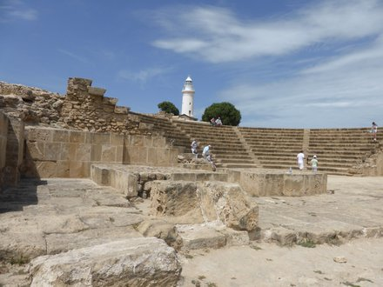  Pafos Archaeological Park is located, at the southwest coast of Cyprus and is situated near Pafos Harbor. The park, still under excavation, is within the "New Pafos",section of the coastal city. Its sites and monuments date from prehistoric times through the Middle Ages. Of the most significant remains are four Roman villas, the House of Dionysos, the House of Orpheus, the House of Aion and the House of Theseus, all with preserved mosaic floors. In 1980 Nea Pafos and Palaipafos were inscribed on the World Heritage List of UNESCO.  Pafos Castle  Pafos Castle is located on the edge of Pafos harbor. It was originally built as a Byzantine fort to protect the harbor. It was then rebuilt by the Lusignans in the thirteenth century after being destroyed in the earthquake of 1222. In 1570 it was dismantled by the Venetians. After capturing the island, the Ottomans restored and strengthened it. Throughout the ages it has seen many uses. It has served as a fortress, a prison and even a warehouse for salt during the British occupation of the island. More recently the castle serves as a backdrop to the annual open air Pafos cultural festival which takes place in September.  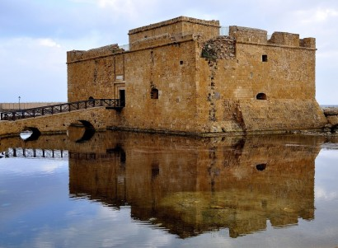 | Mosaics  The House of Dionysos  The mosaic decorations and the mythological compositions  are the main characteristics of this restored Roman villa,  dating back to the second century A.D. The name “House of Dionysus” is mainly due to the many representations of Dionysus, the god of wine.  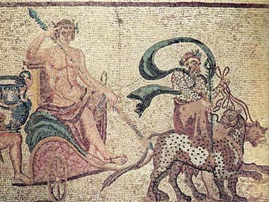  The House of Four Seasons  This house lies north of the House of Orpheus. It was named after the mosaic that represents the personification of the  four seasons, which dates back to the first half of the third century A.D.  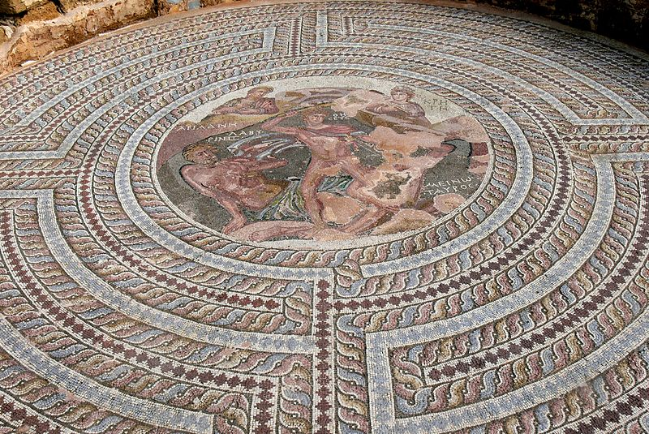

Aphrodite’s rock  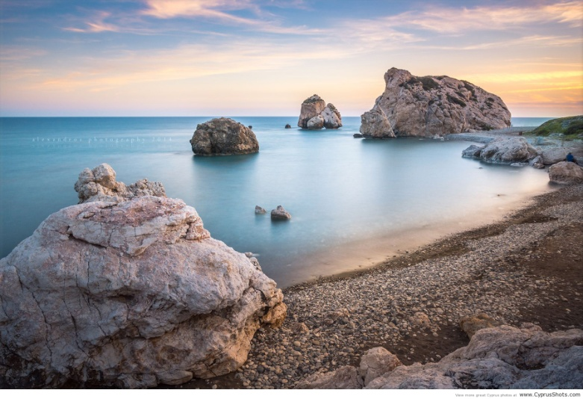  “Petra tou Romiou”, also known as Aphrodite's Rock, is a sea stack in Pafos. It is located off the shore along the main road from Pafos to Limassol. The combination of the beauty of the area and its status in mythology as the birthplace of Aphrodite makes it a popular tourist location. The sea in this region is generally rough, persuading tourists not to swim there. It is not permitted to climb the rock.  According to one legend, this rock is the site of the birth of the goddess Aphrodite, perhaps owing to the foaming waters around the rock fragments, and for this reason it is known as Aphrodite's Rock. Another legend associates the name Achni with the nearby beach, and attributes this to it being a site where the Achaeans came ashore on their return from Troy..  Aphrodite’s Baths  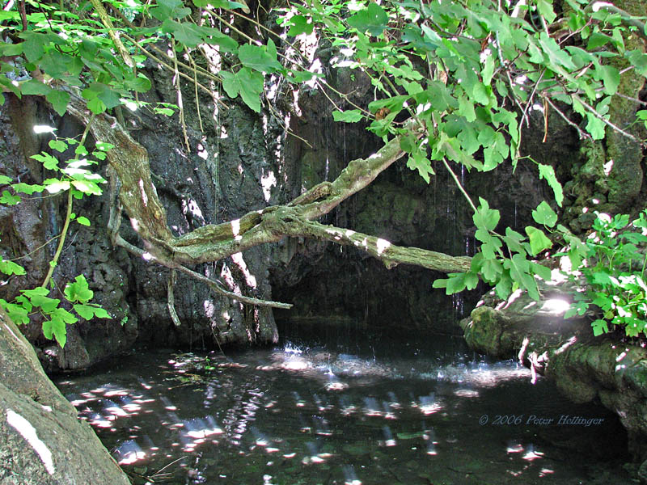  Aphrodite’s Baths are located in the Akamas Peninsula near the little fishing village, Latchi and is considered as a famous mythological site. It is believed that she used to take her baths in the pools of the natural cave. The cave is surrounded by a fig tree with beautiful natural wildlife. There are many myths surrounding the pools. | Akamas  Akamas , is a promontory and cape at the northwest extremity of Cyprus with an area of 230 square kilometers. Ptolemy described it as a thickly wooded headland, divided into two by summits rising towards the north. The peninsula is named after a son of Theseus, hero of the Trojan War and founder of the city-kingdom of Soli.  Until the year 2000, the peninsula was used by the British Army and Navy for military exercises and as a firing range. Under the 1960 Treaty of Establishment, the British Army was allowed to use the Akamas for exercises for up to 70 days a year.  At the southern end of the peninsula is the town of Pegeia and on its northeast side the town of Polis. Due to the mountainous nature of the peninsula there are no roads running through its heartland.  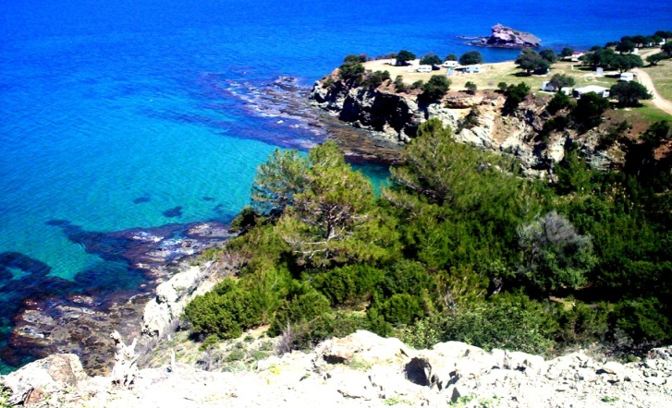 | Pafos  European Capital of Culture 2017  Pafos is a coastal city in the southwest of Cyprus  and the capital of Pafos District. In antiquity, two locations were called Pafos: Old Pafosa and New Pafos.The currently inhabited city, New Pafos, lies on the Mediterranean coast, about 50 km west of Limassol. Pafos International Airport is the  country’s second-largest airport. In Greco-Roman times, Pafos was the island's capital, and it is well known for the remains of the Roman governor's palace, where extensive, fine mosaics are a major tourist attraction.  