Overpass and elevator for disabled people  Ramp and floating wheelchair  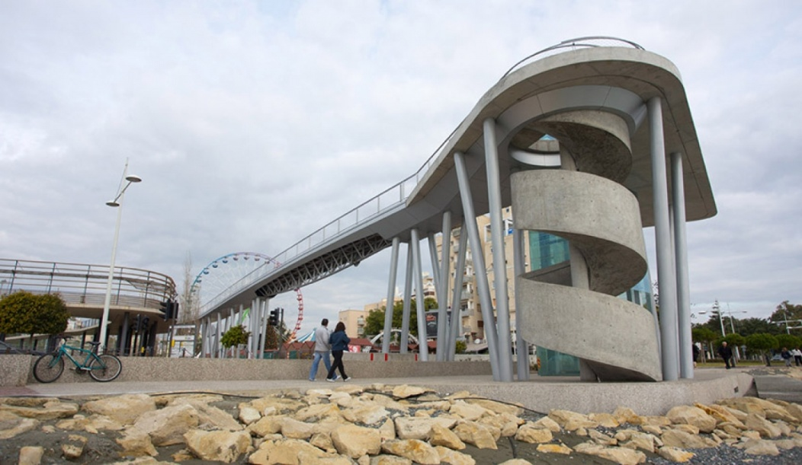  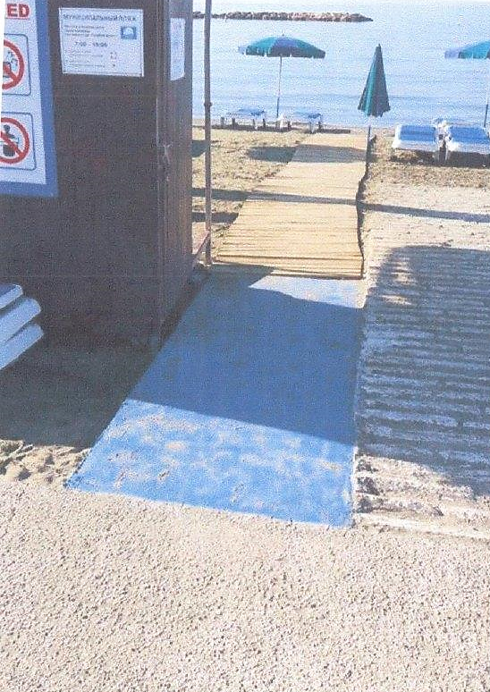  “Enable”  Handcycle  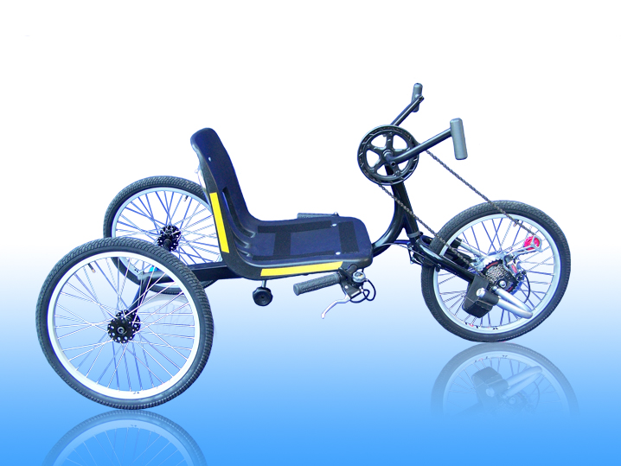 | 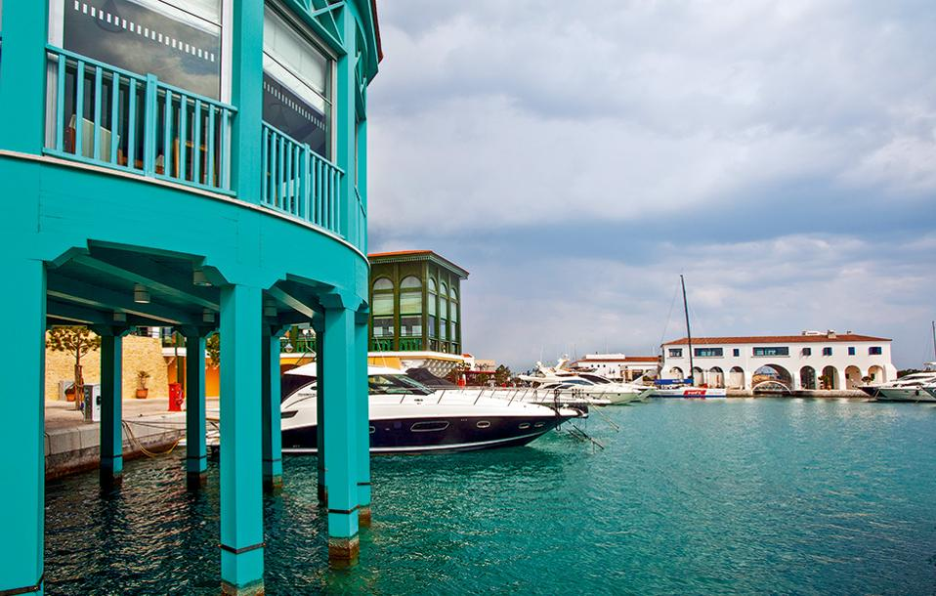  The Limassol Marina  Limassol “appeals to a wide range of tourists, from those interested in sun and sand vacations to those who prefer to delve into the island's culture at its museums and sites of archaeological interest”. TripAdvisor, 2017  Tour guidance and brochure by:  - Anna Constantinou (Limassol)  - Chloe Protopapa (‘Enable’ tour)  - Gracia Totoro (‘Enable’ tour, Castle)  - Lorentana Marzinian (Promenade) | Recipient Name  Address  City, ST ZIP Code | LIMASSOL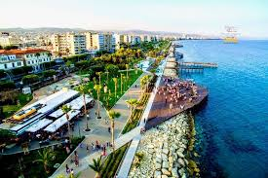  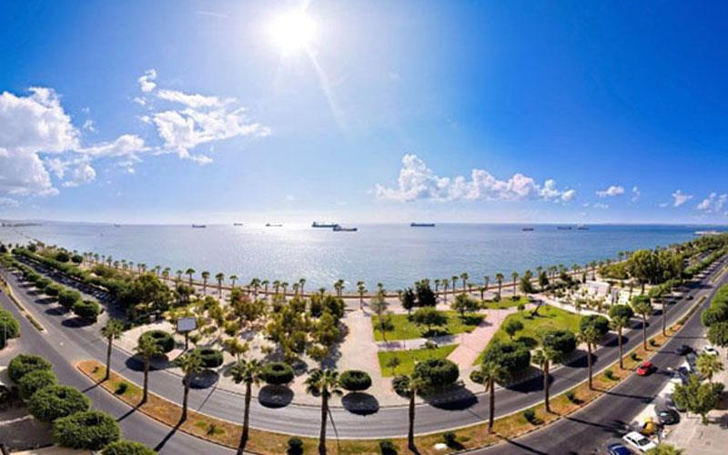

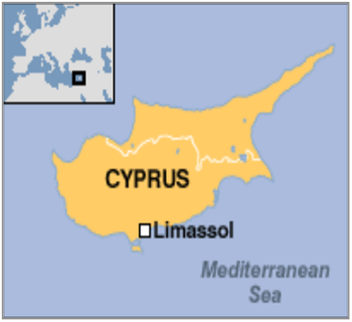  Limassol is the second largest town in Cyprus and the southern town in Europe. It is also the largest port in the Middle East. Its population is about 170.000 residents. Limassol is well known for its rich nightlife and cultural traditions. The Limassol Carnival attracts thousands of tourists every year. | Molos (Promenade) is located in the centre of the town and next to the harbor. It is one of the most popular parks in the Mediterranean basin. In the multifunctional park of Molos, there are trees, playgrounds, restaurants and outdoor gyms.  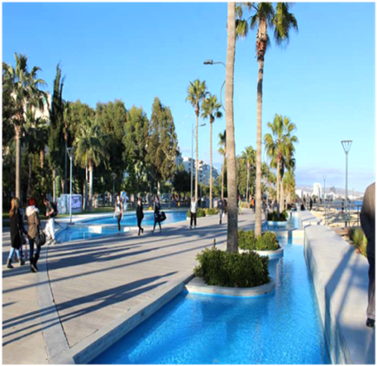 | LIMASSOL CASTLE  According to archaeologist Etienne Lusignan, the original castle was erected by Guy de Lusignan, a French Poitevin knight, in 1193. However, according to the tradition, this is where Richard the Lionheart married Berengaria of Navvare and crowned her Queen of England in 1191.  From its erection until the beginning of the 16th century, damages were caused by the Genoese and the Mameluks as well as by earthquakes. In the 16th century the Venetian governor of Cyprus decided to demolish the castle in order to avoid its possible seizure by the Ottomans. After the Ottoman acquisition of Cyprus in 1571, the remains of the castle were incorporated in the new Ottoman fort, which was considerably strengthened. The underground chamber and the first floor were transformed into prison cells and remained in use until 1950.  Nowadays, the castle houses the Cyprus Medieval Museum.  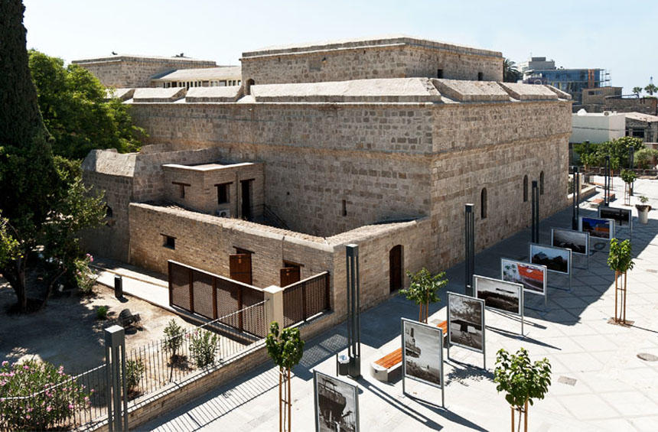  Company Name

