Arches are also used as decorative elements; among them those of the following images:
Ogival arch | Half point arch
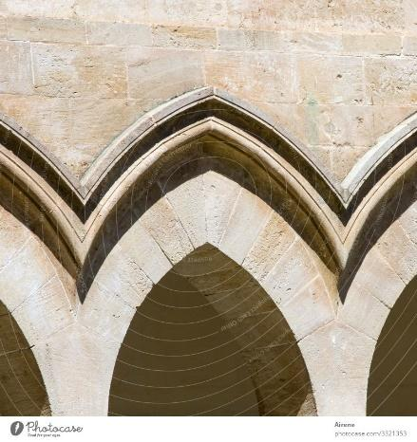 | 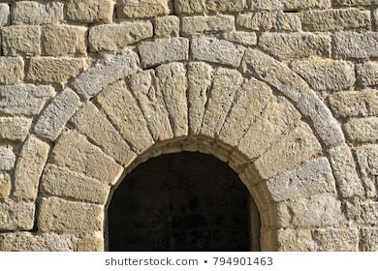
Horseshoe arch | Lobed arch
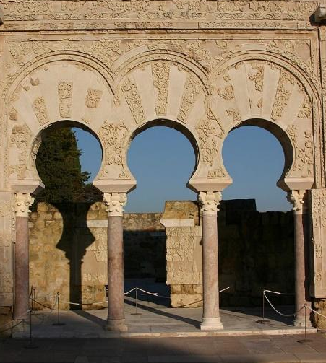 | 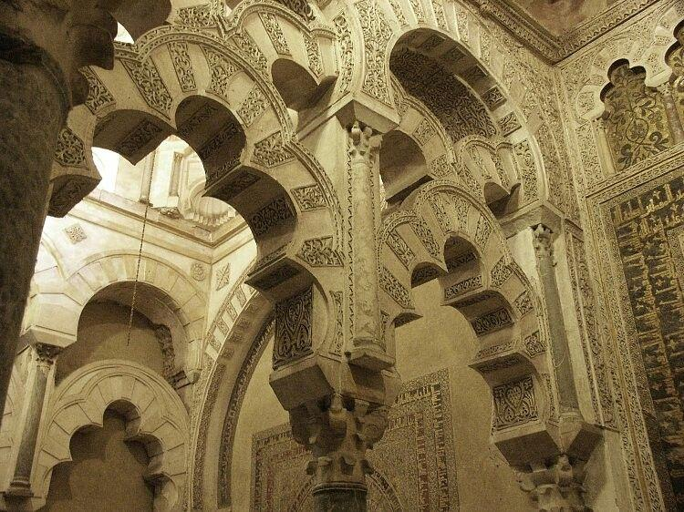

- Which arch can support more weight? What part do you think is just decorative?
- Each type of arch is used in a different architectural style. Order the ones in this exercise chronologically, explain the details of the artistic style to which they belong and give a couple of examples of buildings that contain them.
- What improvements did technological advances in arches entail for the construction of structures and their end result?
- Look for information on other types of arches. Choose two, the ones you find most curious, and explain how they are, where we can find them and what style they belong to.

