EDUCATIONAL COLORING BOOK
for preschool children
Princess Europea
and kids

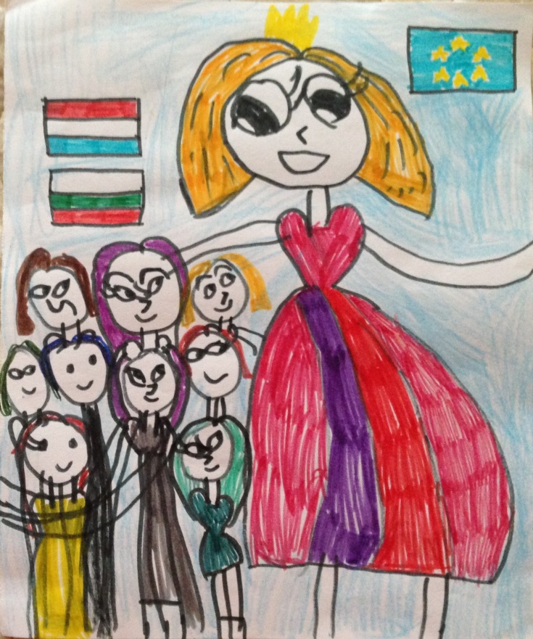

2018

Author's team:

Bulgaria

Kindergarten “Latinka” - Shumen

Yana Zhetcheva

Mariqna Mileva

Galina Georgieva

Svetla Popova

Croatia
DV Petar Pan - Zagreb

Alen Ptičar

Renata Senfner

Hello!

Do you love adventures? And dangerous adventures? Are you afraid of witches? Who live in dark and accessible castles?

Then this book is right for you.

See the map. Here is the way you have to go. You can mark any overcome obstacle with a cross. The game starts at Start, and the final is the witch's dark castle!

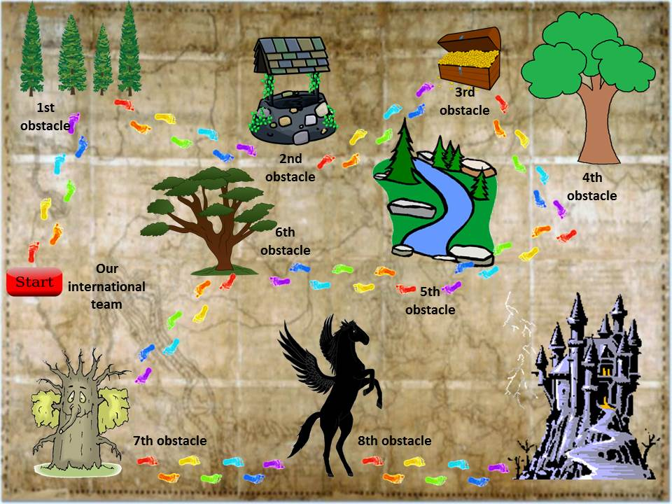

START NOW!

Once upon a time ... a beautiful princess. Her name was Europea.
Draw the princess here:
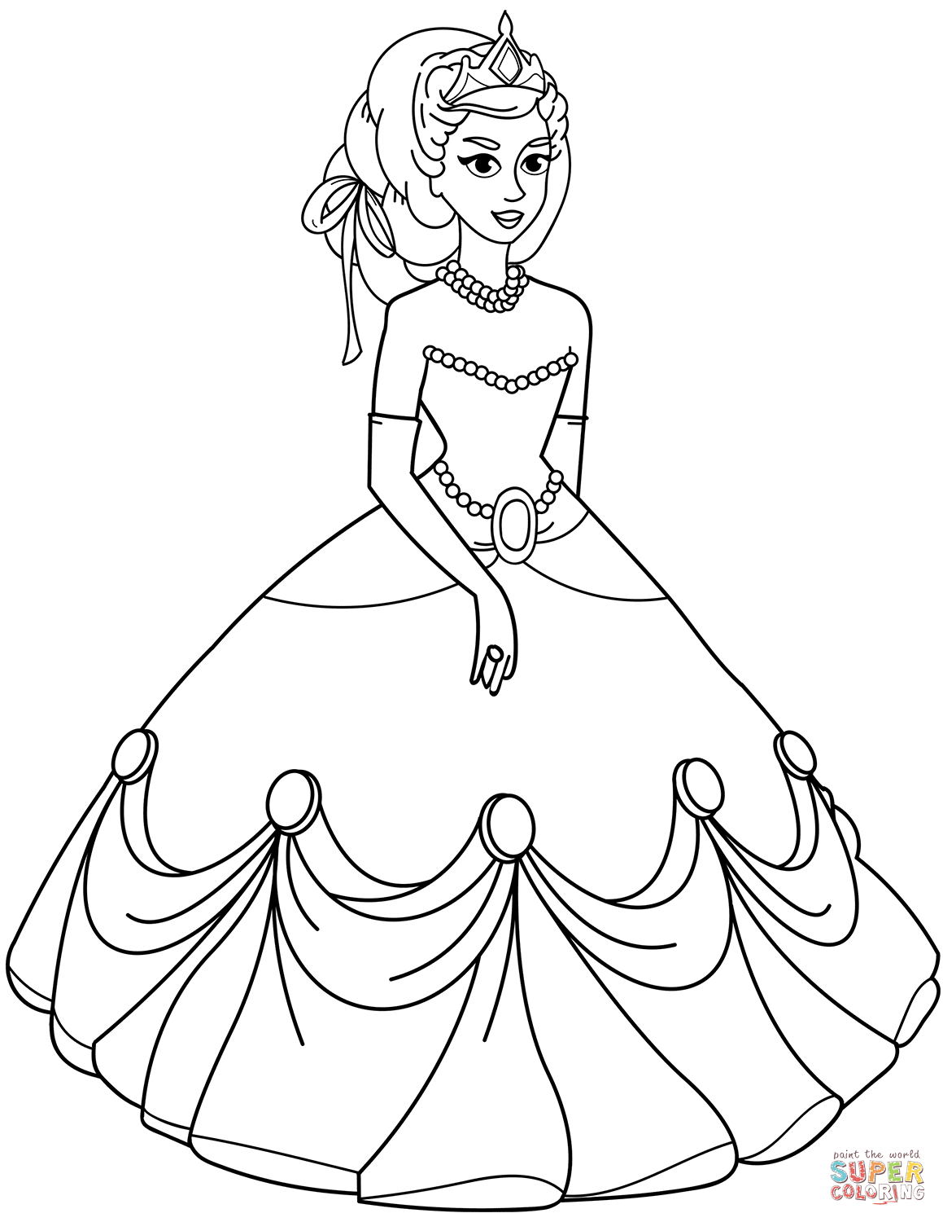

She lived happily in a large palace, and the lands of her kingdom were enormous - spread across a continent.
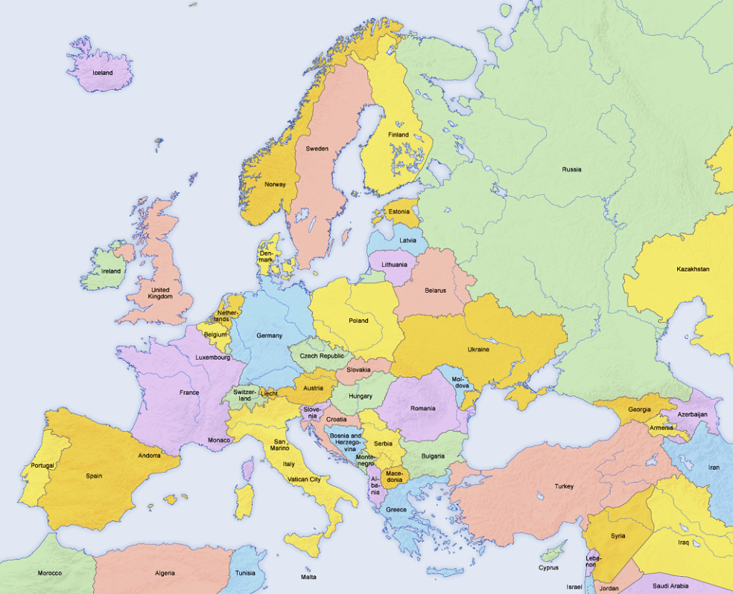

There lived people who spoke different languages. This was not an obstacle to co-living peacefully for centuries.
Find your country on the map!

But, an evil witch kidnapped the beautiful princess and took her in a dark castle.
Draw the evil witch here:
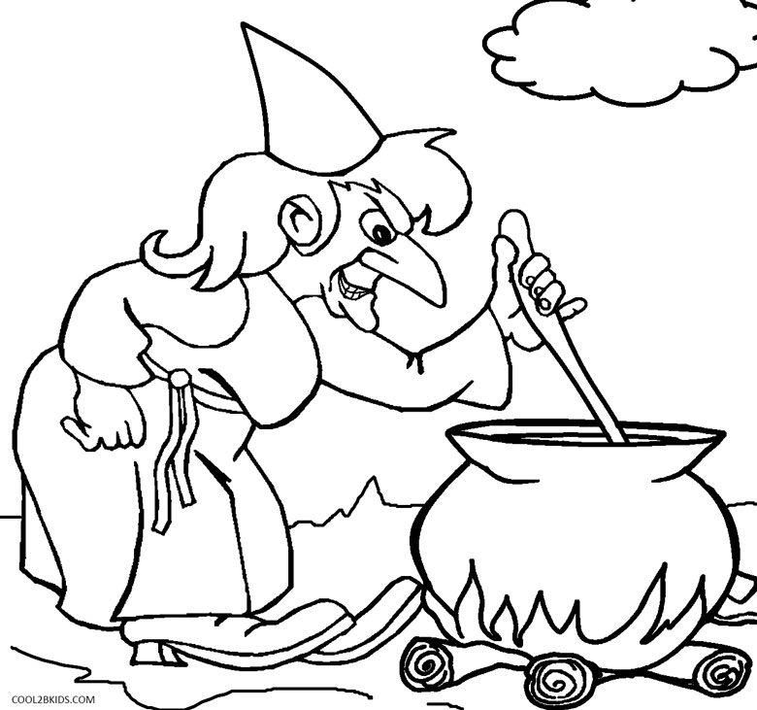
The citizens of the kingdom were saddened. The King, her father, announced an award for the one who succeeds to rescue princess Europea and return her home.
Brave men from different countries of the kingdom have gone to rescue the princess. And … The road to the dark castle was very dangerous. No one was able to reach the evil witch. No one was able to rescue the princess.
People were wondering how to release a beautiful Europea! Strong men failed to get through the obstacles, who can then …
Children from Croatia and Bulgaria heard the sad story and decided to take on rescue mission. They knew there were many obstacles waiting for them on the long road.

The Croatian children learned the language of Bulgarians and the children from Bulgaria learned Croatian to understand each other, to be a united and unbeatable team.

Write ЗДРАВЕЙ! - it's "Hello!" in Bulgarian

Write DOBAR DAN! - It’s "Hello!" in Croatian

They got to know each other and went bravely together forward. They reached the first obstacle. Suddenly the evil witch appeared. She asked:
- Do you know the colors of the national flags of Croatia and Bulgaria? And the flag of Princess Europea's kingdom?
Draw flags here:
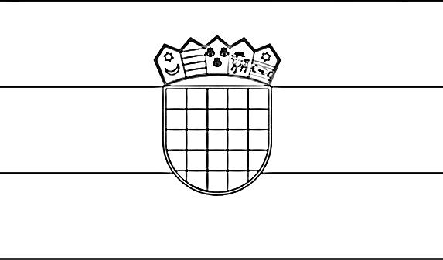
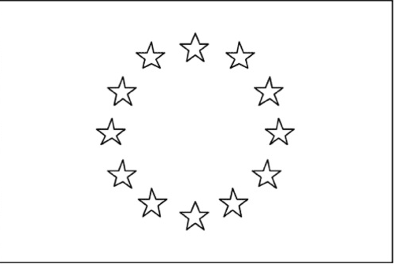
- Well done! You are very fast! Stay under the shade of the trees and you can move on! - said the evil witch.
They continued on the road, but a second obstacle appeared before them ...
- Stop! - the witch said - I do not know anything about the history of your cities. I am listening to you! Tell me!

Children tell about Shumen and Zagreb here:
Draw the most famous buildings in your cities here:
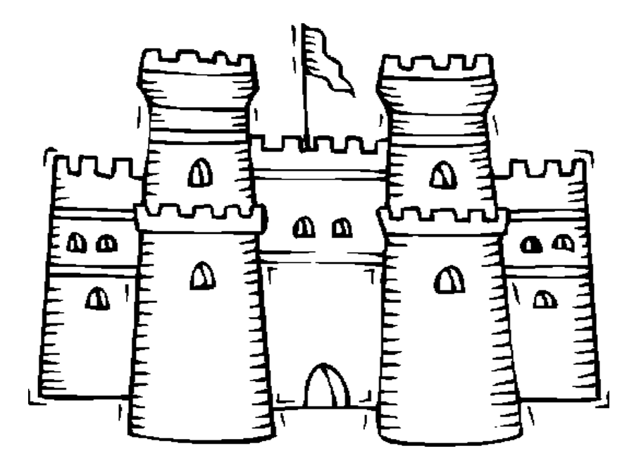
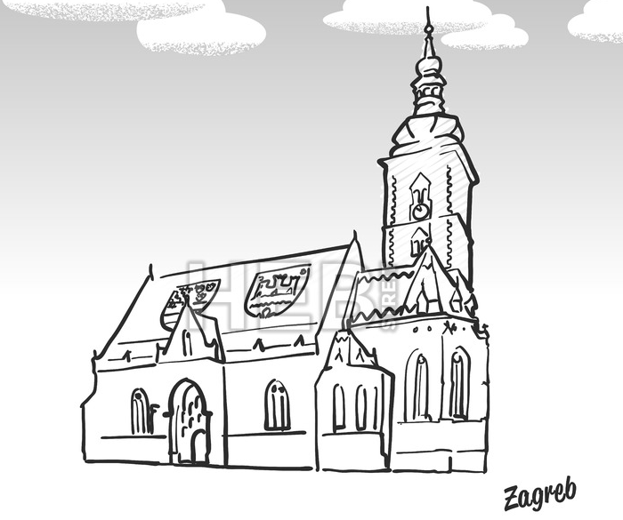
- Well done! You can drink water from the well and continue - the witch said.
The children continued along the way. In the distance just in front of them something was shining brightly. The closer they approached to the thing, the stronger it shone. The children found with surprise that this was a box of jewels.
- Do not touch! - cried the witch - First you have to tell me what interesting customs and traditions there are in your countries. They are more valuable than money. I want you to draw them together. And you have to put the picture into the box with jewels.
The children told and celebrated Grandma Marta and Day of the cravata together –
see how here

Draw martenitsa and cravata here:
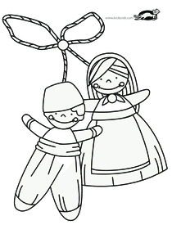

- I am very pleased. What interesting customs you have with martenitsi and cravata. These customs are the greatest treasure of your nations! And the pictures you drew are just great! That's why you get one coin from the treasure box. You can proceed to the tree of knowledge.
The children continued along the path to the fourth obstacle. In front of them - a tree, an unusual tree! The witch said:

- It does not grow fruit, but encrypted messages that tell of a unique craft and cultural monument. Use a QR reader to decode them.

Draw pictures here:
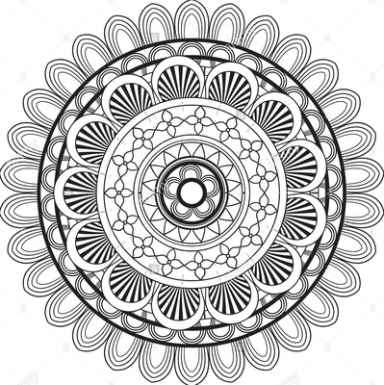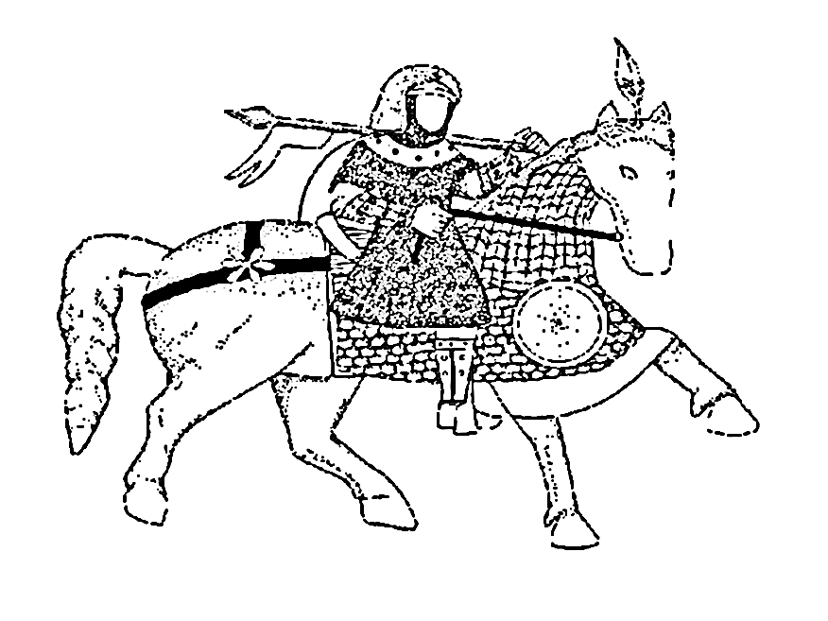

- Unique - Lace and Horseman! The more you learn about each other, the stronger your international team will become. And I do not like that at all! Because I am the most powerful of all. Ha-ha-ha!

- You can continue to the stream. Come on, go! Probably you are thirsty!
The children continued to the fifth obstacle, drinking cold clear water from the stream. And the witch flew with her broom over them and did not stop talking:
- Can you guess riddles? Listen to this: "White, smooth and without a hole, its wall is a shell. What is it? "
The witch had expected that it will make difficult for children, but ... she did not guess. And you? Did you guess the riddle?

- Smart children, I admit! I've hidden boiled white eggs under the stones. They are not enchanted, honest! In my bewitched kingdom we have the custom of painting them with dark colors. And in your kingdoms? Show me how you do it!
Draw egg here:

The children continued along the path and reached a large green tree, the sixth obstacle. From the crown of the tree, the voice of the witch was heard:

- Ha, ha, ha, children from Bulgaria and Croatia, this is a magical tree full of evil leaves, do you know what can evict the evil spell from it?
The children from Bulgaria and Croatia did not think long time. They presented different customs in their countries, which expelled evil spirits.
Watch these customs here:
Draw masks of mummer and zvončari here:
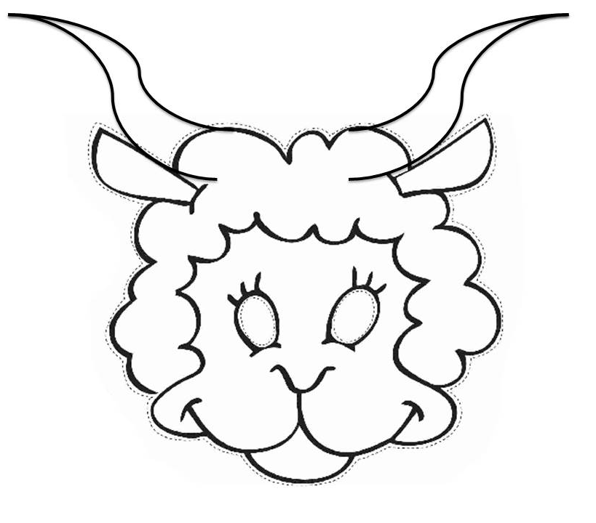

-You really know a variety of spells and do not be afraid of the fire. You can move on! – said the witch.
The kids have reached very old and wise tree on the edge of the swamp - the seventh obstacle.
- Stop, only the one who will show this tree a very beautiful landscape, a miracle of nature, that will cheer him up, can pass, because he is looking all over life in the mud and he is very disappointed.
What the children showed you can see here:
Draw the natural phenomena here:
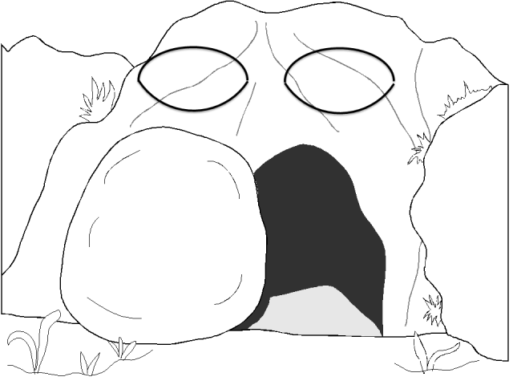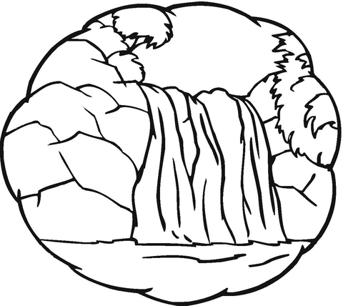
-You've really shown a wonderful nature. Nature is the greatest artist. You can go further! – said the witch.
And the witch laughed maliciously and thought: "Their most difficult obstacle is ahead. No one has ever been able to pass it. The 8th obstacle is insurmountable. Ha - ha - ha! "
Friends from Croatia and Bulgaria went, holding their hands. So easier to step on the uneven path. They did not suspect anything...
Suddenly, a black horse appeared before them. Yes, a black horse with wings on the back. Can you imagine the reaction of young rescuers? They scared and hugged.
- Ha - ha - ha! Let me see you now.... - the witch said - no one has ever been able to ride this winged horse. If you can get on it back, it'll take you right to the front door of my dark castle. And then I'll have to release the princess, and I really do not want to do that.
You can also play this game with horse. Invite your parents to read the questions. Just open this link:
So, after a long journey, our friends found themselves in front of the big door of the witch's castle.
-No, no, no - she screamed - it is not possible! You are so young, but you have managed to get through all obstacles. No!
The witch did not want to release the beautiful princess!!!
Then friends decided to act boldly. They sang together the anthem of the kingdom of Princess Europea. The words of the song were very powerful.
Sing the anthem with children:
The big door of the castle opened with a squeak. Princess Europea smiled gently:
- Thank you, friends from Croatia and Bulgaria. You succeeded because you were together. You were strong and brave, and so you overcome all the difficulties along the way. I declare you honorable citizens of my kingdom! Three times hurray!
Say three times “hurray!”
The sky was illuminated with colorful fireworks. A flourish of trumpets announced about the return of beautiful Europea.
Draw the festive fireworks here:
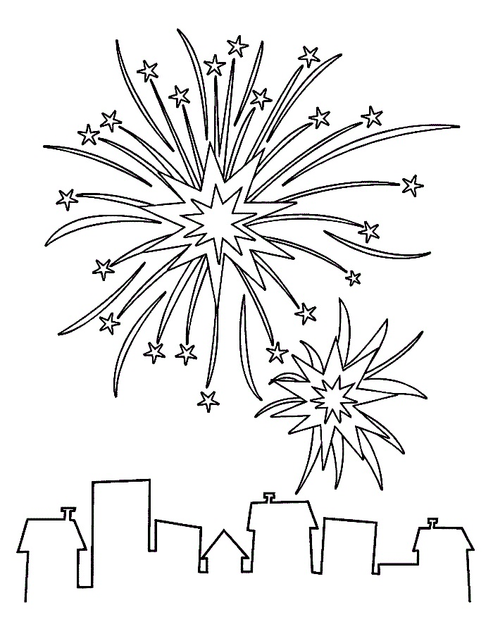

The book was written by children and teachers
from Bulgaria and Croatia
on the eTwinning project "Kids in Action".

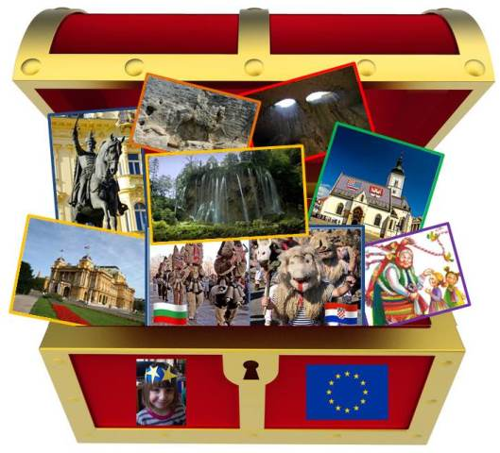

2018
