EDUCATIONAL BOOK
for preschool children

Princess Europea
and kids

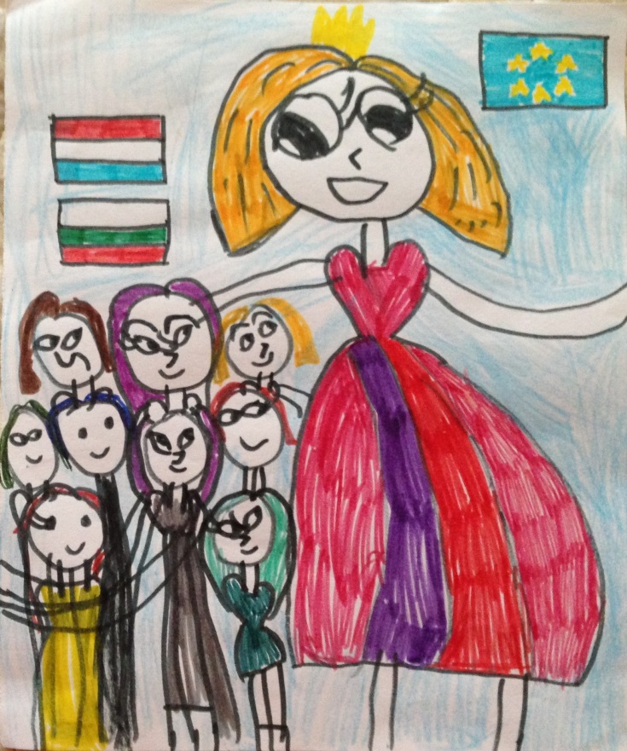

2018

Author's team:
Bulgaria
Kindergarten “Latinka” - Shumen
Yana Zhetcheva
Mariqna Mileva
Galina Georgieva
Svetla Popova
Croatia
DV Petar Pan - Zagreb
Alen Ptičar
Renata Senfner

Hello!

Do you love adventures? And dangerous adventures? Are you afraid of witches? Who live in dark and accessible castles?
Then this book is right for you.

See the map. Here is the way you have to go. You can mark any overcome obstacle with a cross. The game starts at Start, and the final is the witch's dark castle!

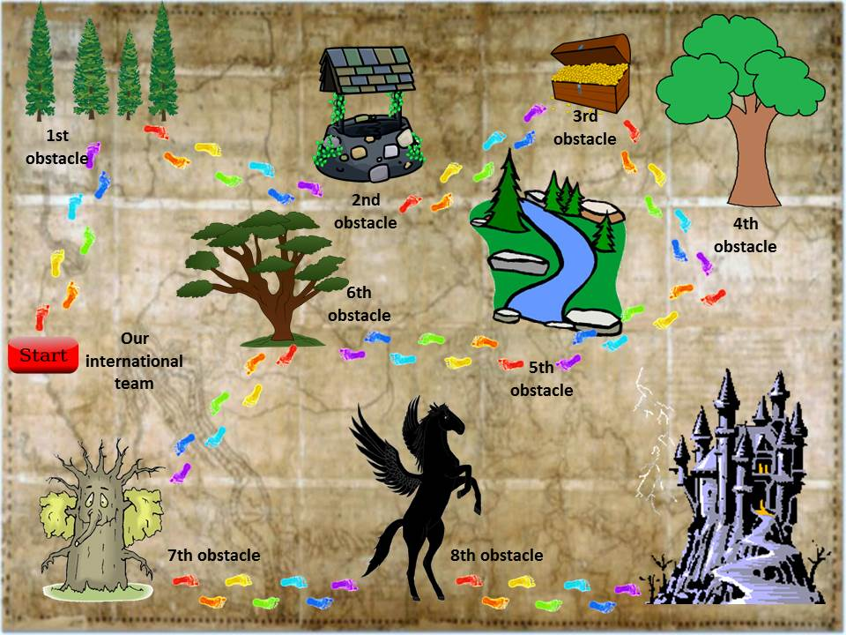

START NOW!

Once upon a time ... a beautiful princess. Her name was Europea.
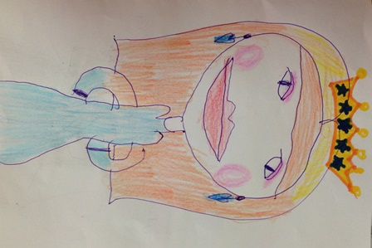

She lived happily in a large palace, and the lands of her kingdom were enormous - spread across a continent. There lived people who spoke different languages. This was not an obstacle to co-living peacefully for centuries.

But, an evil witch kidnapped the beautiful princess and took her in a dark castle. The citizens of the kingdom were saddened.
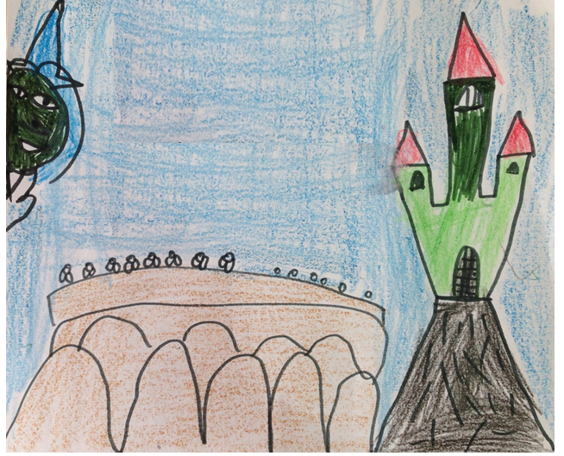

The King, her father 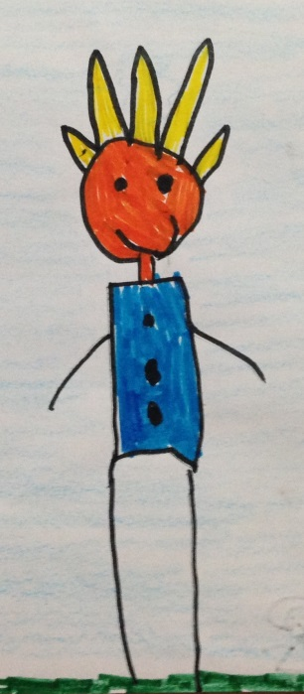
announced an award for the one who succeeds to rescue princess Europea and return her home.
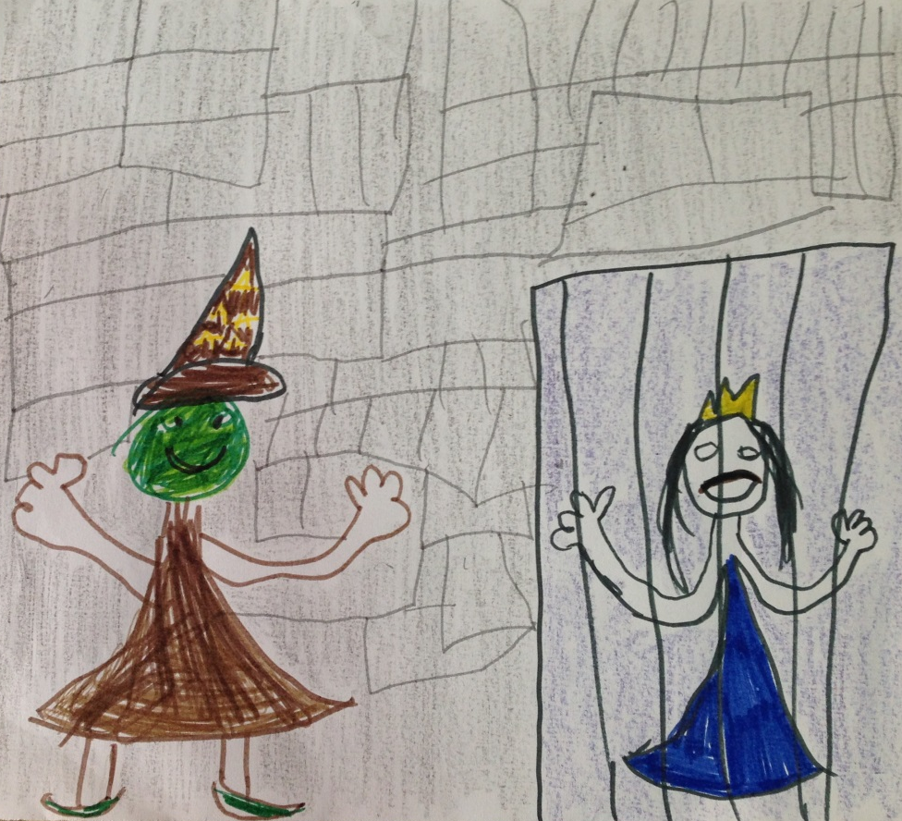

Brave men from different countries of the kingdom have gone to rescue the princess. The road to the dark castle was very dangerous. No one was able to reach the evil witch. No one was able to rescue the princess.
People were wondering how to release a beautiful Europea! Strong men failed to get through the obstacles, who can then …
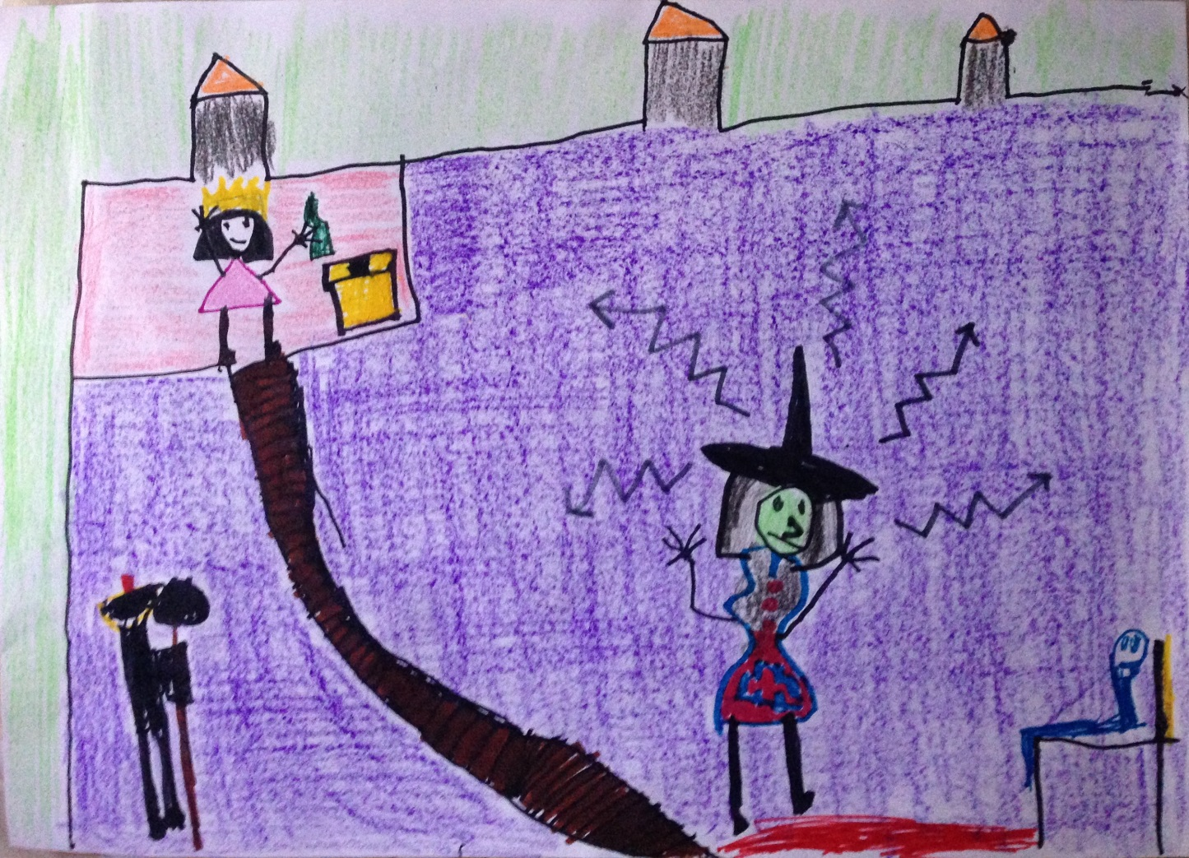

Children from Croatia and Bulgaria heard the sad story and decided to take on rescue mission. They knew there were many obstacles waiting for them on the long road.
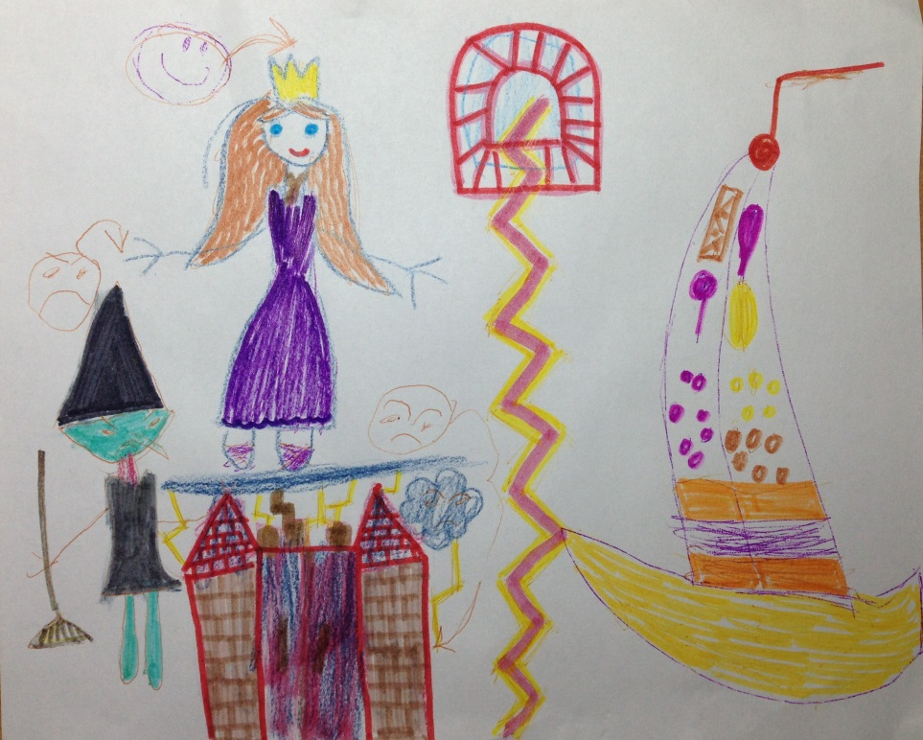

The Croatian children learned the language of Bulgarians and the children from Bulgaria learned Croatian to understand each other, to be a united and unbeatable team.

They got to know each other and went bravely together forward.
Kids reached the first obstacle. Suddenly the evil witch appeared.
She asked:
- Do you know the colors of the national flags of Croatia and Bulgaria? And the flag of Princess Europea's kingdom? Can you solve puzzles? Then you have to compete! I will announce the winners - only they can move on.
https://www.jigsawplanet.com/
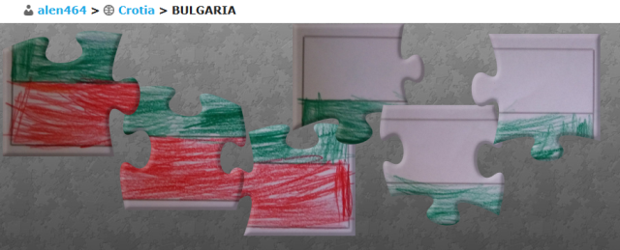
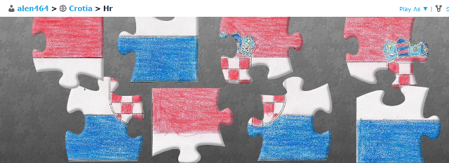
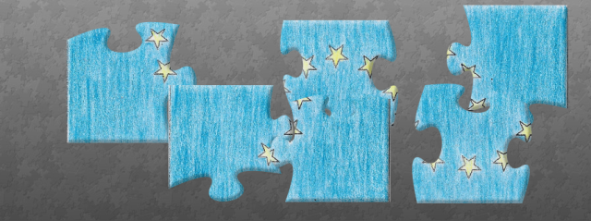

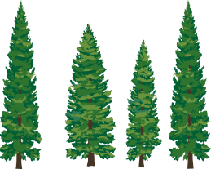
The children solved the puzzle. They were happy!
- Well done! You are very fast! Stay under the shade of the trees and you can move on! - said the evil witch.

They continued on the road, but a second obstacle appeared before them...
- Stop! - the witch said - I do not know anything about the history of your cities. I am listening to you! Tell me!

Children told about Shumen and Zagreb.
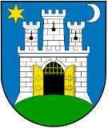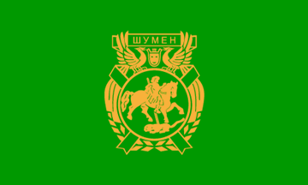
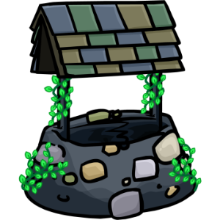
- Well done! You can drink water from the well and continue - the witch said.

The children continued along the way. In the distance just in front of them something was shining brightly. The closer they approached to the thing, the stronger it shone. The children found with surprise that this was a box of jewels.
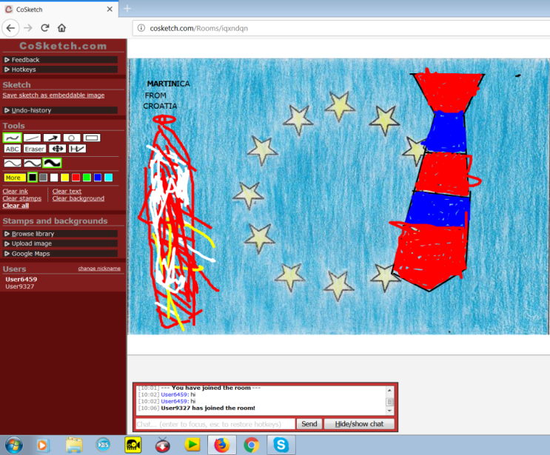
- Do not touch! - cried the witch. - First you have to tell me what interesting customs and traditions there are in your countries. They are more valuable than money. I want you to draw them together. And you have to put the picture into the treasure box.
Children presented national customs Grandma Marta and Cravata and drew them together on an online common canvas – http://cosketch.com/

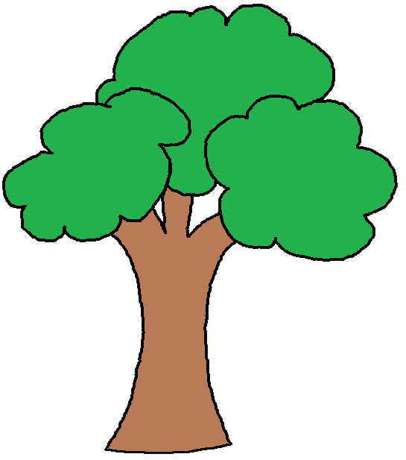
- I am very pleased. What interesting customs you have with martenitsa and cravata. These customs are the greatest treasure of your nations! And the picture you drew together is just great! That's why you get one coin from the treasure box. You can proceed to the tree of knowledge.

- There is no fruit growing on it, but coded pictures – the witch said. Use a QR reader to decode them. Then ask your parents to seek information about the pictures. Read it. And draw pictures to impress me! - www.qr-code-generator.com/

Children drew these pictures: Madara Horseman and Pag lace
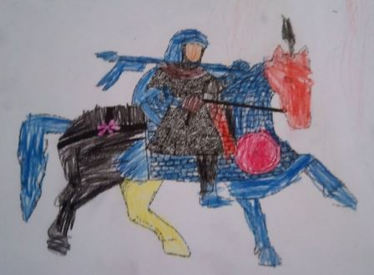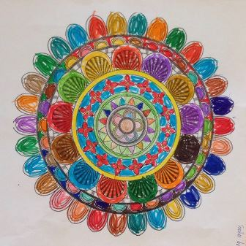

- Unique - Lace and Horseman! The more you learn about each other, the stronger your international team will become. And I do not like that at all! Because I am the most powerful of all. Ha-ha-ha!

- You can continue to the stream. Come on, go! Probably you are thirsty!
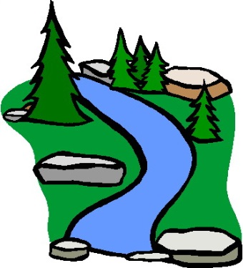

- Can you guess riddles? Listen to this: "White, smooth and without a hole, its wall is a shell. What is it? "/ Egg /

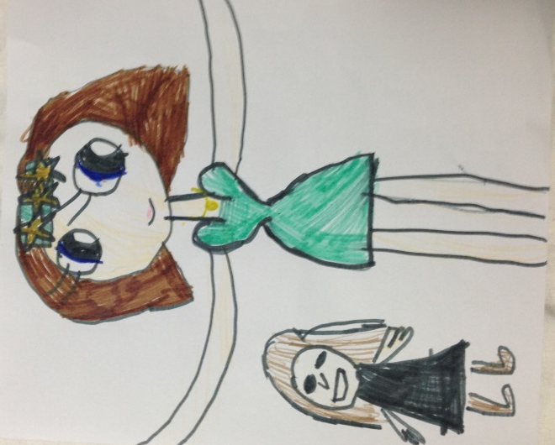

- How did you guess? Smart children, I admit! I've hidden boiled white eggs under the stones. They are not enchanted, honest! In my bewitched kingdom we have the custom of painting them with dark colors. And in your kingdoms? Show me how you do it!
Children met online and showed live techniques for dyeing eggs in their countries. They also drew online eggs. http://www.softschools.com/games/educational_games/easter_egg_designer/
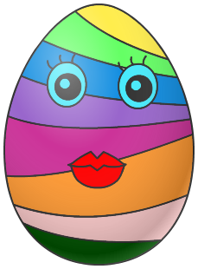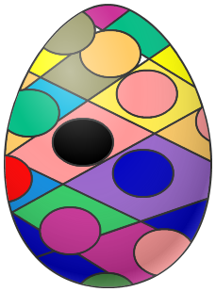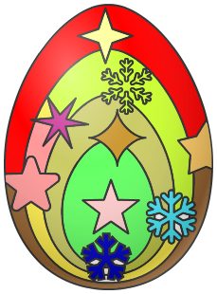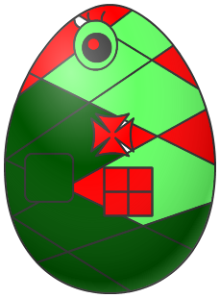

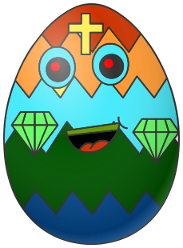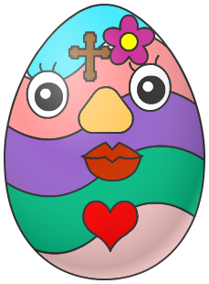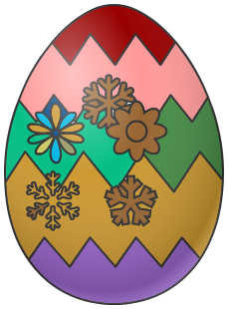

Children gave the witch a basket of eggs.

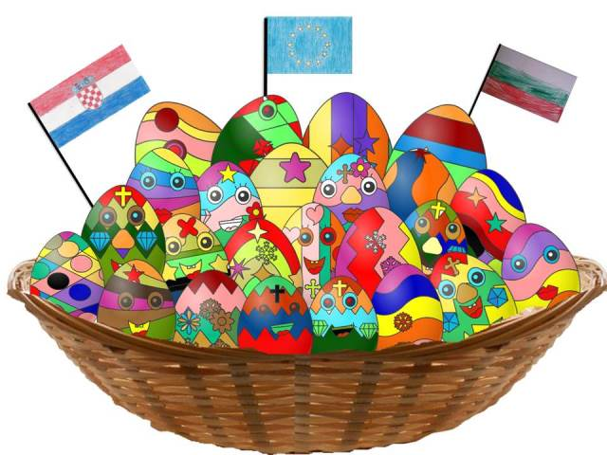

- My mood is colorful! Ha-ha-ha! You can proceed to the next obstacle.

The children came to the big green tree. 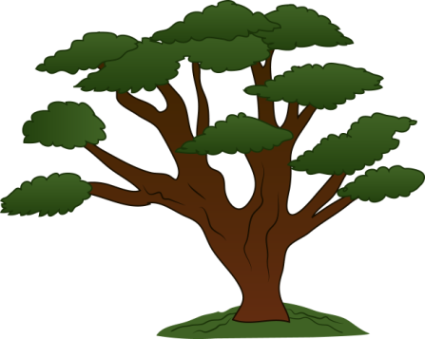

And from the crown of tree they heard the voice of witch:

- Ha, ha, ha, children from Bulgaria and Croatia, this is a magical tree full of evil leaves, do you know what can evict the evil spell from it?

The children presented her mummers Zvončara from Croatia and mummers Surva from Bulgaria.

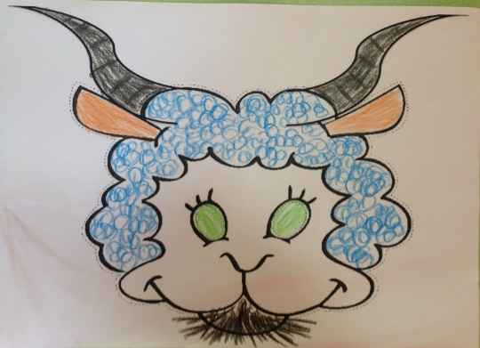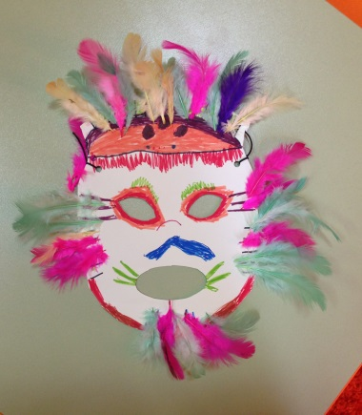

They presented also Bulgarian Nestinarstvo = bare feet walk on the embers and CroatianIvanjski krjesovi = jumping over the fire.
After that children created a common collage - http://www.pizap.com/photo-collage-templates.php

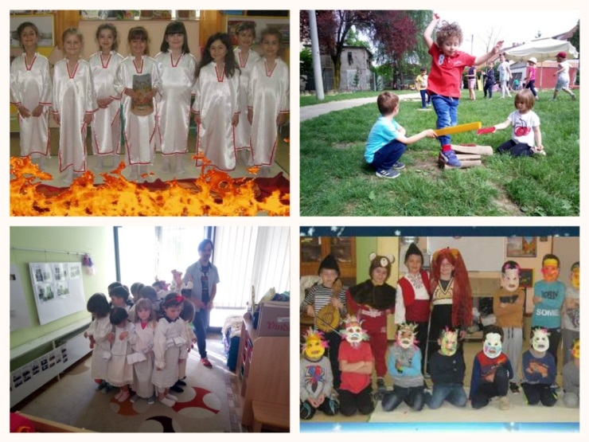

- You really know a variety of spells and do not be afraid of the fire. You can move on!
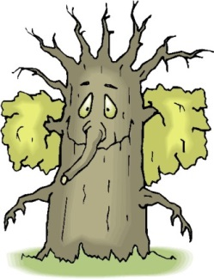

Kids have reached very old and wise tree on the edge of the swamp.

- Stop, only the one who will show this tree a very beautiful landscape, a miracle of nature that will cheer him up, can pass, because he is looking all over life in the mud and he is very disappointed.

Kids drew the cave "The Eyes of God" and Plitvice Lakes together on an online common canvas – http://cosketch.com/

- You've really shown a wonderful nature. You can go further!

And the witch laughed maliciously and thought: "Their most difficult obstacle is ahead. No one has ever been able to pass it. The 8th obstacle is insurmountable. Ha - ha - ha! "

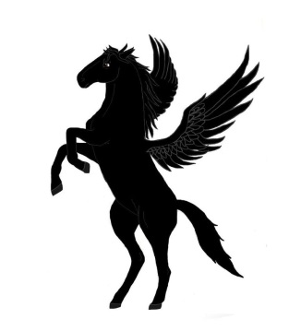
Friends from Croatia and Bulgaria went, holding their hands. So easier to step on the uneven path. They did not suspect anything...
Suddenly, a black horse appeared before them. Yes, a black horse with wings on the back. Can you imagine the reaction of young rescuers? They scared and hugged.
.
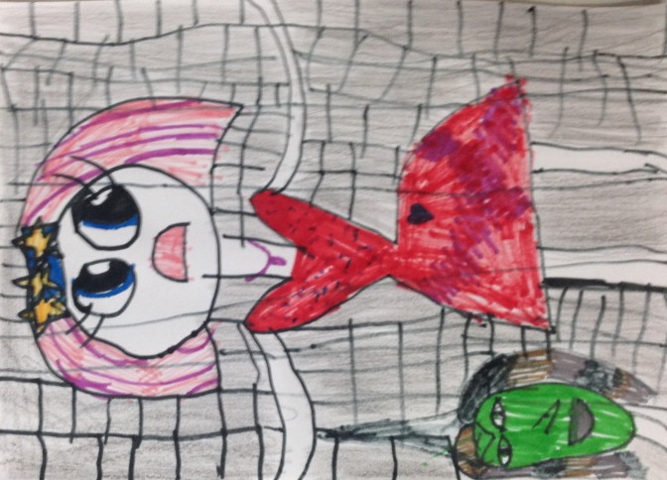

Princess Europea waited the kids in the witch's castle with hope!

- Ha - ha - ha! Let me see you now.... - the witch said - no one has ever been able to ride this winged horse. If you can get on it back, it'll take you right to the front door of my dark castle.

- And then I'll have to release the princess, and I really do not want to do that.

Kids played simultaneous Game “Horse Race” - https://learningapps.org/

So, after a long journey, our friends found themselves in front of the big door of the witch's castle.

- No, no, no - she screamed - it is not possible! You are so young, but you have managed to get through all obstacles. No!

The witch did not want to release the beautiful princess!!!
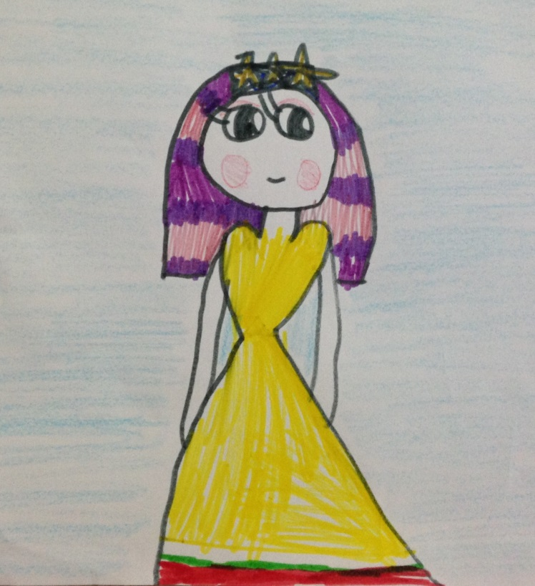
Then friends decided to act boldly. They sang together the anthem of the kingdom of Princess Europea. The words of the song were very powerful.

The big door of the castle opened with a squeak.

Princess Europea smiled gently:
- Thank you, friends from Croatia and Bulgaria. You succeeded because you were together. You were strong and brave, and so you overcome all the difficulties along the way. I declare you honorable citizens of my kingdom!

Three times hurray!
The sky was illuminated with colorful fireworks. A flourish of trumpets announced about the return of beautiful Europea.
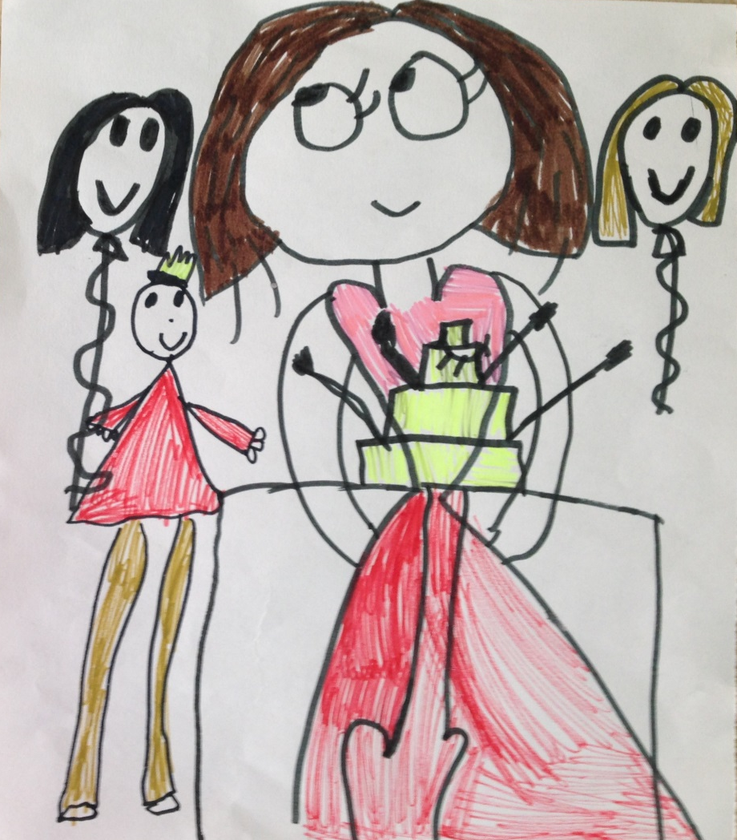

The book was written by children and teachers
from Bulgaria and Croatia
on the eTwinning project "Kids in Action".

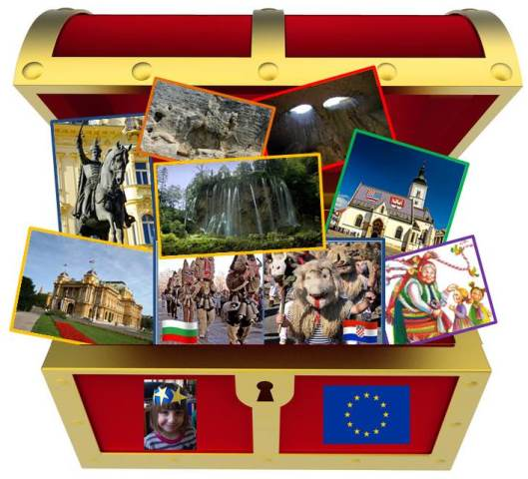

2018
