An interview with our school‘s Spanish teacher Ali Alatorre
by Greta Senkutė and Greta Kazlauskaitė from Vilnius Žvėrynas gymnasium

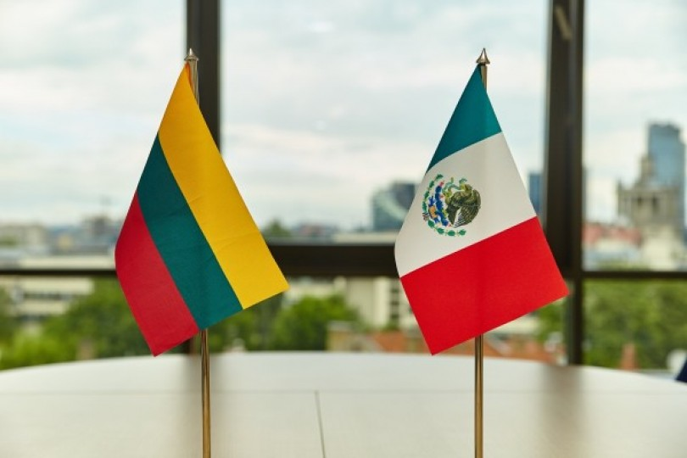
When did you come to live to Lithuania?
I came here in 2010 and yet I still feel so young.

What citizenship do you currently hold?
I am still Mexican.

What made you want to move here?
That‘s a difficult question to answer, but I think it was all in fate‘s hands. When I was in Germany, I met some Lithuanians who encouraged me to visit their country. After coming here three times I decided to stay here permanently.

How tough was learning the language?
Learning Lithuanian was difficult. Although I started learning from books, later I moved on to a different learning platform - the outside. That included buses, trolleybuses and local markets. Now I try to teach my class in Lithuanian.

Was it hard to adapt to a new country?
Not really. Although the cultures differ, adjusting wasn‘t an issue.

Did you have any difficulties taking care of immigration papers?
Immigration wasn‘t difficult, but I wish it was easier to deal with various documents now.

Since when do you work as a Spanish teacher?
Practically from the moment I started living in Lithuania.

And how is your life in Lithuania now?
It‘s definitely better than in Mexico and I‘m not planning on coming back. I have a family here with two kids who can speak both Spanish and Lithuanian. Life is all right.

