Meeting in Croatia
4th-8th March 2019
Day 1
At 17:25 we landed in Zagreb. Then we went to Čakovec by bus. We were welcomed by our host families.
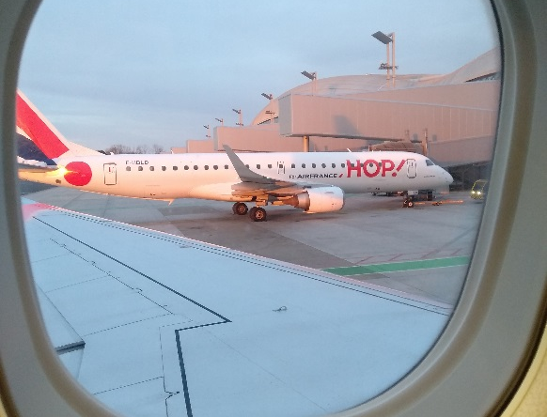

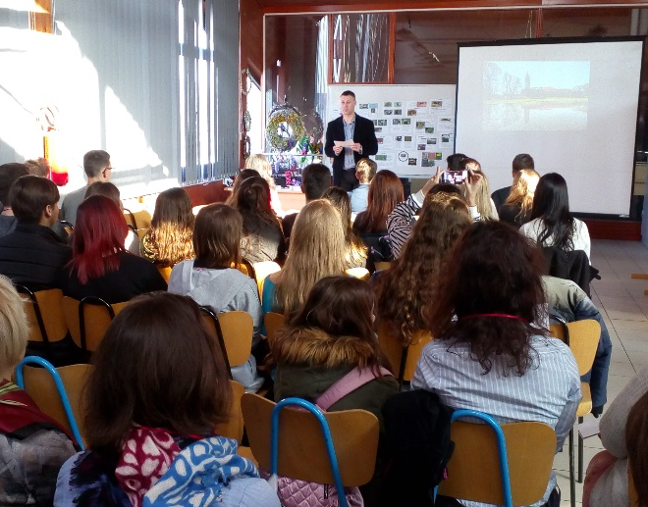
Day 2
At 8:00 we went to school. We were welcomed by headmaster of Gospodarska škola and croatian teachers. We heared two traditional croatian folk songs. Then we saw two presentations: about Medimurje and invasive snails.

We had an ice-breaking game: we were sitting in the circle and we had to say our and ours friends' names.
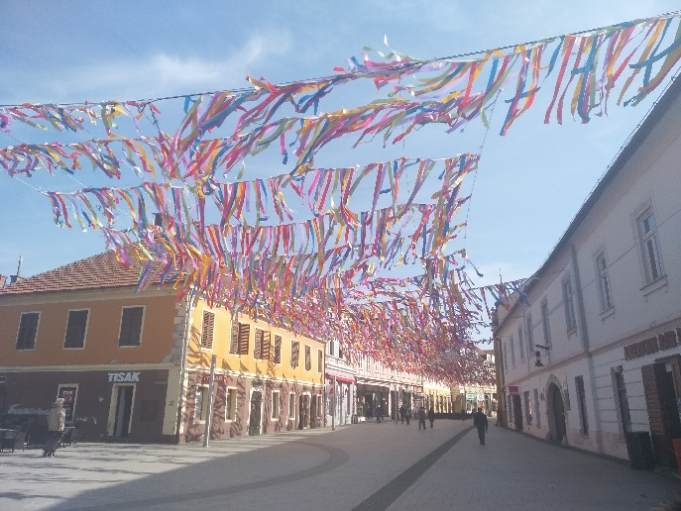
After small school walk we went on sightseeing Čakovec and then on lunch.
In the afternoon we took part in workshops about migrations of plants and animals. Ola was in the group working on animation in School of Animated Film and Wiktoria and Agata were in a group making a performance in Theatre Company Pinklec.

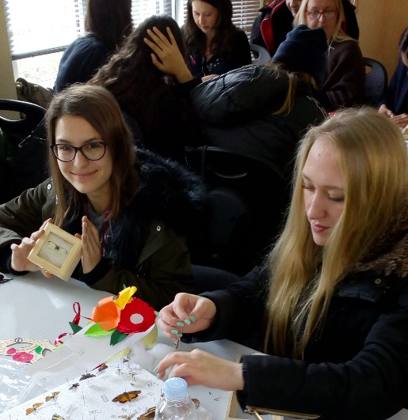
Day 3
At 7:00 we went by bus to Zagreb. Firstly we went to the Faculty of Agriculture, where we did carnival masks, collections of insects and painted mugs with plants and animals migration theme. We also saw two presentations about invasive plants and insects.
After that we went on lunch and then on sightseeing Zagreb. We also had some free time to buy souvenirs or grab something to eat.

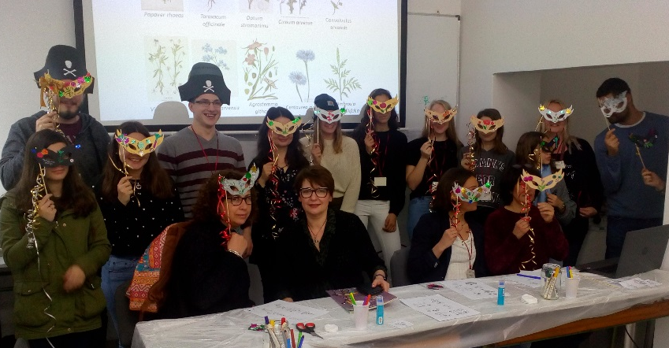
Day 4
At 12:45 Ola started to work on animation with her group. Wiktoria and Agata at 13:15 went on their performance rehelsal. Then we had free time.

Day 5
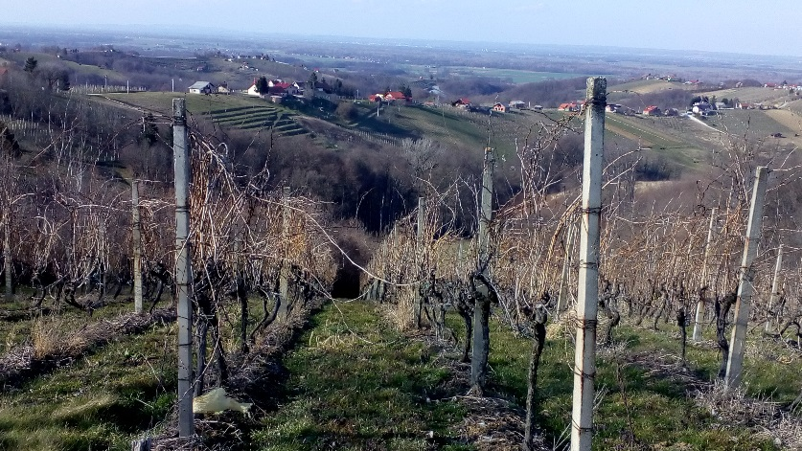
On 8:30 we went to school to see a presentation about invasive fish in Drawa and Mura rivers. Then we went to Dubrava Hydro Power Plant. After that we were sightseeing Medimurje County: we saw grapes fields near Slovenia and were on view point. We went back at 17:00.
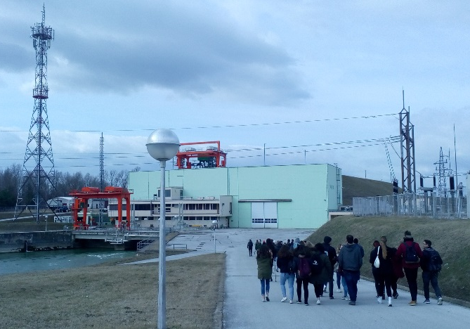
Day 6
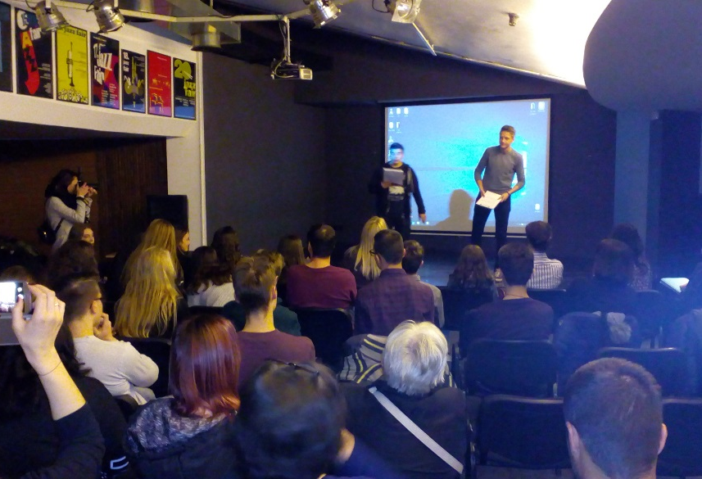
At 9:00 we saw results of our workshops: animated film and performance. Women recieved flowers for International Womens' Day. We got our certificates and did an evaluation of the project. Then we went back to our hosts to prepare for goodbye party, which took place in Metalac Bar at 16:45. We also celebrated Agata's 18th birthday with cake.

Day 7
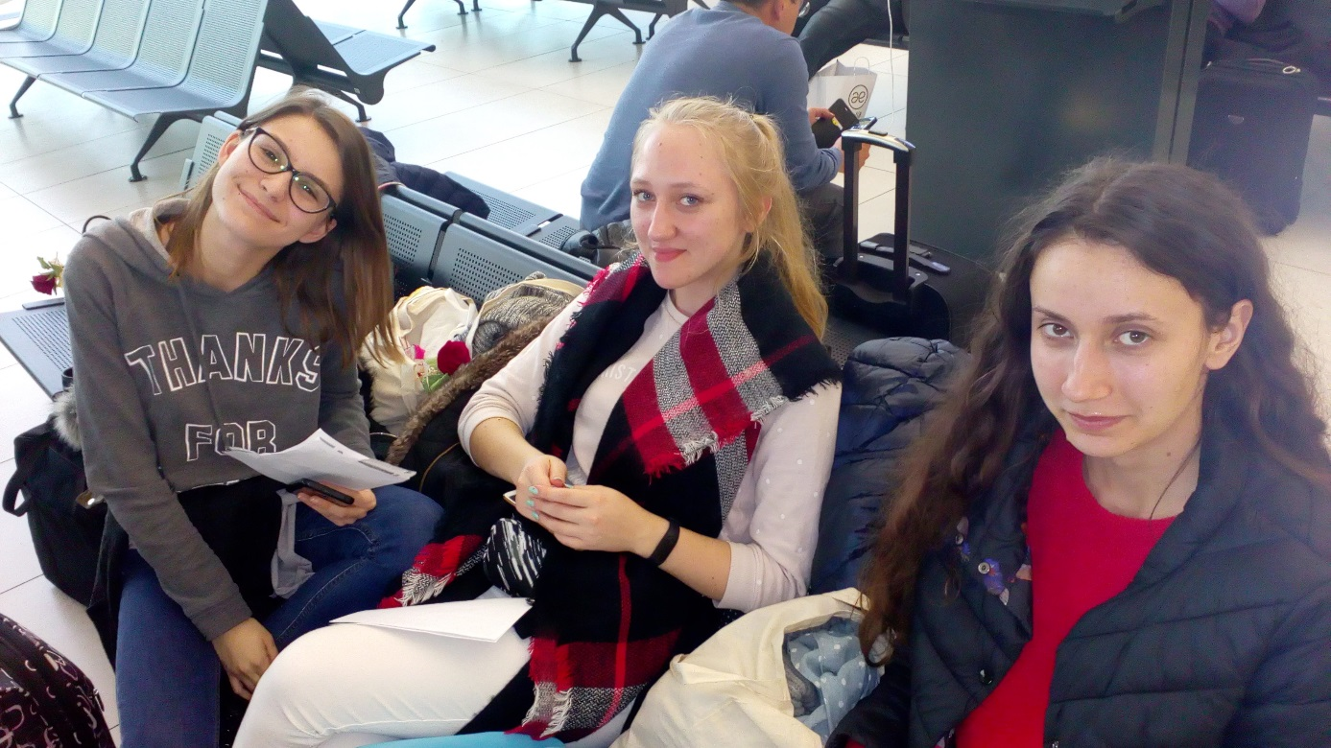
At 14:00 we met our teachers and went by bus to the airport in Zagreb. We arrived in Poland at 19:40.

