The barbed wire on the Croatian-Slovenian border
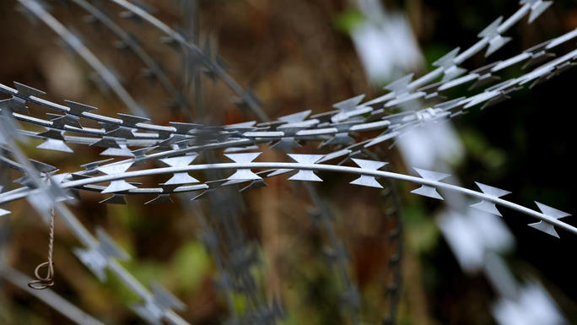
In November 2015, Slovenia started construction of the barrier consisting of razor wire. The stated aim of the barrier is to control the flow of refugees and migrants, while the border stays open.

Environmental impact
Croatia complained to the EU that the Slovenian fence is an obstacle for migration of wildlife such as deer and that "Slovenia is violating European legislation on the conservation of natural habitats and the environment". The razor-wire fence laid by Slovenia in December 2015 on the border with western Croatian regions of Istria and Gorski kotar endangeres the habitat of the wolf and the brown bear, both of which are protected by law in Croatia. Local hunters have found deer killed by the fence.

