Our stay in Vilnius, Erasmus Plus “Migration matters” project

Day 1
Monday, 8th April

We met at 9 in the auditorium where the official start of the project took place. The students presented folk songs and dances that we later learned. After integration games we had lunch and then a tour of Vilnius.

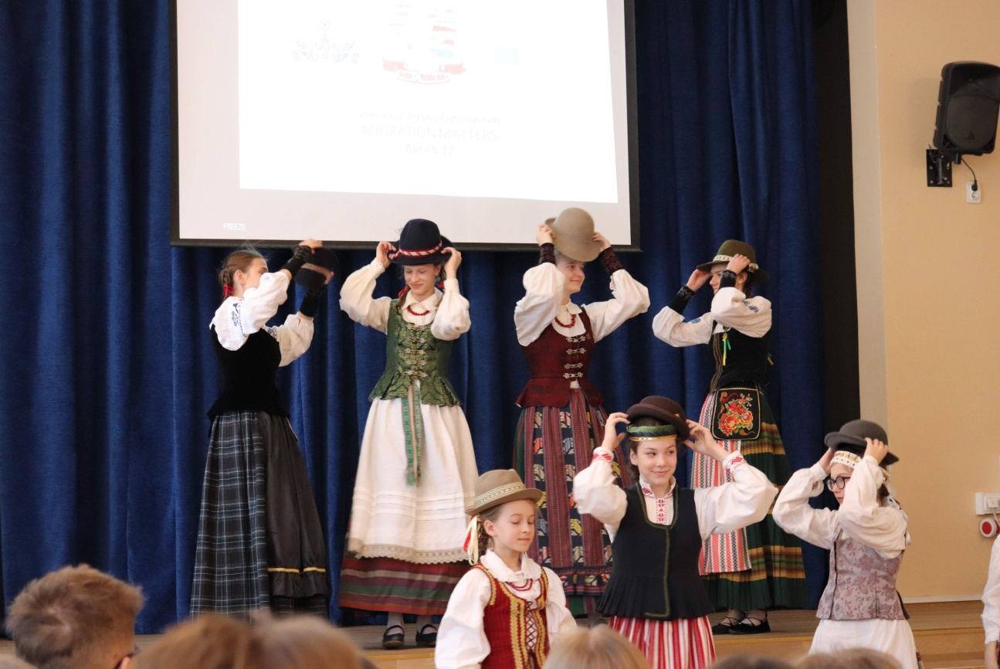

Day 2
Tuesday, 9th April
We were in Norviliškės Castle where we ate a traditional Lithuanian dinner. We did not have plates, instead of that we used bread. We did not have the cutlery, either so we used our fingers. Norviliškės Castle (a former monastery, also called Norviliškės Manor) is a Renaissance style castle in Norviliškės, Lithuania. The Norviliškės Castle was first mentioned in 1586. In 1617 the owners donated part of the real estate land to Franciscans. Around 1745 they built a monastery and a church in Renaissance style. The monastery was reconstructed at the end of the 18th century by Kazimieras Kaminskis. After the November Uprising of 1831, Russian authorities closed the monastery and turned it into barracks for soldiers, and later to a boarding school for girls. The Church of St. Mary Compassionate Mother was closed at the same time as the monastery. A new wooden church was built in 1929.
It is a really impressive place and we had a good time there!

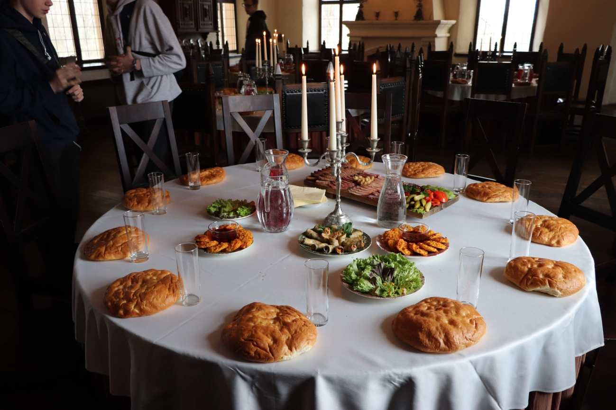

Day 3
Wednesday 10th April

We went to Trakai and made traditional Lithuanian kibins (pastries filled with mutton and onion) and we visited the Trakai Island Castle. In Eastern Europe it is the only island castle.
The construction of the stone castle was begun in the 14th century by Kęstutis, and around 1409 major works were completed by his son Vytautas the Great, who died in this castle in 1430. Trakai was one of the main centers of the Grand Duchy of Lithuania and the castle held great strategic importance. Trakai Island Castle was built in several phases. During the first phase, in the second half of the 14th century, the castle was constructed on the largest of three lake islands by the order of Grand Duke Kęstutis. The construction of Trakai Island Castle was related to the expansion and strengthening of the Trakai Peninsula Castle. Kęstutis moved his main residence and his treasury to the Island Castle.

The castle suffered major devastation during an attack by the Teutonic Knights in 1377. After the assassination of Kęstutis, a power struggle between Jogaila and Vytautas the Great for the title of Grand Duke of Lithuania began. The castle was besieged by both sides. Soon after the reconciliation between Jogaila and Vytautas, the second phase of construction started and continued until 1409. This phase is regarded as the major development in the history of the castle. Apparently, during the truce with the Teutonic Order, the construction works were supervised by the Order's stonemason Radike, four years before the Battle of Grunwald.

Day 4
Thursday, 11th April

At 10 am we all gathered in front of the Museum of Occupations and Freedom Fights which was a former KGB building. After splitting into two teams the guide started talking about the past events that had happened in that place. Based on this information we could extend our knowledge and maybe more clearly understand wartime period.
In the upper two floors we could see document about the Lithuanian partisans’ resistance against the Soviet occupiers, the deportations of Lithuanians to Siberia and day-to-day life in the LTSR. The other part of the museum are the prison cells and torture chambers in the basement. The cells are exactly how the KGB officers left them upon leaving Lithuania in 1991. 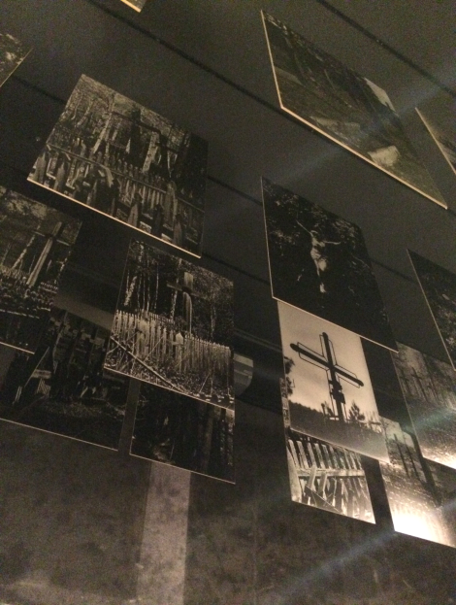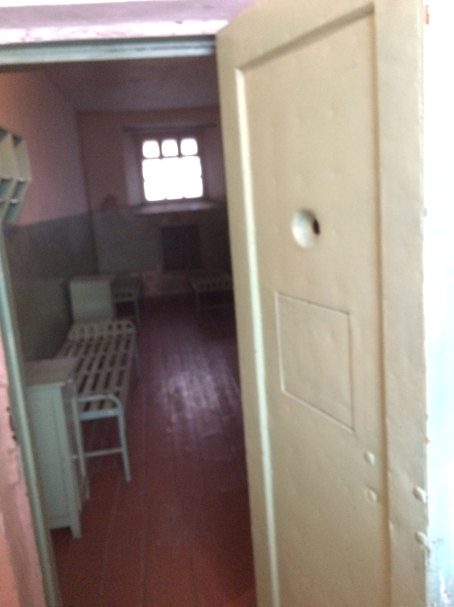
After the excursion we watched a documentary film called ‘Ice of June’.
Next we had free time for lunch break in the city.
At 1pm we returned to the museum where we had further workshop in order to collect information for our main task. We were given a task to do an interactive map. The subjects of our tasks depended on the group we were in. For example fisherman group had to focus on daily life of fishermen, how much they earned, how they worked, if they were using any tools or no etc.
When all groups finished their task we could return to home.

Day 5
Friday, 12th April
We met at 10 am in the Palace of Grand Dukes of Lithuania where we had musical education excursion. In the rhythm of flute music we listened to stories about life of the Grand Dukes. We had a great chance to try playing on harp on our own!

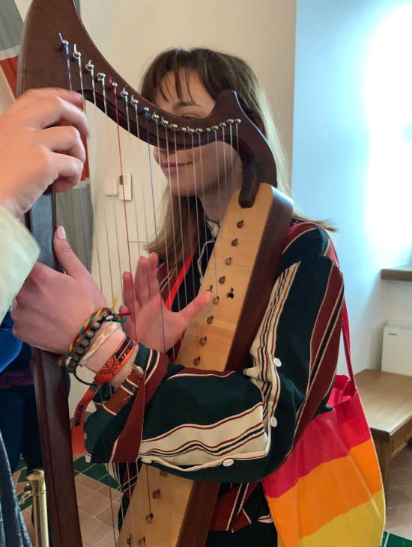

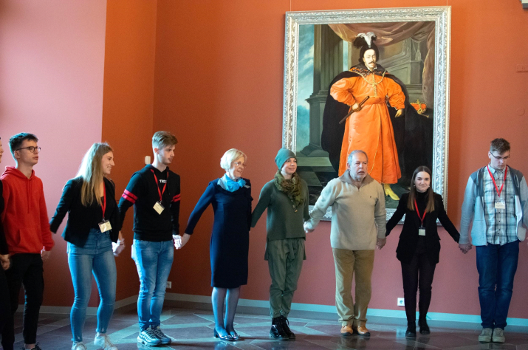

We also learned traditional dance. When steps became faster we all got lost, but despite this fact, we made a good job!
Later we moved to another room where we could present our work that we made on Thursday. After all presentations we received diplomas and we took souvenir photos. There was free time during which we could move back to the house, get changed or just stay in the city and then we went to the school for a goodbye-party. At 5pm the concert started. Students sang in a small group with their own accompaniment. There was also a solo singer, a boy with dance performance and also a duo who played a short musical. We spend amazing time dancing and singing together.

It has been such a pleasure to visit this wonderful city and have a chance to meet all of these kind people. We have very much enjoyed our time together!