Economic migrations and language

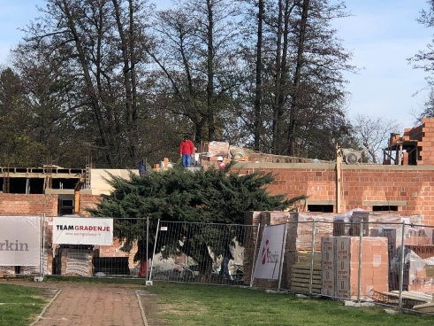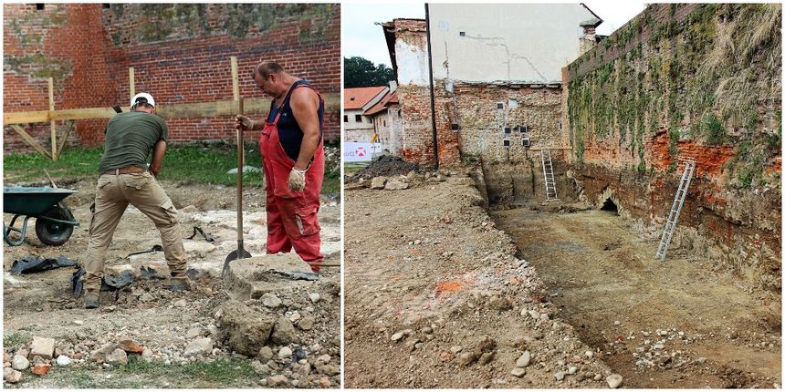
Young Bulgarian and Albanian workers come to work on building sites in Croatia and so they come to Čakovec. At the weekends they go out with our local people and they talk to one another. In this way they exchange words and phrases which will definitely leave a trail in our launguage. Also, it is interesting that in Međimurje County people use Germanism bauštela (die Baustelle) meaning bulding site, that originally comes from the German language by Croats who have worked on building sites in Germany because of economic migrations.

Migrations and literature I

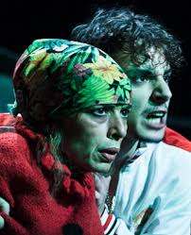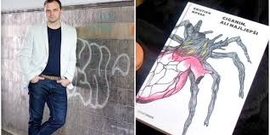
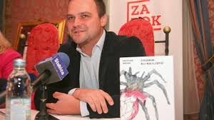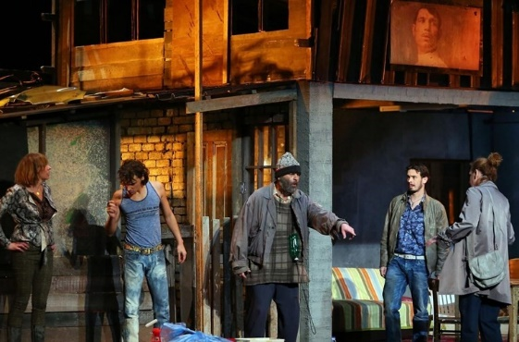

The best-selling novel Ciganin, ali najljepši (1916) (The Gypsy, But the Most Beautiful) was written by young writer Kristian Novak. He was born in Međimurje County, in a village 15 km from Čakovec. The story of the novel takes place in Međimurje. It is about a forbidden love between a middle-aged Croatian lady and a young Romany, a refugee wave and emigrant Nuzat's journey from Mosul to the West, human trafficking and forcing young girls from eastern countries into prostitution. The novel was successfully adapted into the play produced by Croatian National Theatre in Zagreb.

Migrations and literature II

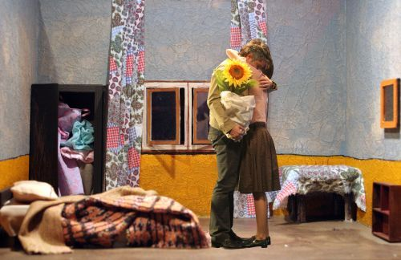
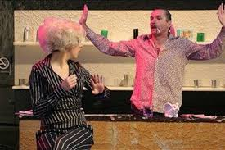
Tena Štivičić is a young Croatian dramaturg and writer who was born in Zagreb and is currently living and working in London. Her most famous drama Fragile was originally written in English and then translated into Croatian. A fragment from the drama is used in the second grade high school coursebook as an example of modern literature. The drama is about the destinies of migrants from Croatia, Serbia, Bulgaria and eastern countries. It deals with the problems of relations between East and West, postsocialist society, war profiteers, organized crime and prostitution. It is performed in Croatia, Germany, Slovenia and Great Britain.

Migrations and architecture I
The Pula Amphitheatre or the Pula Arena is the largest and best preserved ancient Roman monument in Croatia. It is the sixth largest Roman amphitheater in the world and the only with all the three Roman architectural orders completely preserved.
It is still unknown why the Romans built such a large building in Pula. Legend has it that the Roman emperor Vespasian built the Pula Amphitheatre in honour of his mistress Antonia Cenida who owned some lands in Pula.
The Arena is nowadays a first-class tourist attraction. It hosts Pula Film Festival every year and has done it since 1954. Also, the Arena is now a magnet for world-famous musicians who give concerts there.
The photo of the art installation A Cravat around the Arena in 2003 spread around the world. It was the photo of the longest tie in the world tied around the Arena. That is how a cravat which was 808 m long and which weighed 800 kg got into the Guinness Book of World Records.

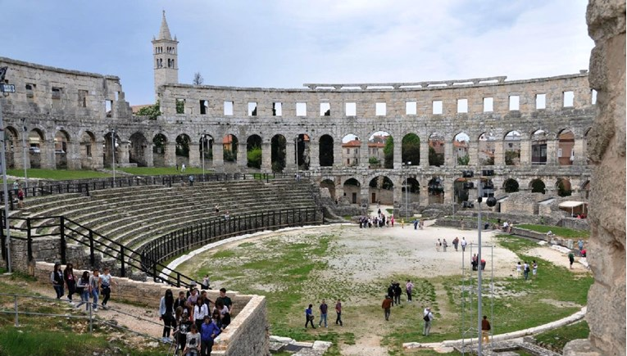
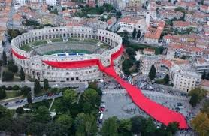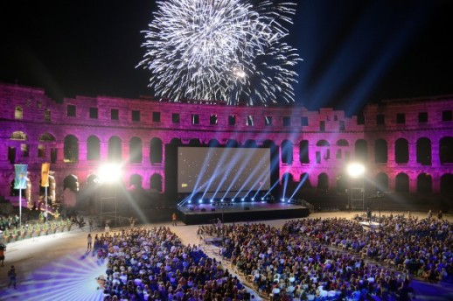

Migrations and architecture II

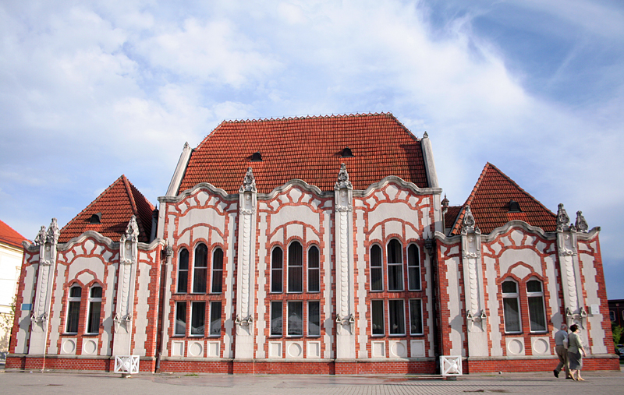
In the very centre of Čakovec there is one of the most representative and best preserved Secession buildings in Southeastern and Central Europe. By its architectural layout, which has been characterised as bizarre by many, it stands out from all other city buildings. Secession (also known as Art Nouveau in France, Jugendstil in Germany , or Art Deco in the USA) is an international style of art, architecture and applied arts. The Croats loaned the term from Austro-Hungarian terminology.
The building was built in 1904 as Trade Casino by a Hungarian architect, Ödön Lechner, who was a pioneer of the art movement. Namely, he combined contemporary trends of Art Nouveau and Jugendstil with Hungarian and Turkish folklore influences, including arabesque and floral motifs. The building was commissioned by a lawyer from Čakovec, Rudolf Wollak, a Hungarian Jew who moved to Čakovec contributing to its construction and the economic and social life of the city.
It was a gathering place for the middle classes, a new social stratum in Međimurje. Apart from a card room and a room for other parlour games, the building housed a special withdrawing room for ladies, a reading room and a dance room. For two decades, from 1966 to 1986, part of the building was used as a library and reading room. Since the end of World War II, the building has been better known as the headquarters of the trade union.

Migration and art

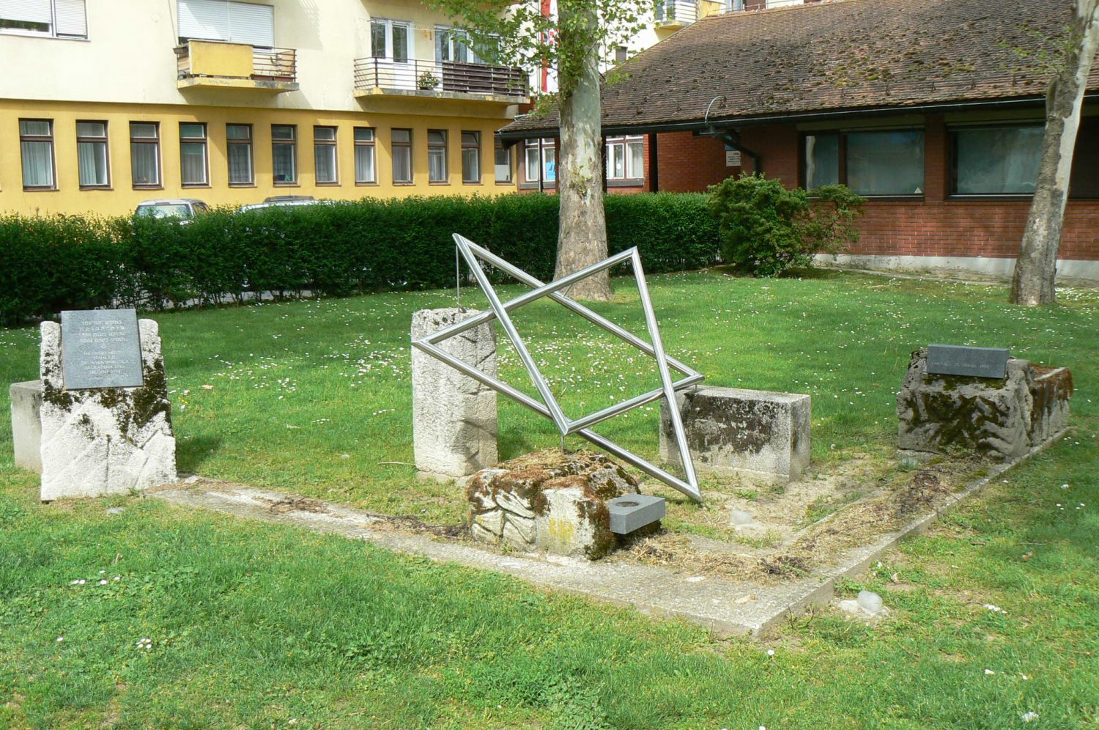

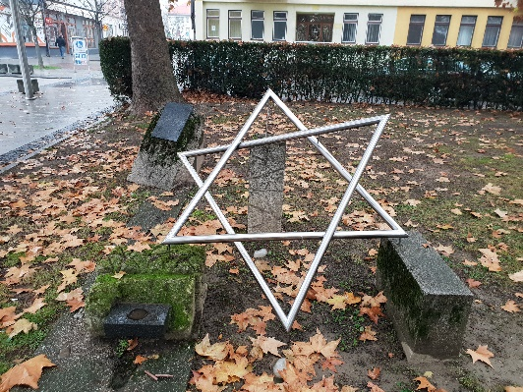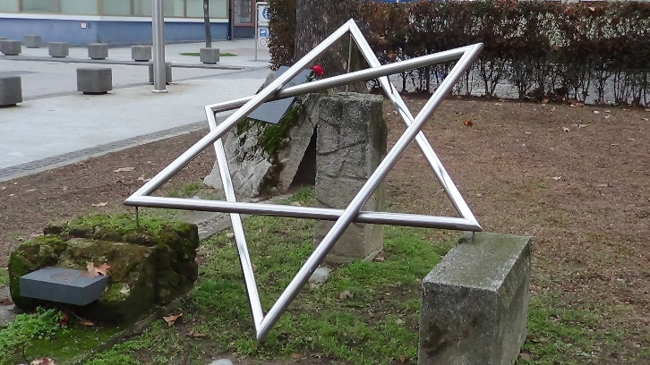
The first Jews in Čakovec are mentioned in 1796 . They were famous businessmen who opened workshops and factories, weaving mills and banks. Many famous factories, which are still successfully working today, were opened by Jews in the late 19th and the early 20th century.
The Jewish graveyard is the oldest part of the Čakovec graveyard.
The Star of David is a monument situated in the place where there used to be the old synagogue in Čakovec which was demolished in 1944 .

Migration and language II

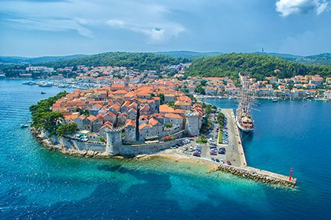
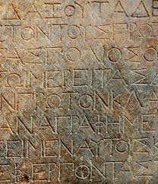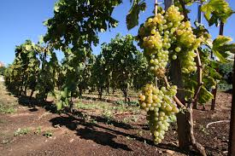
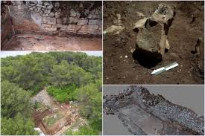
Since the third century BC to the present day, Lumbarda on the island of Korčula has been inextricably linked to its grape vine and its valuable wines. Grk (green grapes) and Plavac Mali (purple grapes) are the two dominant varieties. The Greek name is often linked with the ancient Greeks who first brought wine culture to the island of Korčula and laid the foundations for the now obviously very long tradition of wine-growing in Dalmatia in general. Namely, according to the legend, the island was inhabited by the Trojan hero Antenor in the 12th century BC and Korčula was a Greek colony called Korkyra Melaina, as evidenced by the Psefizm of Lumbarda, an ancient Greek historical document of epigraphic character from the 3rd century. It contains a decision regulating the property relations of Greek settlers in Korčula as well as a list of Greek settlers.

Migrations and language III
Međimurje County is located in the very north of Croatia. It shares its borders with Slovenia and Hungary, and the Austrian border is only 30 kilometers away. In the administrative sense, Međimurje had been, through its entire history, an integral part of the Hungarian Zala County. Only in small intervals of time on specific historical occasions Međimurje was under Croatian administration. Nevertheless, in spite of the enormous Hungarisation, especially in the second half of the 19th and early 20th centuries, Međimurje has remained the most compact Croatian area in the national sense and today its inhabitants are almost 96 percent Croatian. However, there are a lot of Hungarianisms in the language of this region which are in use in everyday communication and many of them do not sound foreign at all today. This is also borne out by the work of Đuro Blažeka, a linguist whose scientific paper deals with Hungarianisms in the speech of Goričan, a village in Međimurje.

Migrations and language III
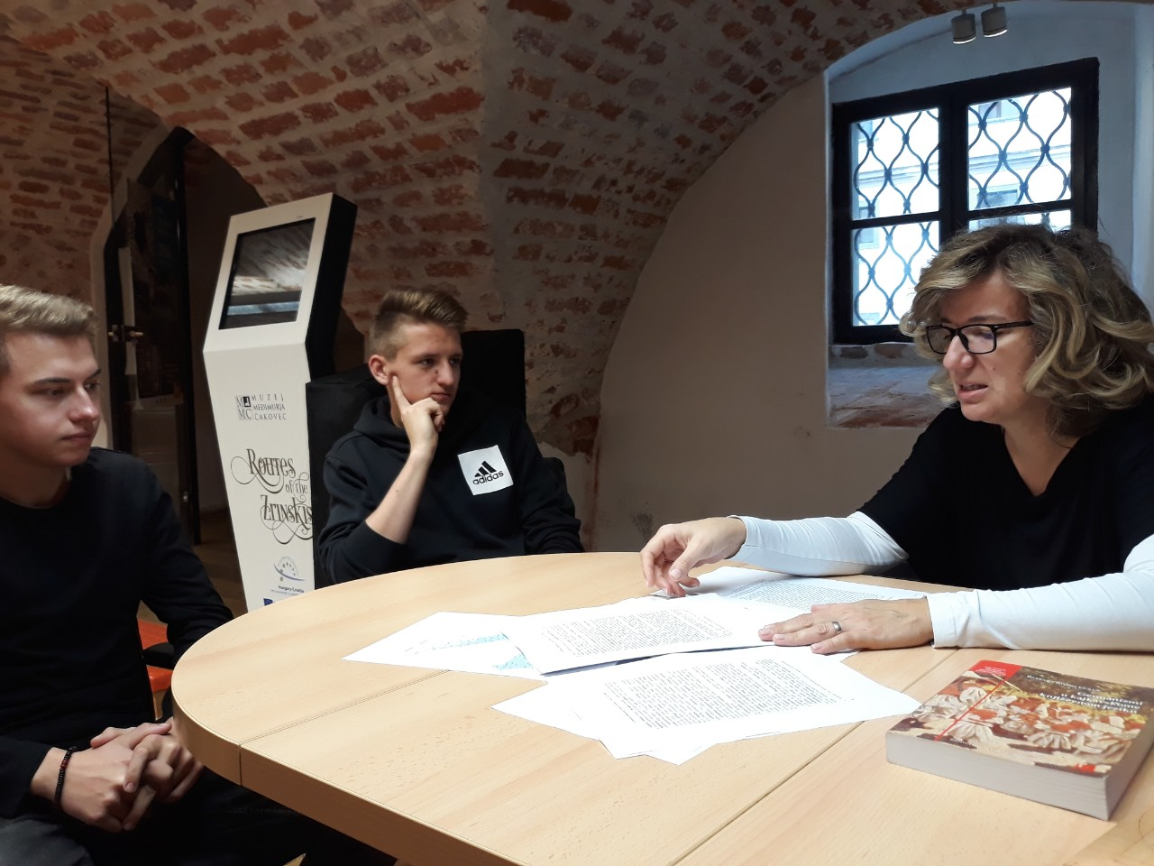
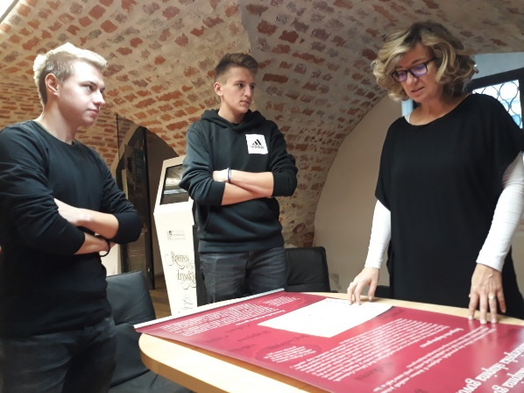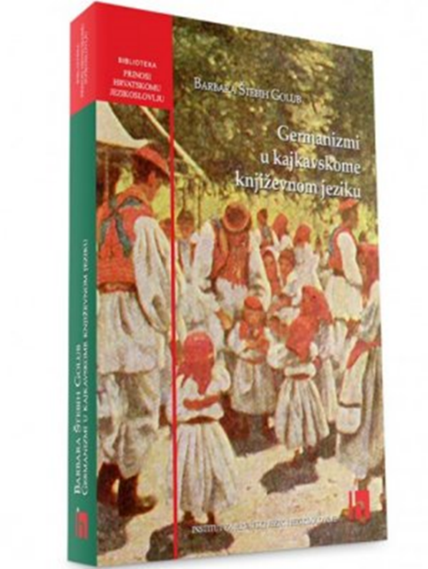
We visited the Museum of Međimurje for a conversation with Ines Virč, Ph.D., who explained why in our language or dialect there is such a large number of Germanisms. She presented to us the book of Barbara Štebih Golub The Germanisms in Kajkavian Literary Language, published by the Institute of Croatian Language and Linguistics.
According to Ines Virč, Ph.D., the significant influence of the German (Austrian) language in the northwestern part of Croatia occurred during the Reformation and Counter-Reformation due to rich translation of literature in the period. When there were no translation equivalents, German words were taken over. The act of entering a common state with Austria at the beginning of the 16th century, which lasted until 1918, made the influence of the German language greater and its use more widespread.
In more recent times, after World War II, there were migrations - many Croats went to Germany or Austria for economic reasons but also for political reasons. They had to communicate in German, and their children went to German schools. By having returned to their homeland, they also introduced Germanism into their own language. The last wave of migration began due to the Homeland War and the great economic crisis.
Thus, historical circumstances and economic migrations in the modern times have also influenced the language.

Migrations and art

Diocletian's Palace in Split was built at the turn of the 4th century during the reign of the Roman emperor Diocletian. After withdrawing from the throne in 305, he moved to the Palace and lived there until 316. After Diocletian's death, the Palace underwent numerous changes, but has remained brilliantly preserved ever since and is considered one of the most important Roman monuments in the world. It is particularly interesting that the area has been inhabited since then. It is a place where people live, a place which is constantly adapted to life, so it is still developing and changing.
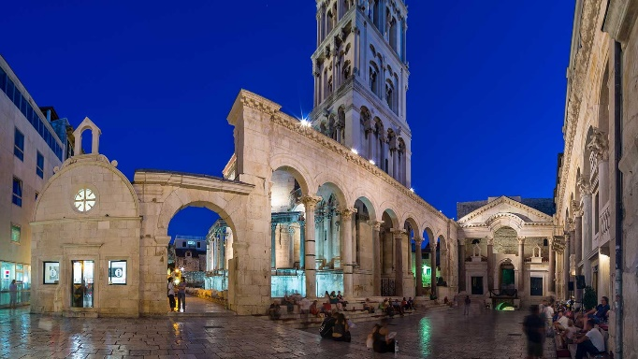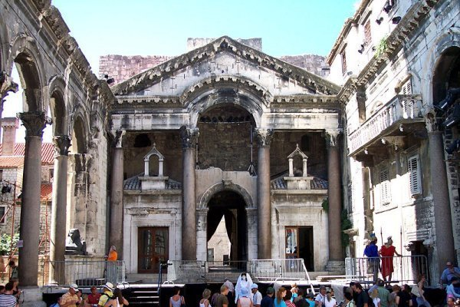
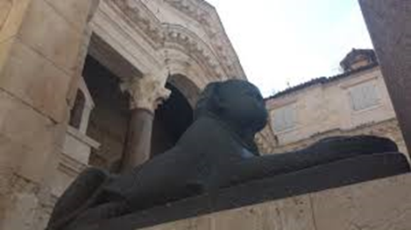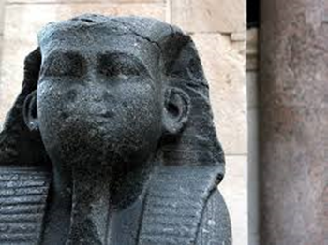

The beautiful Peristyle in Split is known primarily for the famous Cathedral of St.Domnius that dominates it. However, one detail attracts the attention of the passerby - the Egyptian sphinx on the west side of the church.
Of course, the question arises of how the sphinx got into the centre of Split. The answer should be sought in the period of the Diocletian's reign and the one immediately after it. Namely, Diocletian was considered a divine ruler, similar to pharaohs, and accordingly assumed their custom of putting sphinxes in front of the entrance to their last resting place.
As Diocletian's mausoleum was at the site of today's Cathedral of St. Domnius, so did the sphinx come to the Peristyle. It was probably not the only one, they might have been either in a pair or there might have been even four of them. In addition, there were more than ten sphinxes in Split and in different locations in the surrounding area at the time, but some were lost or severely damaged in the meantime so the one in the Peristyle remains the most representative specimen.

Migrations and architecture

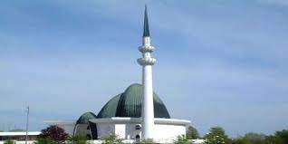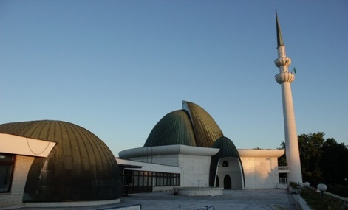
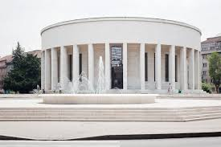
With the arrival of a large number of Islamic believers in Zagreb, after the founding of the Kingdom of SHS, in 1922 a muftiate, a high-ranking religious center, was established. The Zagreb Mufti raised the question of the construction of a mosque, but the issue was resolved in 1944 by rebuilding the House of Fine Arts, a project of world-renowned sculptor Ivan Meštrović from 1938, into the mosque along which Stjepan Planić and Zvonimir Požgaj raised three minarets. In 1948, by the decision of the city authorities, the mosque was moved out of the building, and the minarets were demolished.
The construction of the present mosque and the Islamic Center in Zagreb was completed in 1987. Sarajevo builders Džemal Čelić and Mirza Gološ built an architectural complex that occupies an area of ​​about 10,000 m². It is made up of several functional units: a mosque with a minaret (about 51 m high), Islamic high school (madrasa), library, common rooms, administrative building, residential and economic part.
Although its interior and exterior maintain a traditional layout and content, the architecture of this complex is in line with contemporary building design.

