Emigrants in our neighbourhood

Emigrations to Poland
Amount of emigrants increased over the last years. According to statistics in 2015 in Poland were living 218000 people of different nationalities. There are many reasons why people leave their countries, for instance: a war, a job or family. Sometimes we don’t realize that emigrants live in our neighbourhood.

A Chinese family in Poland
Thanks to our friend we had an opportunity to meet Lily, who was born in China, and her family. They live in Włoszczowa, a city which is located 55km from Końskie.
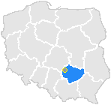

She agreed to answer us for a few questions.

Anna: Could you introduce yourself?
Lily: My name is Lily, my Chinese name is Zhao Li. I come from China and I have been living in Poland for four years. I live here with my husband and two children. My children go to school in Włoszczowa.

Weronika: Why have you decided to come to Poland?
L: I came to Poland, because my husband is Polish and my children, who were born in China, had to go to school. We decided to leave China when my children accepted Polish education.

Piotr: How do you feel here?
L: I feel very relaxed and happy.
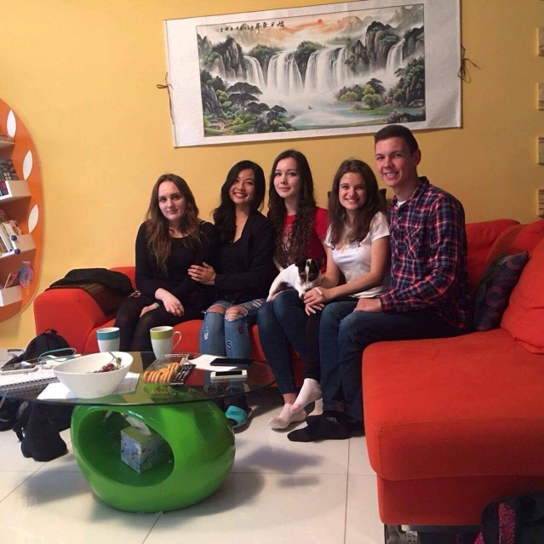
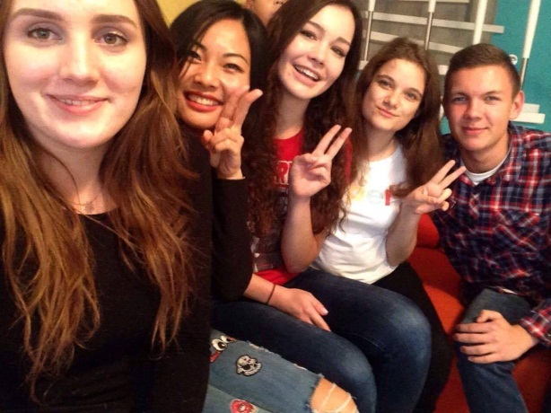

A: Was it hard to make yourself at home?
L: No, it wasn't very hard, because firstly, as I mentioned, my husband is a Polish guy. Secondly, I feel that Polish people are very friendly. The people who I met in my life in Poland were really nice and kind to me. I feel that here is my second home.

W: Is it something that you didn’t expect in Poland?
L: There was something which I really couldn’t expect in Poland. When I wanted to go to the hairdresser's, I had to make a phone call to make an appointment. If I hadn't done it a few days earlier, I couldn't get my hair cut, because they were busy. This was totally different from China. We have more hairdresser's in China, and more people who provide the service, therefore I had never had to make an appointment. Now I used to do it and I always call when I want to have my or my children’s hair cut.

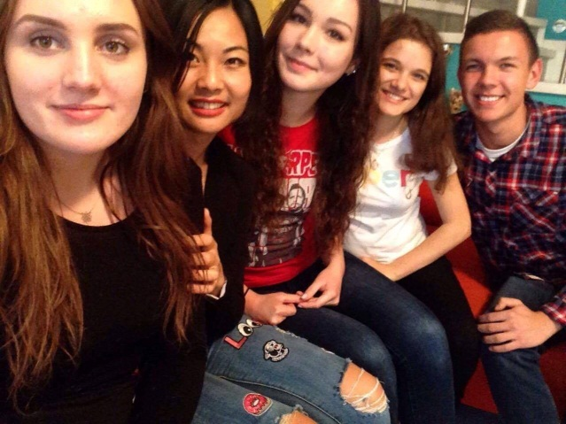
P: Włoszczowa is a small city, but in China you lived in bigger city, didn’t you?
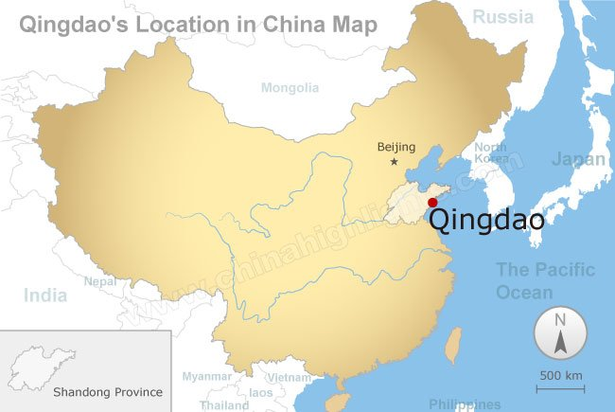
L: Yes, I lived in a kind of big city, Qingdao. We have a significant amount of big cities, because, as you know, our population is numerous.

A: What do you like the most in our country?
L: I like the most in this country that we are really close to nature. Forests and nice views in autumn make me feel relaxed. I don’t feel any pressure.

W: Someday, do you want to learn Polish language perfectly?
L: Yes, I would like to, because I want to help my children with their lessons. I haven’t got any problems with daily communication with people, but I think it would be great to improve it.

P: Thank you for this interview.
L: You’re welcome. It was a pleasure.

Authors:
Anna Głąbała
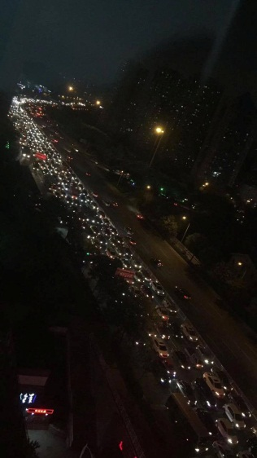
Weronika Muskała
View from Lily's
house in Qingdao.
Piotr Pawlik
II Liceum Ogólnokształcące
im. Marii Skłodowskiej - Curie
in Końskie
Poland

