Lithuanian-Belarusian border in Norviliškės

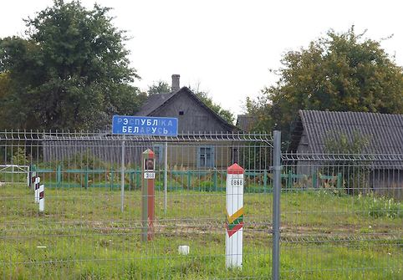
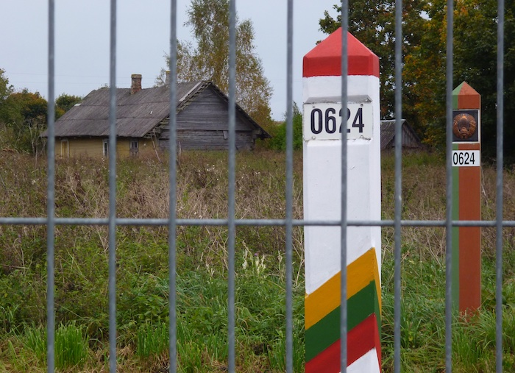

When both Lithuania and Belarus declared independence from the Soviet Union, the formerly internal administrative line became an international border and when Lithuania joined the European Union in 2004, the 677-kilometre stretch became part of the external EU and later Schengen Area border, obliging both states to step up smuggling and illegal migration control.
There is a village that is separated by that border - it is half in Lithuania(called Norviliškės), half in Belarus (called Piatskūny) and that causes some problems: firstly, in order to come to Lithuania, border-zone Belarusian inhabitants must first travel more than 100 kilometers to the nearest Lithuanian Consulate in Grodno, wait in a long queue, then return later to collect their visa, cross the border at a designated checkpoint, and return to their own village – only called Norviliškės on this side. Secondly, the church of Norviliškės stands on the Lithuanian side, while Belarusians can freely come here only three times a year – on Easter, Christmas, and All Saints' Day.

