

**Iga Aleksandrowicz has been our classmate for about a month. She came from England to Poland last year so she’s a migrant and we want to know more about her lifestyle there and here. We’re going to interview her.**

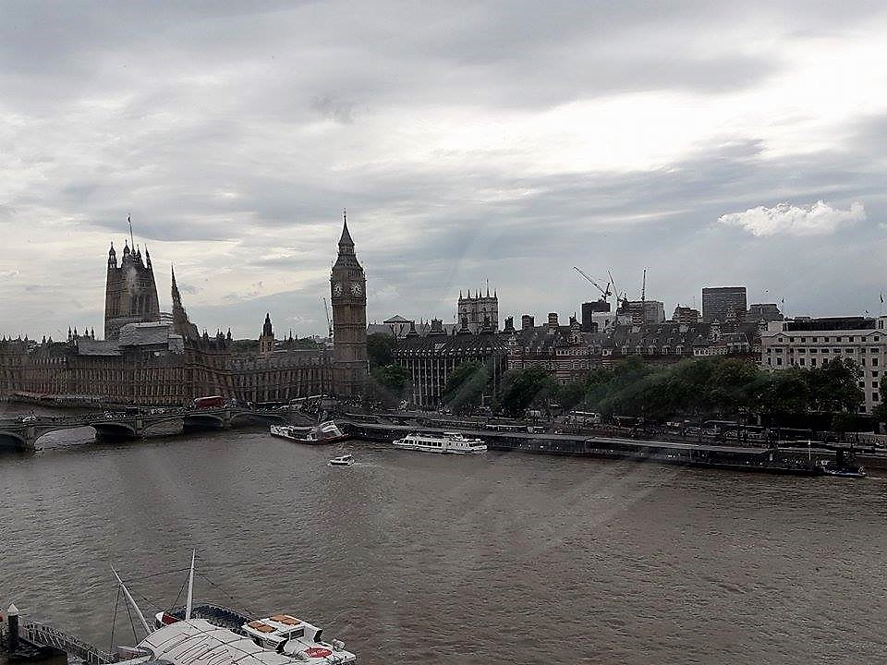

**Why did you and your family come to Poland ?**

*Because my mum really missed Poland and her family. We decided it was a perfect time to come back as I finished high school and my siblings finished primary school.*

**What do you like the most about living in Poland?**

*I like being in Poland because I’m closer to my family and I just feel more free.*

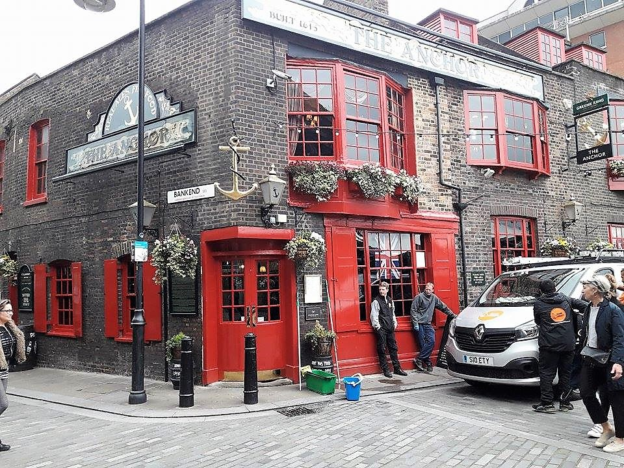

**What are the biggest differences between living in London and Poland?**

*There are many differences but mainly schools differ, or for example, people in London don’t really know what real winter is like.*

**Do you prefer living here now? Or maybe you would like come back to England?**

*I like being here and I would be really unhappy if I had to go back*.

**Have you noticed something special about Polish people’s behaviour?**

*I knew some of Polish culture so nothing suprised me*.

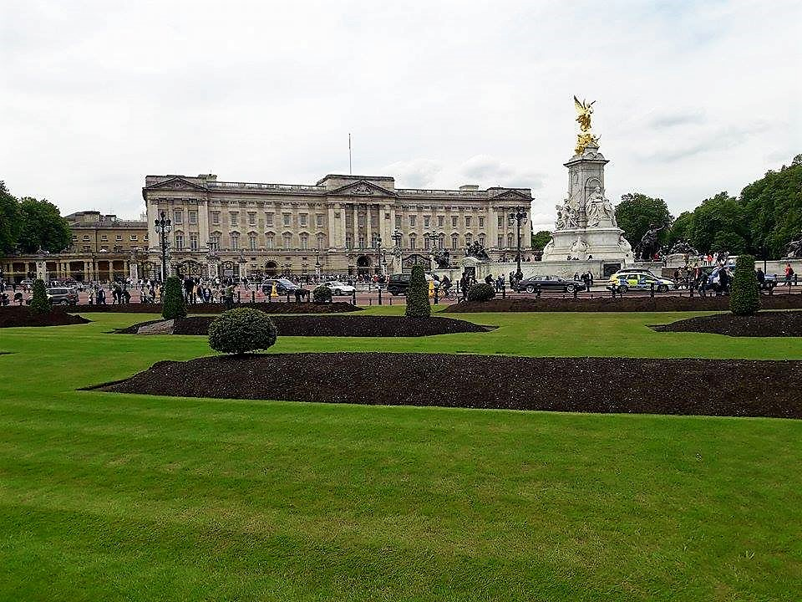

**Was it hard for you to fit in new environment?**

*Not really because I had contact with Polish friends while I lived in London. But there still is a huge difference in learning between me and my friends.*

**How did your siblings accept the fact about leaving?**

*My sister was really happy unlike my brother who was terrified but actually he doesn’t like changes.*

**Did you leave something or somebody?**

*No, all my family came here with me but sometimes I just miss my friends from London.*

**How were you feeling when your parents told you about leaving the country?**

*I was really happy and excited as I really wanted to move back. I have family here and I was here many times before the moving. I always feel good in this place.*

**What did you have to change in your behaviour when you came to Poland?**

*I didn’t really have to change anything.*

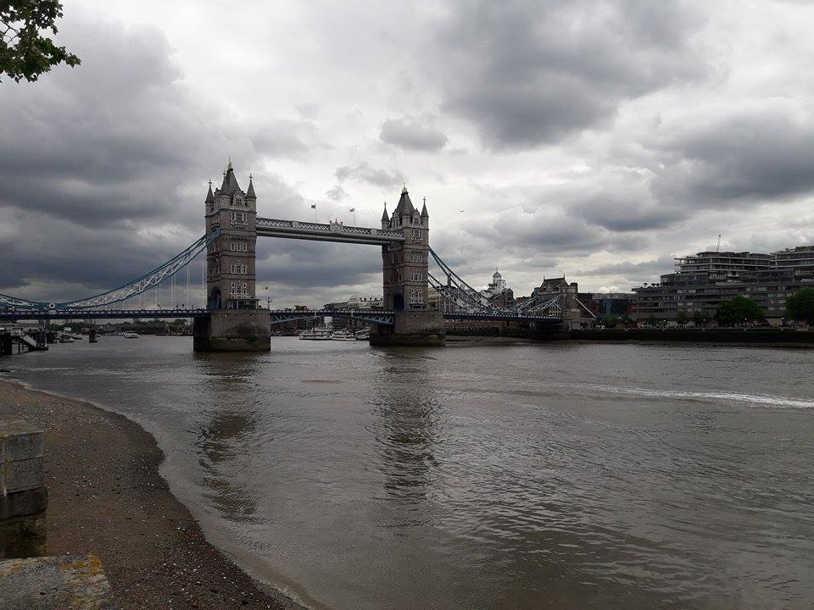

**And the last question - what do you miss the most?**

*I miss the fact that there was a lot going on and that wherever I went there were things I needed, unlike here where even in a small city I can’t really buy what I like.*

**Ok, that’s all, thank you very much, bye!**

*No problem, bye!*

**

**By Julia Kamińska, Julia Kwiecień, Dominika Majchrzak 1C1**