Croatia Meeting
Portuguese Team

- Second task:

The Wall between USA and Mexico

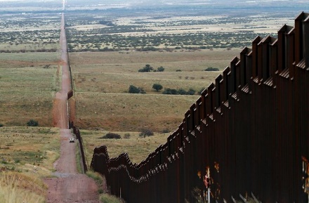
http://www.radiomigrantes-es.net/userfil 1

In 1994, small barriers started being constructed with the aim of reducing the transport of illegal drugs and immigration.
When Donald Trump was ellected ,and even during his presidential campaign,
he wanted to build a wall with much larger dimensions than the barriers that existed on the border between the US and Mexico. He intended to build this wall to monitor immigration very strictly.
In 2018, the huge wall started being constructed.
This wall makes it very difficult to enter the country and it became one more obstacle that many migrants have to get through.
This can also be a problem for some species since it can cut natural migration routes.

