LEYEND OF MAGACELA CASTLE:
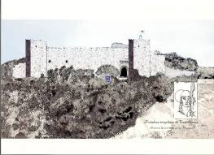
During the Reconquista, the Christians attacked a Moorish fortress in Extremadura. This fortress was ruled by the Moorish governor Ahmed-Ben-Ali, whose daughter, Leila, was famous for its beauty and value. In one of the raids of Christians, led by Arias Perez, Ben-Ali dies, even before her daughter entrusted the defense of the castle, she swears. Battles continued until Arias Perez decided to take the castle by surprise and caught unsuspecting Arabs. Leila, who was having dinner, shouted "Bitter dinner for me!" She launched into combat, but she was defeated, and before a Christian gentleman could capture her, she died with her own dagger, and the castle was taken by Cristians. The name of Magacela is from "bitter dinner".

By Nacho, 5th Grade

LEYEND OF MONFRAGÜE CASTLE:
The tower’s owner was the earl Don Julián. Florinda la Cava took refuge there after to be dishonoured by the Goth King Don Rodrigo and her son stay haunted in it. It is told that the prince kidnaps children who cross the place and they disappear, because he wants to form an army with all the children to recover the kingdom.
By Rubén, 6th Grade

LEYEND OF OROPESA CASTLE:
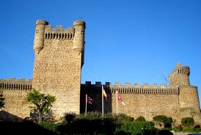
A lady was rescued by the Templars of the power of the Moors, who were captive in the fortress, providing for her as much gold as she weighed (‘gold weigh’)

LEYEND OF ZAFRA CASTLE:
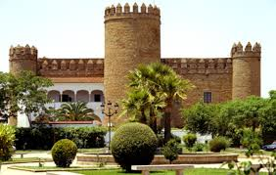
The knight Mendo Méndez Peláez (it is called Bigotes’) goberned Zafra in 1460. He lived in a castle. That summer was very hot and the springs flowed , only castle fountains had fresh water. A morning in August a gypsy woman went to the castle to fill a pitcher, but she was surprised by the guard and she was brought to Mendo.
-How dare you enter the castle for steal water, poor gypsy?
The woman cried and replied:
-Forgive me, my lord, my mother is dying of thirst and water jug is for her.
But the lord of the castle was not moved by the woman's request and ordered the pitcher on air suggest and every piece to reach the ground was a whip for the gypsy as punishment for having broken into the castle. The pitcher broke into seven pieces, so the woman received seven lashes, and then was expelled from the square. When she was leaving she looked at Mendo and cursed him:
- Seven pieces, seven! The seven days of the week! Today is Tuesday, I wait for next Tuesday! So much water will have, which will sail in it, damn!
Next morning, Mendo got up with a high flu that was increasing day by day. His health got worse until he died next Monday. On Tuesday, his body was exposed in one of the rooms of the castle, and it was a strong storm, in a few hours all the dependencies flooded and some of the town's streets. The coffin containing the governor floated and moved through the village, reaching a waterfall where he got stuck. At that time, the family and soldiers saw the image of the gypsy who shouted:
-My curse is fulfilled. So much water will have to be sailing in it, damn! Sink!
The gypsy disappeared and the coffin of Mendo was lost.

By Piluca, 6th Grade

