EXTİNCT
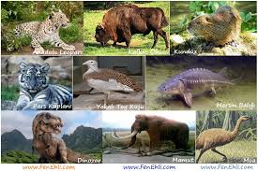

The number of exting animals is too much to think. Many species have been extininct for many reasosns, such as natural disasters, climate or earth changes. As a natural balance of the world , the disappearance of some living things is a natural result. However,due tol the cehuman factor, the deterior a tion of the natural balance has led to the extintion of many living species due to the human factor. Many species have come to an end as a result of direct hunting.
Beyza ÇOLPAN
Sevde BAYGÖNÜL

