In the sport sector, gender equality it is a given in most countries but women will still face gender inequality problems.
It is harder for a woman to make a carrier or get a job in the sport sector than a man. Because they are still looked down on and most men don’t see women as equals.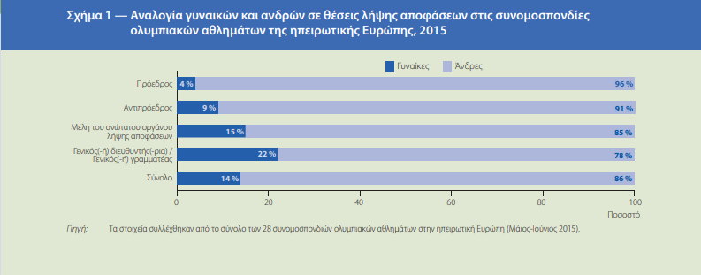 In the picture above we see the Proportion of women and men in decision-making positions in continental European Olympic sports federations in 2015.
In the first column, we see in the president position there are only 4% women and 96% men
In the second column, we see in the vice president position there are only 9% women and 91% men
In the third column, we see in the Members of the highest decision-making body there are 15% women and 85% men
In the fourth column, we see in the General Manager / General Secretary Position there are 22% women and 78% men
And in total there are 14% women and 86% men in decision-making positions. That goes to show how underrated women are and how unequal will the pay be if the percentage of women working in the sport sector is this low. (Source: Data collected from a total of 28 Olympic sports confederations in mainland Europe )
Women face as a form of gender inequality sexual abuse, for example Sofia Bekatorou, a famous Greek Olympian sailor, recently came out on television saying that in 1998 got raped by the vice president of the Hellenic Sailing Federation, Aristides Adamopoulos, after a dinner with the mission.
It took 22 years for her to make it public, but who can say something about that? If another girl was in her position, would she denounce it at the same time? A young girl was then Bekatorou, an athlete who loved the sea and her sport, when, Aristides Adamopoulos attacked her. That goes to show how underrated and badly treated women athletes are, feeling threatened by speaking out on the inequalities they are facing, especially the young ones that can’t speak out because they fear the consequences.

