Gender Inequality In Politics
Ivanidis Kostas (Greece)

What do we know?
Gender equality in politics is knows as something mandated, the sad fact is that it is not. Everyone knows that women are not treated equally in politics, but everyone simply overlooks this fact.
Women are discriminated by not being given a perspective in politics even though a lot of women could be better in politics than a big percentage of men politics at the moment.
It is historically shown that women were discriminated in politics since ancient years. For instance, in ancient Greece women were hardly considered as citizens and were not allowed to take part in politics and not only in ancient Greece.
-In short politics and society nowadays are showing us something that can be shown with the picture below:

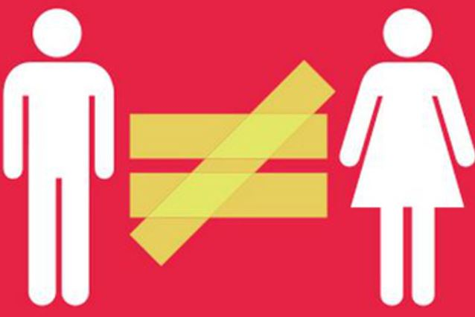

Situation in Greece
To begin with Greece is a parliamentary representative democratic republic which is where the president is the head of the state and PM of Greece is the head of the government within a multiparty system of 300 politics.
Parliament of Greece also known as (βουλή) consist of 300 politics and this is the field where most of gender discrimination happens.
Since 1822 when the first PM of Greece( Alexandros Maurokordatos ) was elected until today 2021 there have been no woman elected on this post. More specifically there were no women among the 99 last PMs of Greece which gives us a ridiculous percentage of 0% . There was never a woman in the post of PM neither in the post of President in Greece
Source:(el.wikipedia.org/wiki/Κατάλογος_πορθυπουργών_της_Ελλάδας)
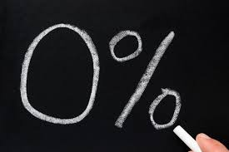

Percentage of Women in Politics
Women in Greek parliament hold a 19.6% percentage which means there are only 62 women among 300 men, which is the lowest number of women in a government system in whole Europe, it is even bellow the Europe's average.
Here is a representation of women in Greek political parties :
(black bar disbanded :considered as criminal organization)
Source:( https://www.iefimerida.gr/ekloges/boyli-mono-62-gynaikes-ehoyn-eklegei)
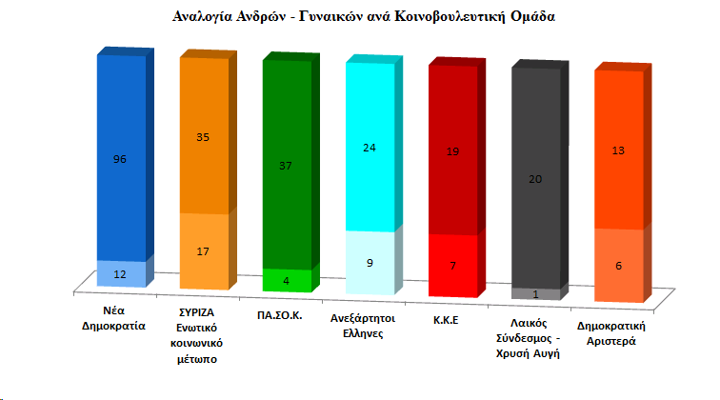

How does it feels?
In an article published on doctv.gr on 19th July 2019 were mentioned the words of Fotini Kuvela who lost hope in gender equality in Greek system so she ended up quitting her post stating that the government decreases rapidly the equality between men and women as concerning politics.
It is very sad to hear about situations like Kuvela's in 2021
Source:( https://www.doctv.gr/page.aspx?itemID=SPG13281)

Will things change ?
To my mind Greece will come to a stability soon , especially when generation Z ,my generation, will get to politic slots .we are thought to be more open minded and strive for equality and freedom of choice. Greece will have a bright future despite the discrimination that is happening at the moment towards women .
source: none

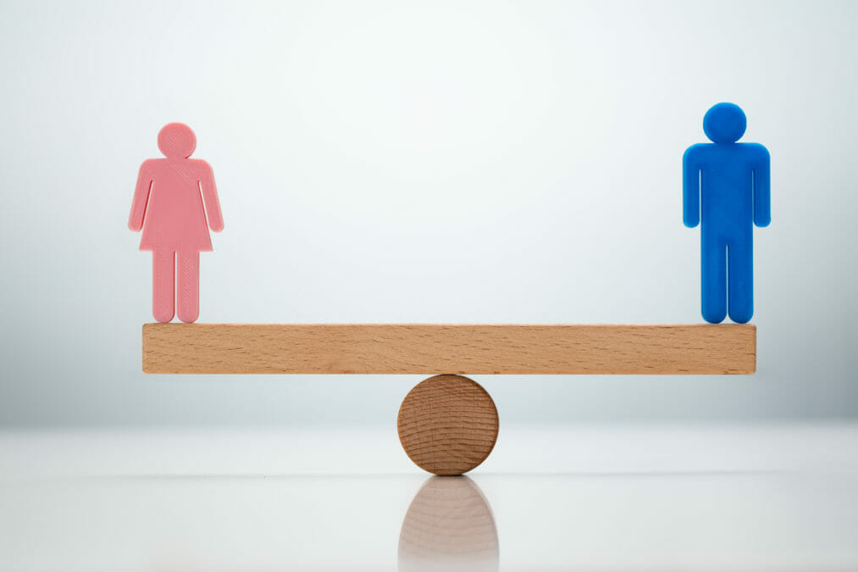

More Percentages !?
It is sad to compare the percentages below with the percentage of Greece, because by looking at those statistics it is apparent that even thought equality is a given some people cannot simply understand it, women have to be treated equally in every situation and field.

source:( https://www.doctv.gr/page.aspx?itemID=SPG13281)
Sweden | 46.7%
Finland | 41.5%
Belgium/Spain | 39.5%
Austria | 36.5%
Portugal | 36.4%
Denmark | 36.3%
Italy | 35.3%
Germany | 33.8%

Netherlands | 31.4%
Latvia | 31%

Conclusion
All things considered , gender inequality in politics in Greece is not something rare and it can be seen to the naked eye by just looking up some statistics on the Internet. However , nothing is lost yet and things will change with the raise of the new generation .Women in Greek politics play a small in amount but yet as important roles, most of the women that were not able to get into the Parliament could be very good politics and could achieve a lot for my country but sadly that will not happen yet. I wish women were equal with men in my country and I hope that one day I will contribute to this 'Dream' becoming a reality.
Eventually , we all have to help so that women will be finally treated equally , I hope one day everyone will have in mind that we all have:
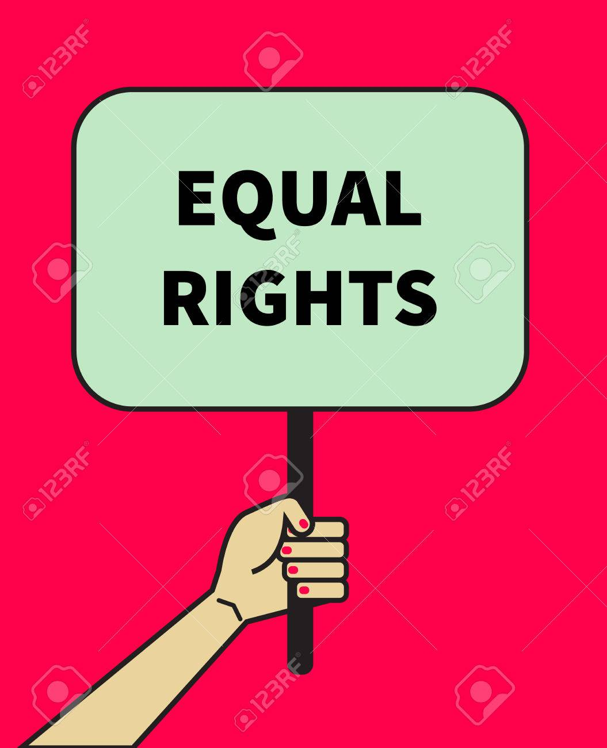

The End
Ivanidis Konstantinos (Greece)
I hope my presentation will give you a taste of what Greek government is about and how women are treated according to the statistics and the everyday life and events I have seen or experienced here. I hope one day women from all countries and continents will not be outweighed by men in any way neither do I want to opposite , I am simply dreaming of a world where everyone is equal and everyone has the same opportunities in any field either its Medicine , Politics, Media etc.

Thank you for reading !

