Cultural Heritage of Project Partners

Belgium

Adolph Sax was born in Belgium . He was the musical instruments maker and the inventor of saxophone. Belgium has a very active jazz scene.
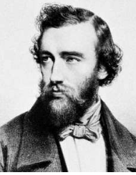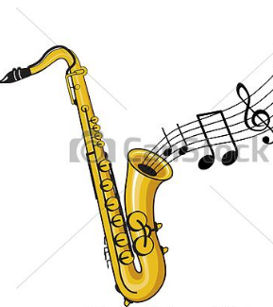

Gilles Binochois is one of the three most famous composers in the 15th century.
https://www.youtube.com/watch?v=tREK3qOoAx8
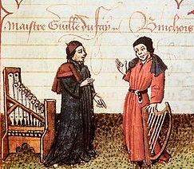

ITALY
Festivals –horse racing, jousting, medieval traditions
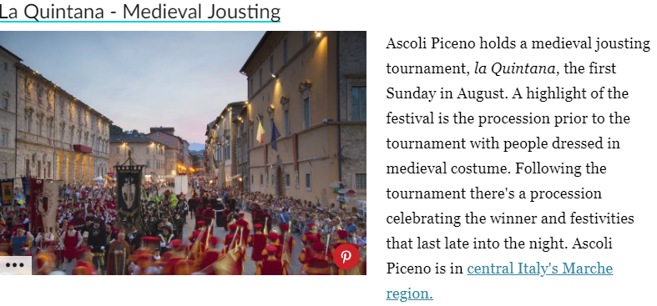
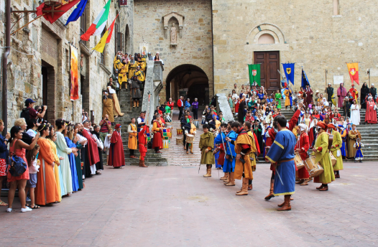

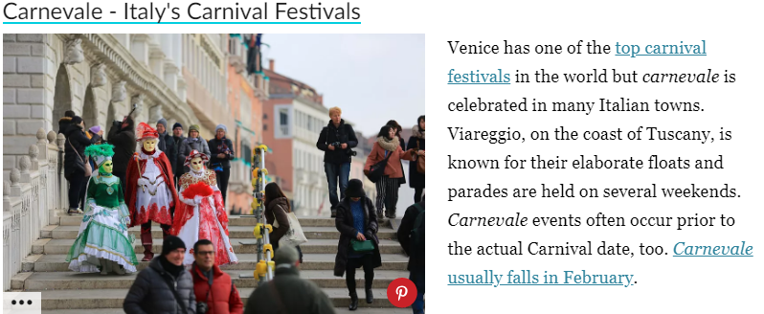

ART
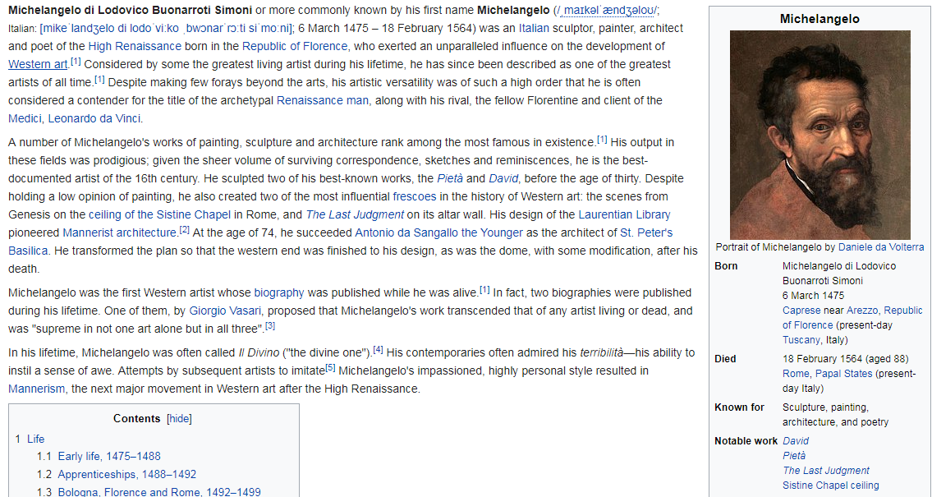

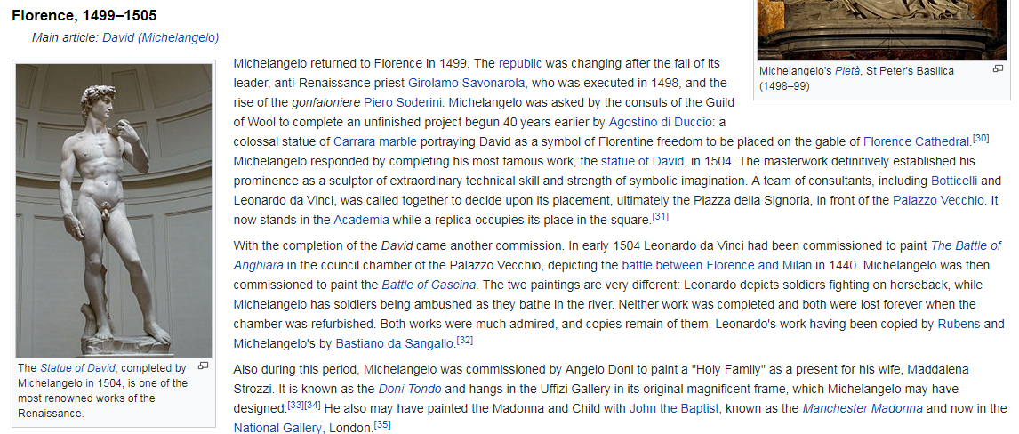
Creation of Adam, Michelangelo
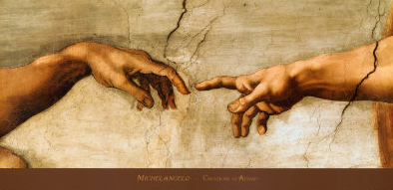

Last Supper , Michelangelo
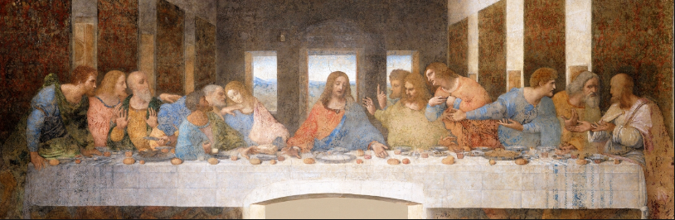

Paul Cezanne, Card players
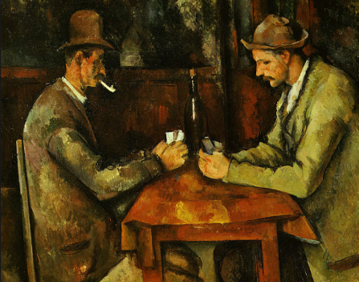

Girl with a peral earing., Johaness Vermeer
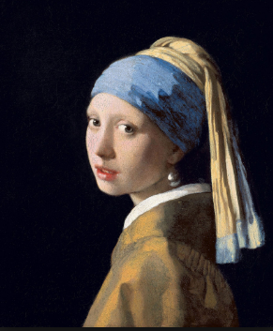

GREEK ART
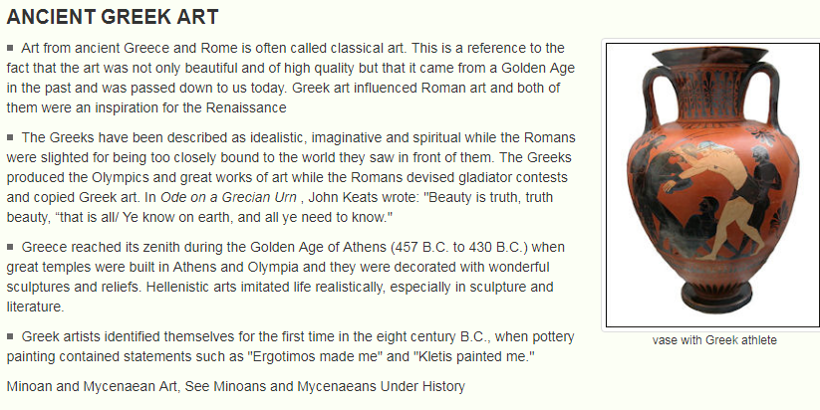

ACROPOLIS
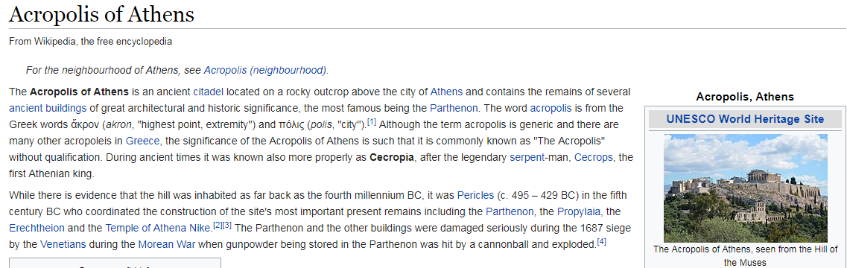

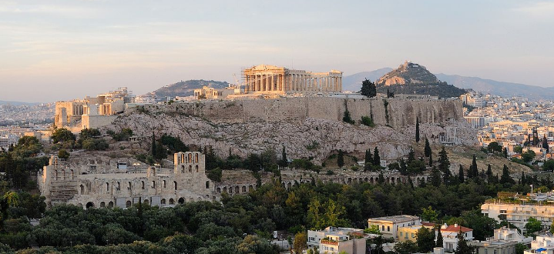
Greek salad

Tzatziki salad
Moussaka
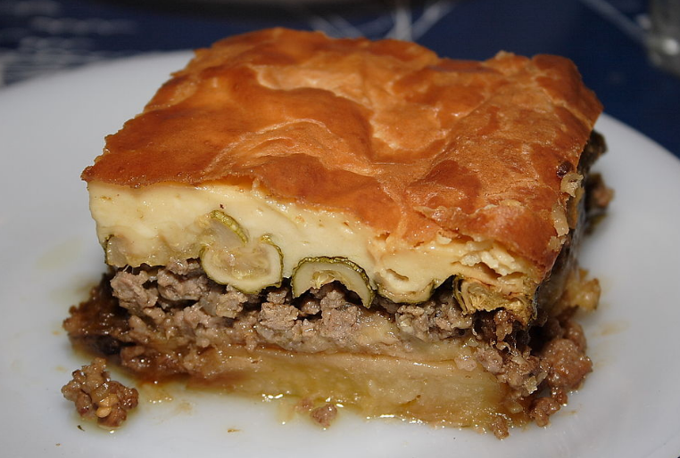
Sistine Chapel - Vatikan