GingerBread

The first mention comes from Egypt where gingerbread was found in

pyramids but in Europe the first mention appeared in 14th century.

The original recipe contained only three ingredients: honey, flour and pepper so in the Czech Republic the gingerbread got its name after pepper. As time went on people improved the recipe.

At the time of Charles IV many people who made gingerbread came to Bohemia so the gingerbread was very popular.

Gingerbread was sold in stores but also in fairs. Today gingerbread is mainly Christmas or Easter candy.

The most famous city in the Czech Republic in which gingerbread is baked is Pardubice.

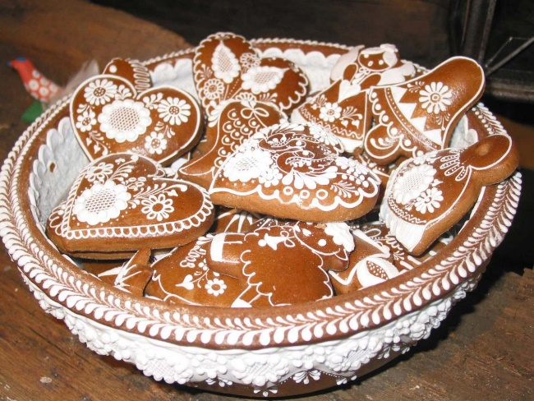

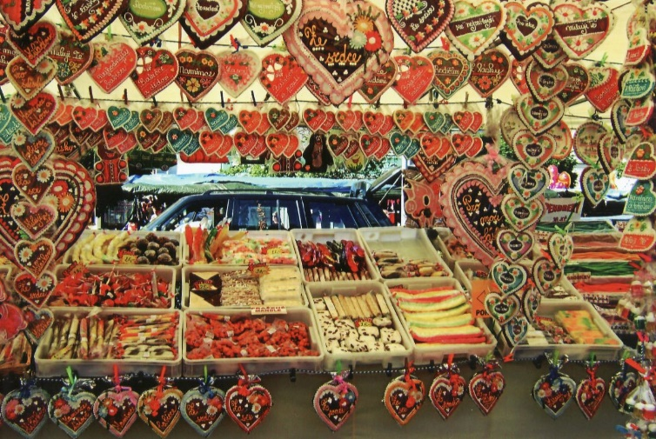

**Gingerbread**

**Ingredients:**

**Dough Icing**

|  |  |
| --- | --- |
| 50 g | butter |
| 650 g | flour |
| 7 spoons | milk |
| 250 g | icing sugar |
| 4 | yolks |
| 150 g | honey | |
| 2 tsp | gingerbread seasoning |
| 2 tsp | bicarbonate of soda |

|  |  |
| --- | --- |
| 170 g | icing sugar |
| 1 | egg white |

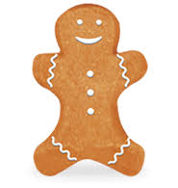

**Instructions - dough**

1. Put flour, sugar, soda and gingerbread seasoning into a bowl. Stir it and add butter, yolks, honey and milk.

2. Tip the dough out and knead until smooth. Wrap it in a cling film and leave to chill in the fridge for 15 minutes.

3. Preheat the oven to 170°C.

4. Roll the dough out to a 0.5cm in thickness on a lightly floured desk. Use cutters and cut out different shapes. Place them on the baking tray and leave a gap between them.

5. Smear shapes with yolk or milk and bake for 10-12 minutes or until they are lightly golden-brown.

**Instructions -icing**

1. Stir sugar with glair until sugar melts.

2. Pour it into a piping bag and get creative with decorating.