|  |  |
| --- | --- |
| ***Torta Rustica ABRUZZESE*** | SUMMARY  This document describes the typical recipe of the Abruzzo rustic cake, from the ingredients to the procedures.  Federico Dell'Elce |

 ***Torta Rustica ABRUZZESE***

Ingredients

For the base are used:

* 300 gr of fiadone base dough (alternatively you can use a disc of brisee pastry or a disc of puff pastry)

For the filling:

* 150 gr of grated Grana Padano
* 150 gr of grated rigatino
* 50 gr of grated pecorino
* 2 medium eggs
* 2 dry sausages in oil (you can add any other cured meat of your choice in the absence of these)
* a pinch of pepper
* a grated lemon
* 1/2 teaspoon of baking powder

The tradition of the Easter holidays in our Abruzzo wants that on the Easter day breakfast table there is the delicious rustic Abruzzese cake.

The rustic cake was born from the need to use the dough or the filling leftover from the fiadoni.

When precision scales did not exist yet, grandmothers dosed the quantities by eye, and it is not yet known how with their skills they bordered on a precision worthy of a modern electronic instrument.

Sometimes, however, it happened that some ingredients were leftover and the rustic cakes thus became a natural consequence so as not to waste anything!

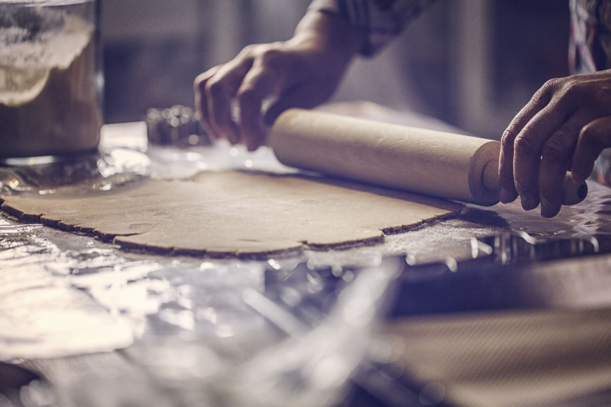 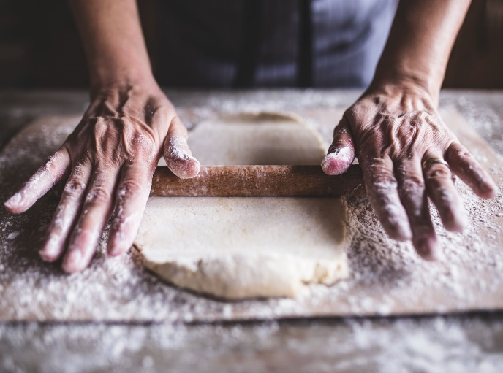

Directions

For the rustic cake, roll out the dough with a rolling pin or with a machine (after leaving a piece for the decorations), giving it a height of approximately 2/3 mm.

We advise you not to make it too thin, otherwise, it risks breaking!

Roll it out in a small mold, after having oiled it well (we used a 15 cm diameter mold).

For the filling, instead, beat the foam eggs well and then add them, a little at a time, to the two grated slices of cheese.

Add the pepper, the grated lemon zest, and the sifted yeast.

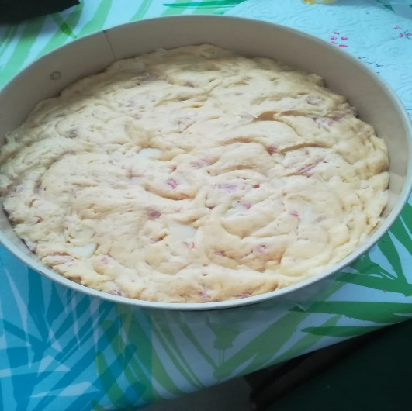The filling must be fairly consistent and not too soft.

Cut the sausages into cubes or thin slices, and add them to the cheeses.

Now spread the filling on the ready-made base, level it well, and then decorate the surface with the strips cut out with the pulley, adjusted as a weave.

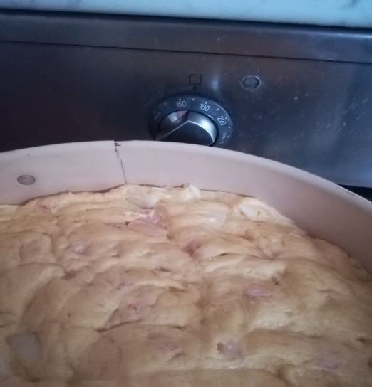Brush the strips with beaten egg and then bake at 170 degrees for approximately 35 minutes, until the surface is golden and the filling is golden brown.

Turn off and let cool in the oven.

You can enjoy the rustic cake on Easter day, if you ever prepare it in advance, remembering that it can be kept at room temperature (suitably covered with a cotton cloth), even for two days.

