What are the three biggest employers in your area? (and their field of activity)
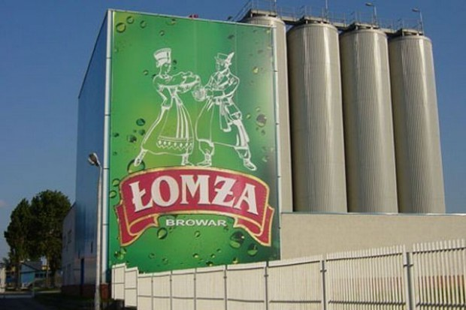 Łomża Brewery
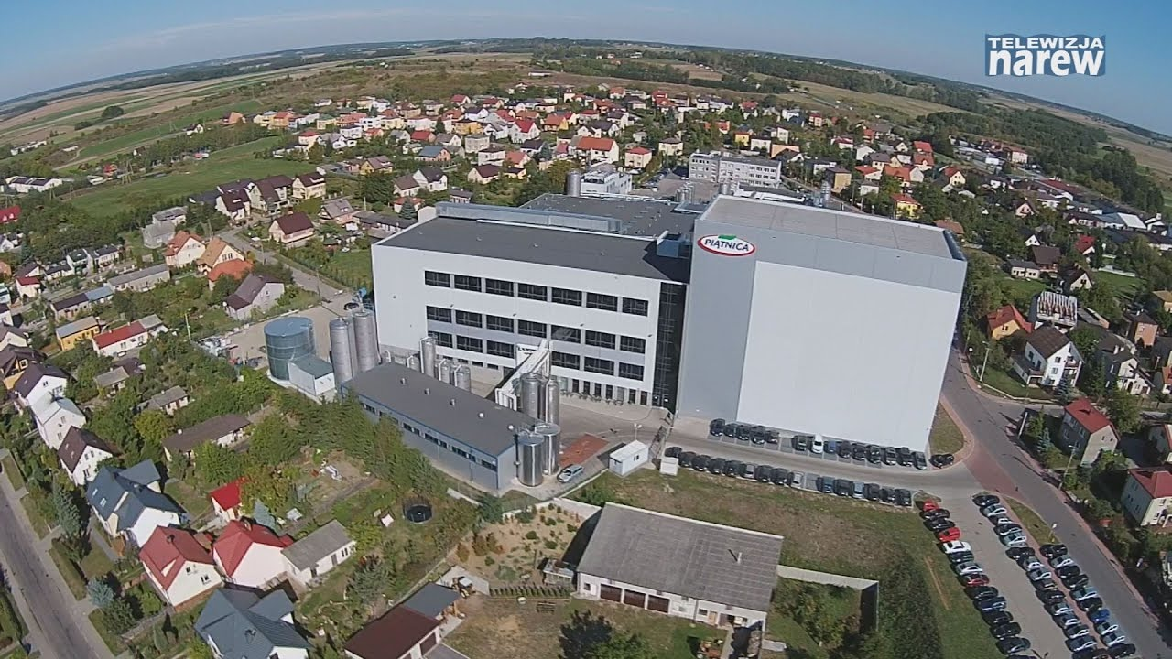

Piątnica Dairy

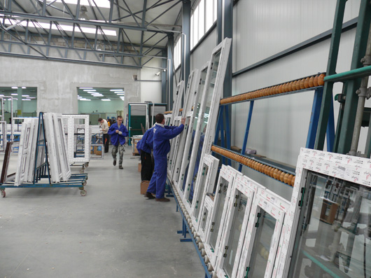
Sonarol Windows Production in Jedwabne
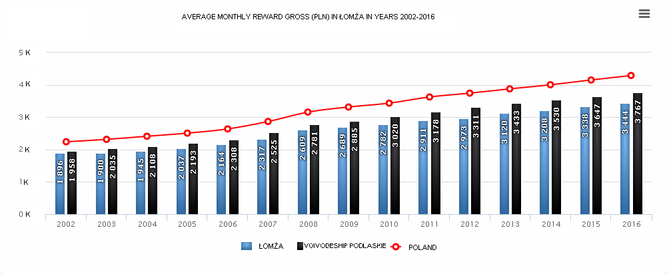
-How many local employees are working for them?
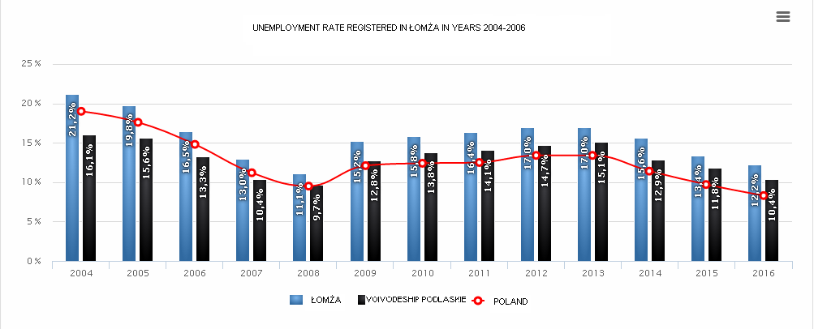
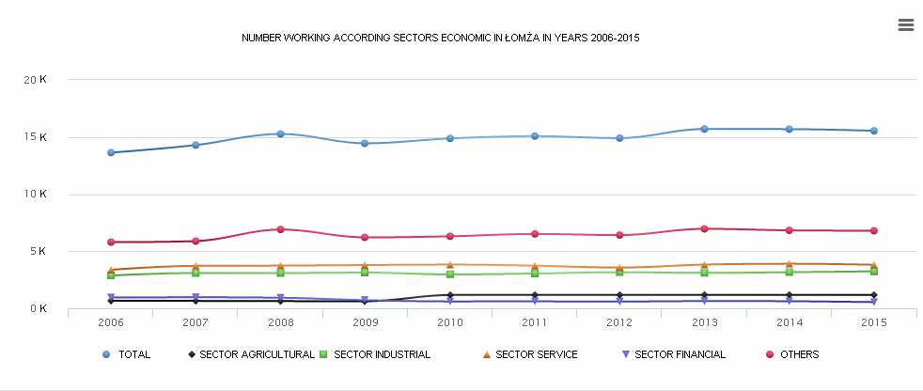

Make a pie chart showing the % of the employees in primary, secondary and tertiary industries in your urban area (or, if not avaible, your region).Give local examples of jobs or activities.
examples:
- primary industry
- husbandry
- fishing
- forestry
- secondary industry
- construction
- manufacture
- tertiary industry
- trafficking
- transport
- insurance
- education
What agricultural crops?(with pictures)
-rye
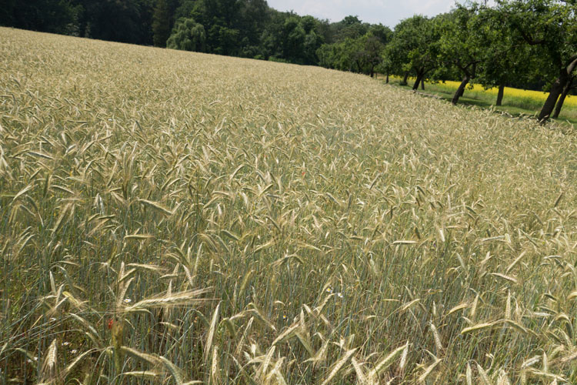
-wheat
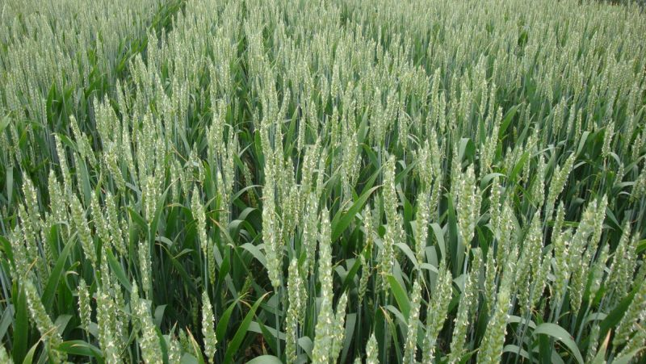

-oat

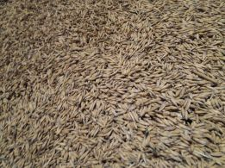

-grass
-maize
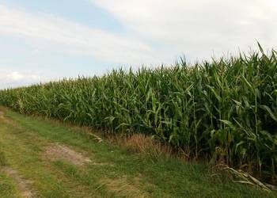
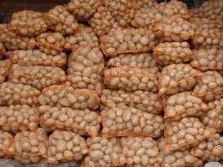
-potatoes

-What industries?(with pictures)
The largest industrial companies in Łomża

1.PEPEES S.A. based in Łomża, it is the largest starch potato processing plant in Poland and the only domestic producer of crystalline glucose.
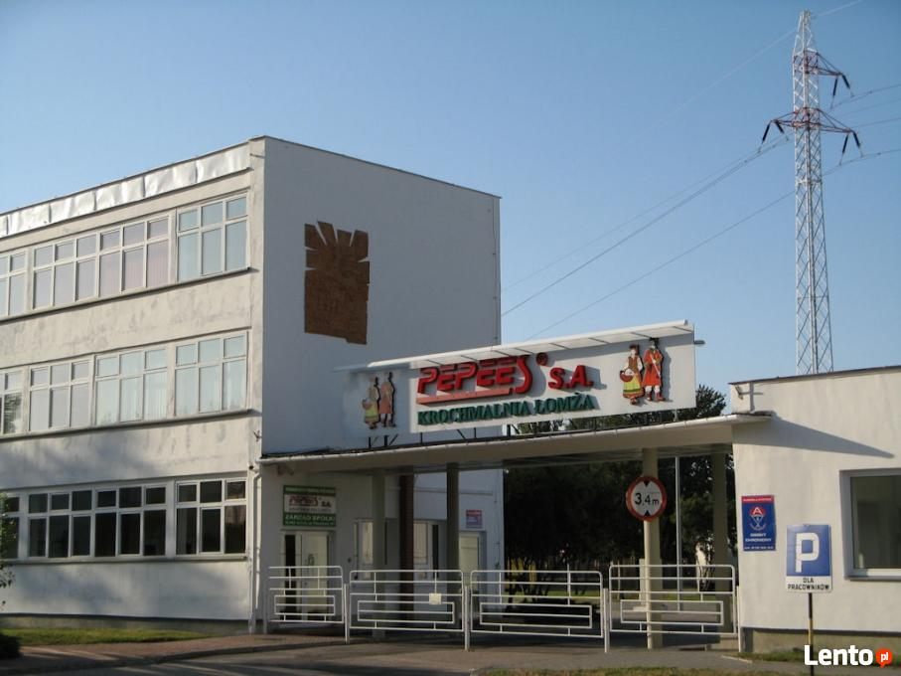

2. WHOLESALE DW DOMEL is one of the largest specialist companies dealing in the sale of internal doors, entrance doors, technical doors and garage gates and drives and accessories related to the above-mentioned joinery products.

3.PPHU GEAL S.C Joinery company. GEAL offers a wide range of products: PVC windows, wooden windows, entrance doors, internal doors, technical doors, garage gates, reloading technology, door drives, door handles, window sills and other goods complementing window and door woodwork.

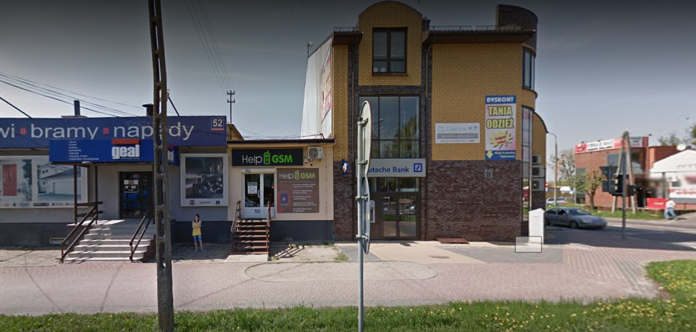
-Average yearly income (in Euros)How many tourists per year?
2016 tourist movement in the Podlasie voivodship
In 2016, tourist information points in individual areas Podlasie Voivodship was visited by 153 141 tourists. This number applies only to those IT points that have made their data available to us statistics. The given number certainly does not show the full number of tourists visiting the Podlasie province. The obtained data can only be estimated determine the size of tourist

traffic in the voivodship.
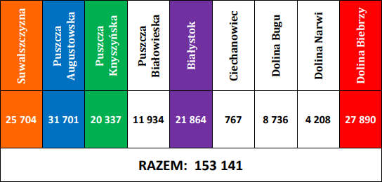

-GDP (Gross Domestic Product) per capita, in Euros only (Or converted into Euro sit available in a different currency) For: your country, region,urban area (or city)
Pkb per capita Podlasie is 7846.18 EURO.
The Łomża sub-region is 7007.49 euros per capita.
Per capita of Poland, GDP is EUR 12731.89
Data from 2015
http://www.polskawliczbach.pl/Lomza#rynek-pracy
http://piwolomza.pl/produkty/
https://www.forummleczarskie.pl/TAG/mleczarnia_osm_piatnica/
http://www.sonarol.pl/pl/
Izabela Koszykowska
Martyna Truszkowska
Anna Sokołowska
Kamil Liżewski
Klaudia Piątek

